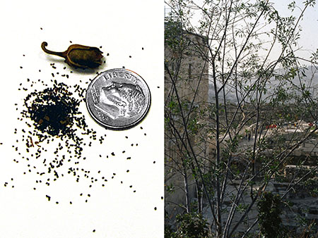
The Parable of the Mustard Seed

The mustard seeds that we know are actually seed pods. The ones that Jesus was talking about are very tiny, like a speck of dust. Fr. Thomas Keating points out that they spread (like dandelion seeds!) and so they were not grown in kitchen gardens. It is hard for us to fathom that the Kingdom of God Jesus told about might not be something spectacular and big, but something small that happens right here, right now, in our midst. It might be that the Kingdom is happening in small and often subtle ways. It might be true that what we most need to do is to notice it. And it might be true that the seeds will spread willy-nilly, in the most unexpected places, and that maybe all those seeds, sometime, somehow, will change everything. I wonder.

Wondering together
I wonder…
What the mustard seeds could really be.
How something as large as a bush (big enough for birds to nest in)
could come from something so small.
If you’ve ever experienced something small that made a big
difference to you, or to someone else, or to a lot of people?

