Healthier Congregations Team Vision Statement
We equip and empower congregations and neighborhoods to support one another for the risky work of discerning how to share God’s love more fully in our community, build healthier relationships,
explore new ways of being church together,
and live as a sign of hope for the world.

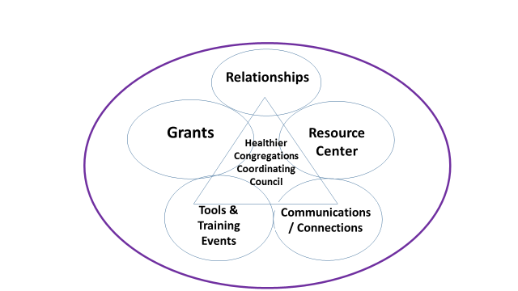
Healthier Congregations Team
Working Groups & Coordinating Council

