The Episcopal Diocese of Montana

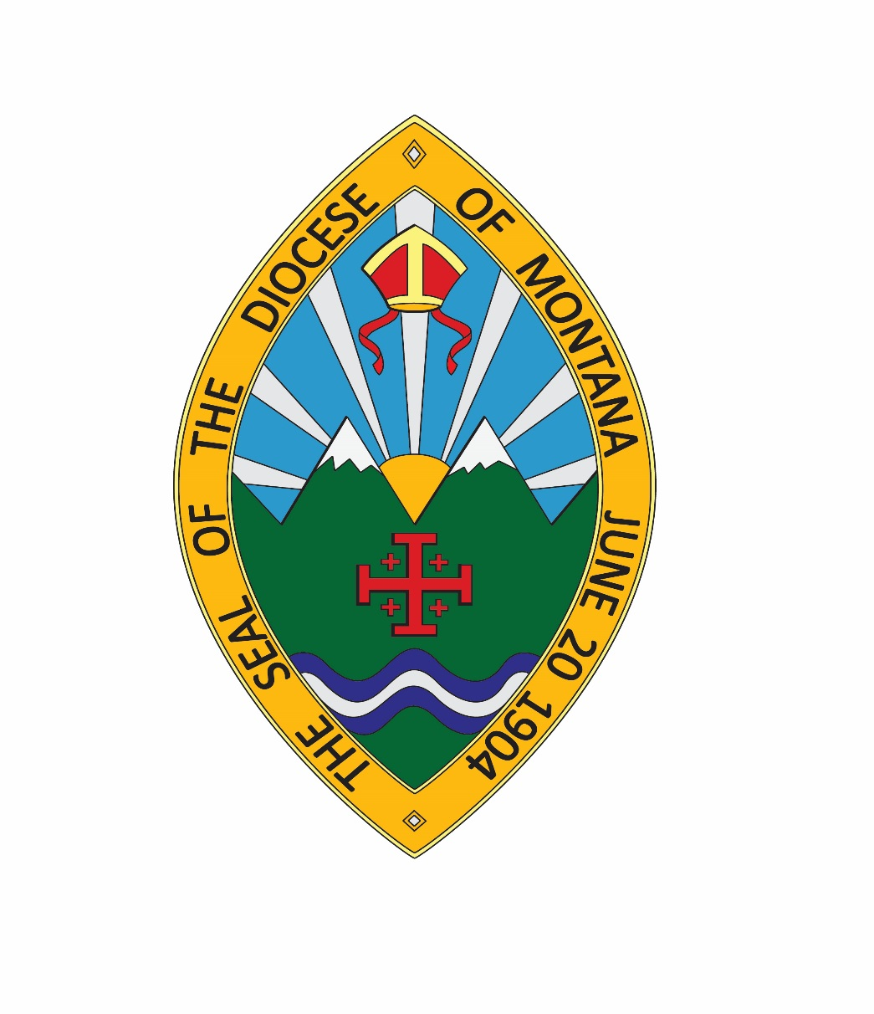

WHAT DOES IT MEAN TO BE A DELEGATE?

A Guide for Montana Episcopalians
As of: Tuesday, August 06, 2019

PRAYERS FOR DELEGATES

For a Church Convention or Meeting (BCP, Prayers and Thanksgivings #12, p818):

Almighty and ever living God, source of all wisdom and understanding, be present with those who take counsel in the Convention of the Diocese of Montana for the renewal and mission of your Church. Teach us in all things to seek first your honour and glory. Guide us to perceive what is right, and grant us both the courage to pursue it and the grace to accomplish it; through Jesus Christ our Lord. Amen.

For Guidance (BCP, Prayers and Thanksgivings #58, p832):

O God, by whom the meek are guided in judgment, and light riseth up in darkness for the godly: Grant us, in all our doubts and uncertainties, the grace to ask what thou wouldest have us to do, that the Spirit of wisdom may save us from all false choices, and that in thy light we may see light, and in thy straight path may not stumble; through Jesus Christ our Lord. Amen.

- Did someone ask you to run for election?

The Senior Warden, or maybe it was a member of the clergy, has just asked you to consider standing for election as a delegate to Diocesan Convention. Or maybe you heard someone talking about it and thought it might be something you would like to do. But you don’t know very much about Convention, and even less about what a delegate does.

- Did someone say:

“Oh, it doesn’t take too much time. Convention just meets once a year on a weekend?”

- Did you hear:

“Don’t worry about how to vote; you can always ask the clergy or the wardens?”

- Did you think:

That Diocesan Convention was only about adopting a budget?

This information was prepared for you by your diocesan staff:

- To help you make an informed decision about standing for election as a delegate;
- To answer questions you may have as a new delegate attending Diocesan Convention
- To suggest ways to engage and inform members of your congregation about matters of importance in the diocese.

- What is Diocesan Convention?

Technically speaking, Diocesan Convention is a governing body of the Diocese, a representative membership of all Episcopal congregations in Montana.

The Convention meets in an annual session and in special sessions for particular purposes such as the election of a bishop.

The annual session of Diocesan Convention meets in the fall, usually at the end of September or early October.

In between Conventions, the Diocesan Council acts as the Convention in recess to formulate policies and implement decisions of the Convention.

- How do I receive Convention information?

Upon your election, usually for an initial one year term, your priest will send notification to the Diocesan Administrator. The diocesan web site www.diomontana.com has a Convention page containing all the current information.

- How do I register for Convention?

All Convention registrations are done online at www.diomontana.com
Please note: See website for final date for hotel reservations. Convention registration closes two weeks prior to convention.

Okay, I’m at the Convention hotel site – where do I go?

Look for the registration tables in or near the lobby or at the church. You will be advised ahead of time where to register. Members of the host congregation Convention committee will check you in and give you your Convention packet. Your registration materials are listed alphabetically by your last name. The packet contains your name tag, final agenda for the meeting, various handouts concerning ministries of the diocese and wider church, and worship materials for the Convention services. Remember to print your annual report and bring it with you. There are limited copies of information available so it is best to print the items from the website ahead of time (www.diomontana.com )

After receiving your packet, you will be directed to the Credentials table to sign in. It’s very important to sign in because the Credentials Committee tallies the number of delegates in attendance and reports this number to the Presiding Officer. This number is the basis for determining whether a quorum is present, and for assuring that the number voting on any matter does not exceed the number eligible.

- What happens on Friday?

We always offer a new delegates briefing and a budget meeting on Friday afternoon beginning at 3:30. The Finance Committee presents the Diocesan Council-approved budget for delegate discussion. We often offer other types of workshops as well. Watch the website for details.

Diocesan staff members are always available to answer your questions about resolutions, procedures or anything else to do with the Convention.

Convention begins at 7 p.m. with Holy Eucharist and the first business session follows the Eucharist. If there are changes to the regular schedule, they will be noted on the website and we will communicate with you regarding any changes.

- What are the Rules of Order for the Convention?

In general, the Convention follows the most recent edition of Robert’s Rules of Order. Rules of Order are essential to the efficient and effective conduct of an assembly such as our Convention. They enable the Bishop (President of the Convention) and members to move through debate, offering substitutions and amendments, calling for an end to debate and finally voting, with assurance that the process is fair and open.

- How do I learn about the candidates for office?

The Diocesan web site Convention page contains nomination information about the candidates. Additionally, the candidates sometimes provide biographical sheets with photos to be distributed at the Convention site registration tables.

- Who are those people sitting at the front table?

They are the Convention officers:

- The Bishop, who is also the President of the Convention.
- The Assistant Bishop
- The Secretary of Convention, elected as the session begins.
- The Parliamentarian, who assists the President on Rules of Order.
- The Chancellor, who rules on matters having to do with the Diocesan Constitution and Canons.

The business session includes reports from diocesan committees and commissions; these are usually printed in the diocesan Annual Report, and are received ‘by title’, meaning they are not read aloud.

- What happens on Saturday morning?

The session begins with a Healing Holy Eucharist. During convention we offer educational and spiritual forums to help instruct and inspire delegates and guests.

- What happens on Saturday afternoon?

This is the main business session of the Convention. The Bishop presents his address at this session. Again, delegates receive full details of all the business sessions when you check in. Please note that during this session, delegates are asked to vote to enact the budget, not to approve it.

The Resolutions Committee presents their final Resolutions for delegates to approve or disapprove. There are several types of Resolutions:

  - Policy Resolutions, urging the Convention and/or congregations to act on matters of study and ministry or to take stands on matters of social and economic justice.
  - Legislation to amend the Diocesan Constitution and/or Canons.
  - Courtesy Resolutions, to express appreciation for the services of individuals or groups to the life of the Diocese, or to extend the greetings of the Convention.

NOTE: The deadline for submitting Resolutions (other than Courtesy Resolutions) to the Resolutions Committee for presentation at Convention is 60 days before Convention. This gives delegates the opportunity to be well informed about issues coming before Convention, and to participate in discussions on these matters within their congregations.

Elections to various offices are part of the business sessions. These include, but are not limited to:

- Officers of the Diocese (Secretary and Treasurer).
- Members of the Standing Committee.
- Members of the Diocesan Council.
- Members of the Foundation Board
- Members of the Disciplinary Board
- Deputies and Alternates to General Convention (every three years.)

- How do I speak at Convention?

First: Be clear about what you want to say, and be brief. Pay careful attention to any time limits the President may have adopted.

Then, go to any microphone on the Convention floor and wait to be recognized by the Bishop (President). When recognized, say, “Right Reverend, Sir, I am (your name) lay or clergy delegate from (state your congregation. Continue with your point).

- How do I vote at Convention?

Voting on matters before Convention can be as simple as saying “Aye” or “Nay”. That is the usual manner of voting for Resolutions.

When using a ballot, the Nominations Committee Chairperson will give you exact instructions as to how to use your ballot. Voting in elections is sometimes by ballot and sometimes by acclimation depending on the numbers of nominees. They are counted electronically; a nominee must receive a majority on the same ballot to be elected. If necessary, the vote is repeated, with new ballots until a nominee receives a concurrent majority.

- What happens on Saturday evening?

This is the delegate banquet and social time.

- What happens on Sunday morning?

All Convention participants attend a Festival Eucharist usually at the host’s church. The United Thank Offering In-gathering is sometimes part of this service.

Worship is the most important part of convention. We know you are eager to get on the road, but this time to be together as a diocesan family and to connect with God and each other is crucial to our life together.

The Convention adjourns immediately following the service.

- What do I do after Convention?

Share information with your congregation about what you learned at convention.

Here are the relevant Diocesan Constitutional and Canonical references:

CONSTITUTION OF THE EPISCOPAL DIOCESE OF MONTANA

As ratified by delegates to the 100th Diocesan Convention in Helena on September 26, 2003

Article IV. Diocesan Convention. There shall be a Diocesan Convention, in which is vested legislative authority of the Diocese, whose members and duties shall be as set forth in the Canons of this Diocese. Convention shall meet at least annually at such times and at such places as prescribed by the Canons.

CANONS OF THE EPISCOPAL DIOCESE OF MONTANA

Canon 3 - The Diocesan Convention

Section 1. Duties. The Diocesan Convention shall perform such duties as are required by the Constitutions and Canons of the Episcopal Church and of the Diocese of Montana, and shall take such legislative action as shall promote the welfare of the mission of Jesus Christ and The Episcopal Church in Montana.

Section 2. Membership.
- A convention, annual or special, shall be composed of two orders: clergy and lay people.
- Every member of the clergy in good standing canonically resident within this Diocese shall be entitled to a seat, voice and vote in this convention.
- Each congregation shall be entitled to lay representation to be based upon adult (age 16 and over) communicant strength in accordance with the following table:

- Adult Communicants Delegates
1 - 100 2
101 - 200 4
201 - 300 6
301 - 400 8
401 - 500 10
501 - 600 12
Over 600 14

- The lay delegates and alternates shall be elected by the congregation at the annual parish meeting, and shall be adult communicants in the congregation they represent. The vestry may elect alternates when necessary.
- Members of the Diocesan Council and Standing Committee shall be delegates to the convention.
- Lay college chaplains, the Diocesan Youth Coordinator, the Diocesan Camp Director and one youth from each Deanery shall be delegates to the convention.
- The Diocesan Secretary, Diocesan Treasurer, Chancellor, and Commission and Department Chairpersons shall have voice at the Diocesan Convention, and shall receive all materials sent to convention delegates.

Section 3. Notice of Convention. The Ecclesiastical Authority shall call the annual meeting of the Diocesan Convention by giving at least three months written notice to each congregation. The Ecclesiastical Authority may call a special meeting of the Diocesan Convention with thirty days written notice. In the case of emergency, the Ecclesiastical Authority may change the time and/or place of convention.

Section 4. Officers of the Convention.

- Presiding Officer. The Bishop or, in the absence of the Bishop, the President of the Standing Committee shall preside at all meetings of the convention, and shall have a vote with the clerical order.
- Secretary. The duties of the Secretary shall be to take Minutes of the proceedings, prepare the convention journal, and to perform such other duties as the convention may direct. The Secretary may appoint an assistant secretary.

Section 5. Preparation for and business of Convention.

- The Ecclesiastical Authority, in consultation with the Diocesan Council, shall appoint the following committees at least three months prior to the date of the annual convention:

  - A committee on credentials. The committee shall review and certify the credentials of lay and clerical delegates to the convention.
  - A parliamentarian.
  - A committee on legislation which shall be composed of at least two clergy and two lay people. All proposed alterations and amendments to the Constitution and Canons shall be referred to the committee at least sixty days prior to convention.
  - A committee on resolutions which shall be composed a two clergy and two lay people. All resolutions shall be referred to the committee at least sixty days before convention.

- Reports of the legislation and resolutions committees, except for courtesy resolutions, shall be prepared in final form, printed and distributed to the delegates at least thirty days prior to the annual convention.
- The resolutions and legislation to be considered by the committees may originate in said committees or be submitted by other individuals or groups within The Episcopal Church.
- Any resolution or legislation submitted by the committees to the convention shall also indicate the following information:
- The identity of the group, committee or persons originating or sponsoring the proposal.
- The recommendation of the committee, if the committee considered the merits of the proposal.
- A statement that the committee makes no recommendation for or against the merits of the proposal, if the committee did not consider the merits of the proposal.
- Estimate cost and source of funding.

Section 6. Quorum. A quorum for the transaction of business shall consist of two-thirds of the clergy with a cure in the diocese of Montana and two-thirds of the lay delegates elected by the Congregations.

Section 7. Opening and order of business.

Every session of the convention shall be opened with the prayers of the Church. The order of business shall include:

- The committee on privilege shall certify to the convention that a quorum is present, advising the convention of the number present and entitled to vote.
- A quorum being present, the presiding officer shall declare the convention organized for business.
- The chair shall appoint tellers to count and report ballots whenever a written ballot shall be called for by these canons or by motion duly passed by convention.
- The election of the convention secretary.
- The annual address of the Bishop.
- Receiving and acting upon the report of the Diocesan Council.
- Receiving and acting upon the report of the Secretary of the Diocese.
- Receiving and acting upon the report of the Standing Committee.
- Receiving reports of departments and commissions.
- Receiving and enacting the annual budget.
- Election of members of Diocesan Council, Standing Committee, deputies and alternates to the General Convention, the Church Advocate and members of the Ecclesiastical trial court.
- Nomination by the Bishop and approval by the convention of the Commission on Ministry, the Chancellor of the Diocese, and delegates to Provincial Synod.
- Receiving and acting upon the report of the committee on legislation.
- Receiving and acting upon the report of the committee on resolutions.
- Receiving and acting upon the reports of special convention committees.
- Receiving an annual report from Provincial Synod
- Such other business as shall come before convention.

Section 8. Conduct and completion of business.

- Upon a motion duly made, seconded and approved by two-thirds vote of convention delegates, a resolution may be introduced to convention.
- If the order of business on any day shall not have been completed, the first business on the succeeding day shall be the matters which were not acted upon the preceding day.

