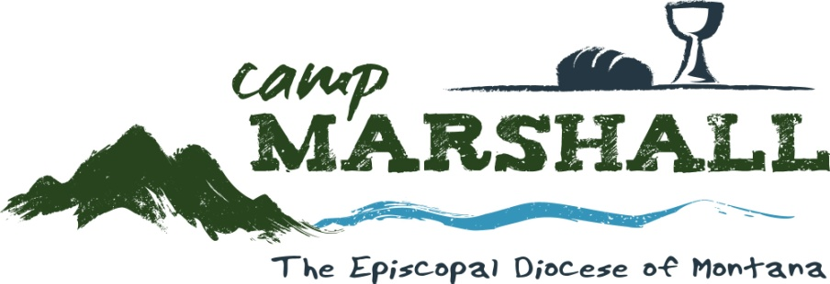

Camp Marshall’s Grace Camp
June 14-19, 2020

Grace camp is for children entering 3rd through 8th grades of (one or both) incarcerated parents. This week of camp is offered at no charge. Transportation is available from several locations around the state of Montana.
We also offer a limited number of scholarships to Senior High Camp
for former Grace Campers entering grades 9-12.

Kids enjoy a week of swimming, kayaking, archery, hiking, arts and crafts and more in our idyllic setting just off Melita Island Road on the west shore of Flathead Lake. 3 nutritious meals and snacks are offered every day. Kids learn to live in community, in a rustic-style cabins, in the beauty of God’s natural surroundings.

Our camp is certified by the American Camp Association, practicing the highest level of safety and professionalism. We are staffed with trained counselors, chaplains and an on-site RN, available 24 hours a day.

Easy registration here:
https://www.campmarshallmontana.org/grace-camp
or call Jill Sallin: 406-422-2230 x-100

See our website for:
A Typical Day at Camp
Packing List
www.camparshallmontana.org

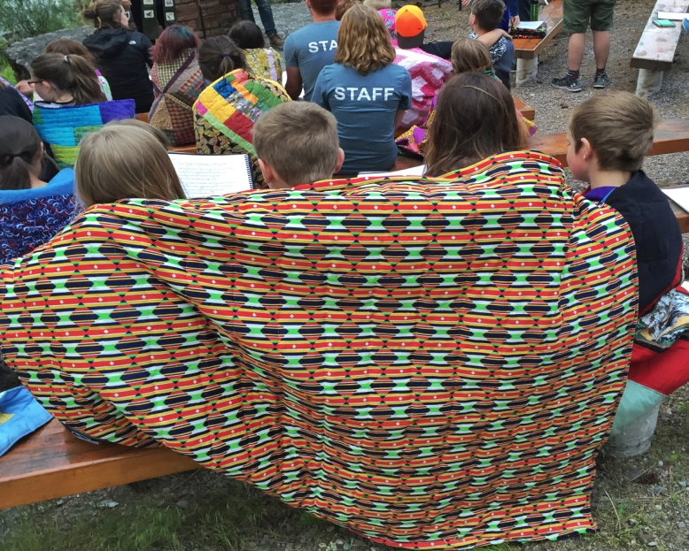
“Grace Camp has shown me in a fresh way that we are better together singing, and laughing and eating together in a community of love”. – Rev. Valerie

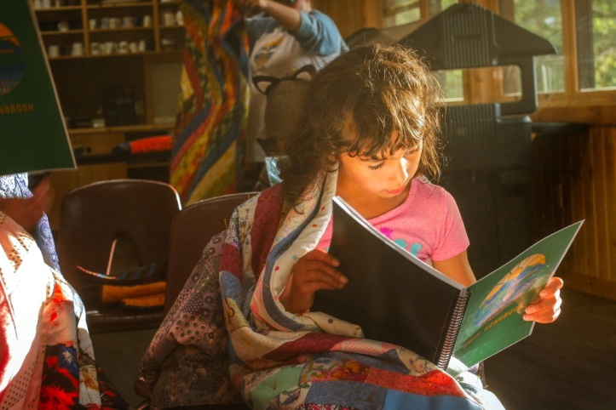

“It means a lot to me. An opportunity to come here with fun activities”. -Grace Camper

“I like meeting new people every year and its really fun. That’s why I come back to Camp”. – Grace Camper

“Grace Camp is a place where I can meet people who have been through the same thing, like having a parent incarcerated”. - Grace Camper

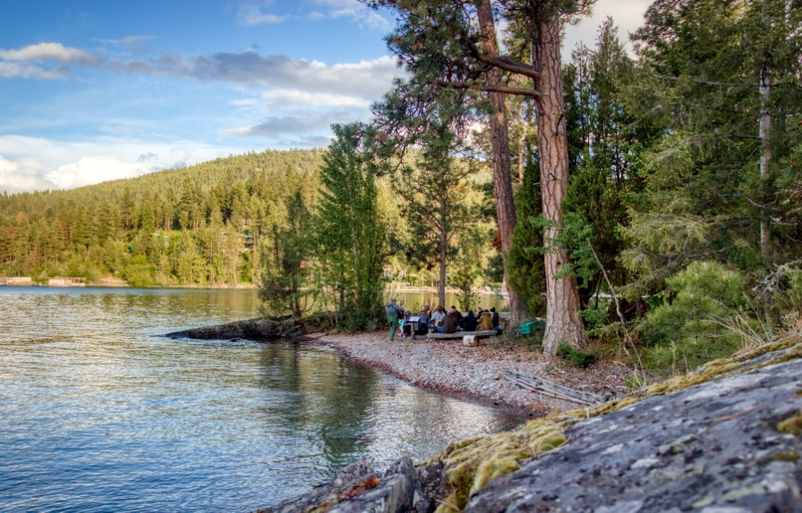

“The place is very special. The lake is gorgeous. The environment us is beautiful. These kids have really touched my heart. It’s one of my favorite weeks of the whole year.” – Fr. Greg

