St. Michael & All Angels 2021 - #1
The Messenger
A LETTER FROM THE RECTOR + + + + + + + + The Reverend Pattiann Bennett

The season of Lent has a purple hew, a dark blue aura..is quiet, hungry, contemplative and desperate at times. In it we are a thread on Jesus' shoulder, connected to his wilderness experience. Because of who he is and what he has, which is nothing and everything, he faces wild temptations in the nether lands and wins. The only way through was through. One temptation and day at a time. With God.
The shut down of the world because of Covid19 with 500,000 dead so far in the US, is cast in a wilderness place which also is quiet, hungry, contemplative and desperate at times. The only way through is through. One day at a time. With God.
Spiritual practices grow our relationship with God and have for centuries. In this day of distraction, temptations, and disruption, God has a lot of competition. Which brings us back to Lent's purple hew, it's dark blue aura. In this shadow, spiritual disciplines, even long after Easter, can cut through distractions, temptations and disruption, those things that separate us from the love of God and each other. The only way through is through. One day at a time. With God.
Spiritual practices, as I've mentioned the last two weeks, include things like praying the rosary, some of you have rosaries I made years ago, or praying the hours. Fasting is another practice. Journaling or giving are others. Intention or mindfulness are others. Reading scripture another. Spiritual writings another. For this I highly recommend 2 books: Presiding Bishop Michael Curry's Love is the Way and ArchBishop Justin Welby and Joan Chittister's book, For All That Has Been, Thanks.
Finding ourselves for the next few weeks contemplating Jesus' time in the wilderness and our very own besides, may we know that the only way through is through. One day at a time. With God. May we Learn, Enter, Notice, Today. Rev. Pattiann

St. Michael & All Angels Intercessory Prayers
For the special needs and concerns of this congregation and abroad:
Aaron, Ann, Avery, Becky & family, Bonnie, Cam & family, Carol & family, Chez, Chloe, Chris & family, Dan & Patie, Dee & Sam, Derrick, Don & Linda, Gwynn, Jillian, JoAnn, John & Sharon, Jordana, Judith, Kaye, Leeann & Bill, Lisena's family, Megan & Sophia, Mike & Donna, Mike & JoAn, Misha & family, Nathan, Nicole, Noel, Paisley, Pat, Richard's family, Rosemary, Ruby, Ruth, Sara, Su, Sue & Family, Tom & Sandy, Tom
Vestry Views

*** 2020 FINANCIAL SUMMARY REPORT – JANUARY 31, 2021
INCOME FOR OPERATION
(includes pledges, morning offering & special. giving). $18,867
EXPENSES:
WAGES $12,513
ASSESSMENT $ 4,434
MILEAGE $ 276
UTILITIES $ 1,951
INSURANCE $ 1,260
CONV/EDUCATION $ 150
PRINTING/ADVERTISING $ 423
SUPPLIES $ 132
TAXES $ 103
LEGAL $ 137
TOTAL EXPENSES $21,228
OPERATING: SEE NARRATIVE ***
SAVING ACC’T $8,962
SAVING ACC’T $4,536 (PENSION LOAN FUND)**
RAYMOND JAMES $3,162
BUILDING FUND $8,479 (SEE NARRATIVE)*
OTHER GIVING:
DISCRETIONARY $4,600
WOOD BANK $300
PRAYER SHAWL $150
ERD $51
Respectfully Submitted, JoAn H. Cuffe, Treasurer
***NARRATIVE: When the pandemic first hit, our monthly income decreased to very little. To keep things paid, the Vestry decided that we would transfer funds from the building account as needed, especially since there was very little we could do to the church. We did talk of requesting an adjustment to our assessment payments, but after review of our reserve funds realized the Diocese likely would not grant our request. It was decided that should we need funds for special projects, we would have fund raisers when the situation allowed.
The following is an accounting of the building fund: Beginning Balance $8,652.55 + $6,000.00 = $14,652.55 - $2,361.16 (short fall), - $3,812.71 (Misc. repairs, computer, programs etc., shed & shed setup etc.).
Thus our Building fund balance is $8,478.68.
At this time, I would also like to suggest that we go ahead and payoff our Pension Loan from the Diocese with a balance of $4,094.86…JoAn
Annual Meeting (January 31, 2921)
Almighty and Everlasting God, you govern all things in heaven and on earth; Mercifully hear the supplications of your people and in our time grant us your peace. Amen. This is the Collect of the day.
Supplications are humble requests. Every moment, somewhere everywhere humble requests are being made to God. In a world reeling with effects of Covid, and all the rest in turbulence we humbly request help in healing, strength, understanding courage, direction, wisdom, peace and life.
Almighty and Everlasting God, you govern all things in heaven and on earth. How so? God isn't Santa Claus who grants our wishes if we're good, who sneaks in, in the night to give us what we ask for. No, God works in a different way.
God works through humanity, through us, through people like you and me by the power of the Holy Spirit Paul writes 1Cor:16 Do you not know that you are God's temple and that God's Spirit dwells within you? It is within this holy temple that we are, that God's spirit dwells and works. It is within this body of Christ that each one of us is a part of. Without what each one of us is and does, this body of Christ at St Michael & All Angles in Eureka, Mt. wouldn't be what it is or do what it does.
Today is our annual meeting and I always give a narrative of what we've accomplished during year, telling how God's Spirit has worked in and through us. Our little church in northwest Montana is the prettiest one in town. At 106 it is the oldest one too. We follow Jesus, mindful of the little, the least, the last, the lost and the lonely. Mindful of the needs of one another and of the community we live in.
Our mission statement says: St Michael and All Angels Episcopal Church is an inclusive, community minded, worshipping parish in the heart of the Rocky Mountains in Northwest Montana. Yes, we are inclusive and community minded.
For years we've had a prayer shawl ministry that is filled to the brim with sacred, prolific energized hearts and hands that have made hundreds and hundreds and hundreds of prayer shawls over the years for those who are grieving, are ill or recovering or just need to be wrapped in love and prayer.
Covid has forced the knitters and crocheters to not gather at the church but the ministry is strong in spite of it. 20+ prayer shawls were given to the nursing home recently and there's an inventory on the altar, blessed and ready to go. More arrive weekly...
My discretionary fund fills up like baskets of loaves and fishes so we've been able to help many people this year buy groceries, pay rent, electricity, phone, water, fuel, medicine, mail prayer shawls and even buy lumber for bird-houses. You can talk all day long about the love of God but when people are hungry or cold or sick they can't hear it.
We adopted 3 families at Christmas and as always grande abundance was the sum. It was kind of crazy to see all those presents under the tree...Ten children thrilled to a Christmas morning with gifts, toys, clothes, hot chocolate, food cards, fuel cards and more.
At Thanksgiving we gave boxes of groceries and funds to buy what they need to the Food Pantry.
We ask for a dollar for Episcopal Relief and Development when we're gathered each Sunday and even tho we weren't gathered after March the total was $455. ERD monies go to help with disasters all over the world, hurricanes, tornadoes, earthquakes and such and it goes to help women start businesses and to educate children and buy cows and ducks and bees and seeds and all kinds of life giving things.
We began the 6th year of All Angels Free Soup Cafe the first Wednesday in December, the beginning of Advent. Since we cannot meet at St Michael we are delivering meals. It took awhile but we have a clear schedule of soup and bread makers and deliverers who bring the meals that feed 26 people. Last week Jim had 33 qts to deliver, when 20 is the goal..so if this continues, I think we should find more people who need a lunch. Another loaves and fishes story.
This is the 10th year of the Wood Bank which has given 80 loads so far this winter. The teachers met again at the pole yard on Martin Luther King Day from 9 til 11 and in that small time cut, stacked and delivered 9 loads. A truck load of logs was given to the bank recently and Tom Stafford and Bruce work there by themselves in between Wood Bank work days..
Eighteen people were at the Bank yesterday to cut and split and stack. A wonder about the wood bank is that it hasn't been so successful because of only what we at St Michael have done. The Bank has become a community project. This church knows how to go out into the world, we are not navel gazers, keeping to our own, we extend our hands and hearts to needs we see and figure out how to take care of it. We ask for help, invite others in no matter what church they go to or not, no matter what political persuasion, no matter how old or even if you're a girl. We don't stand on the corner preaching, we follow what St Francis said, "Preach always ~ if necessary use words"..
There's a song that goes 'and they'll know we are Christians by our love..'that's us.
We lost our routines of going to church last spring and we lost our old friend Bob Burness last fall who died one morning while watering his tomatoes. I hope I go like that.
Sharon created Messengers that are full of news of who we are and what we do at St Michael by putting together beautifully crafted collections of stories and prayers and history, great archives for future years and members of this church.
All this in the midst of Covid 19, which created a whole new way of being for everyone in the world, where more than 400,000 have died and more will and thankfully vaccines are coming available and should help us get back to some kind of being with each other life. Some of our own beloved parishioners suffered it and we thank God recovered.
To continue to be church, clergy have learned to live stream services or record them and upload to YouTube.. Who knew? I certainly fought against all that but you have to flow with the tide in such times and learn new things and do what is unfamiliar and out of our comfort zone. It doesn't kill you even though you think it might. So many of us have grown in ways we never imagined and will probably continue with the technology even when we return to church. We have WIFI now at St Michael.
As I record Morning Prayer each week, I often wonder if some of you would like to do this as well. If you would, let me know. I'll show you how. On Saturday afternoons I deliver the liturgy in town to those who don't have internet or like a hard copy.
Thanks to each of you for whatever you've done to keep St Michael connected. You make phone calls, send cards and emails to one another, even dropping off cookies at door steps, flowers, candy, little things mean alot.
The vestry tends to the business of the church. Doug Merrill has been our Sr Warden for a long time and felt it was time to pass the position along a few months ago while gladly staying on. Jim Pettit agreed to take the position, as you know from the latest Messenger and we are grateful for that. Art Walters is Jr Warden, so looks after the church building and grounds. He and Jim have been organizing the new shed for garage sale items. Art and Kathy go to the church often to clean and put things away after each season, as in taking the Christmas tree and lights down and putting things where they should be. Julia Pruett gives counsel when needed and I appreciate it. Claudia Evans continues as clerk and JoAn Cuffe continues as treasurer. Thank you for taking care of the building and grounds, for keeping records, paying bills, sharing ideas, discussing new projects and supporting me this year as we all learned to adjust to new ways of being.
I say this at each annual meeting: There are some who think they don't do much to make things happen here. It may seem that way to you but you are at work in ways that might just not be obvious. You tithe, which is absolutely essential for the church to pay her bills and to be financially strong when we return. You supplicate. You uphold. You love one another.
Paul says: As it is there are many members, yet one body. The eye cannot say to the hand I have no need of you. On the contrary, the members that seem weaker are indispensable. But God has so arranged the body, giving the greater honor to the inferior member, that there may be no dissension within the body, but the members may have the same care for one another. If one member suffers, all suffer together with it, if one member is honored, all rejoice with it. Now you are the body of Christ and individually members of it.
You and I are the body of Christ at St Michael & All Angels in Eureka, Mt. You should know that our ministries are self-supporting. The Wood Bank is completely financed through donations. We do not take from operations anything to pay for what happens there or Cafe or Prayer Shawl Ministry. The discretionary fund is separate. Wood Bank is separate and ERD is separate.
We will need 3 delegates for convention in the fall. If you'd like to be one please let me know. I don't know how that will happen, whether in person or virtual, time will tell.
God Bless You All for your supplications, for your time, for your talent and for your treasure, all of which continue to make this holy place what it is, a beacon of God's light up on the hill. Amen. The Rev Pattiann Bennett
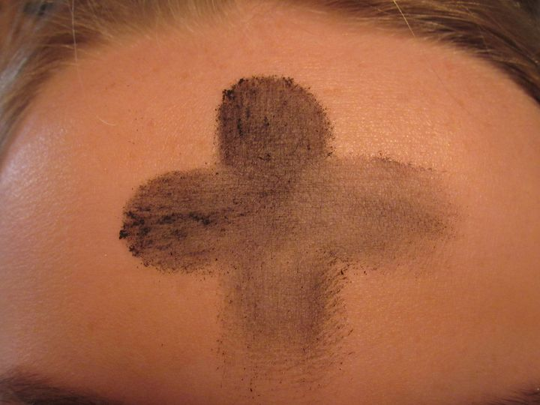
At St Michael & All Angels and thousands of churches all over the world, Ash Wednesday imposition of ashes happened 4 days ago. Here in Eureka, Montana the season of Lent began with a line of cars up on the hill and meetings on the sidewalk in a little snowfall, masks and all. 'Remember that you are dust and to dust you shall return', I spoke drawing the black ashy line down your forehead then across with my thumb. Then my hand on your heads with blessing. You bowed into this with reverence, eyes closed, deep hunger for the Holy was palpable. – 2/21 Sermon

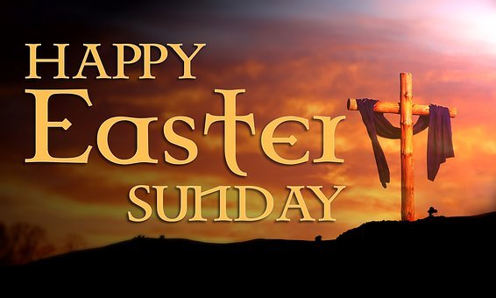
Easter
“Christ the Lord is risen today….”

Easter Service Wood Bank (Hwy 93 S / Graves Creek Rd.) 9:30 am Easter Sunday, April 4th

How great to be together again! Eucharist will be with bread only. Distancing and mask protocol will be maintained. A bonfire for warmth. Bring your own chairs, blankets, and umbrellas if needed; dress warm. Potluck to follow. Not quite sunrise service but how fun!!!

A View from the Pew – Editorial
My apologies for the lateness of the last two issues of The Messenger. No excuses! (Well, lots but none are valid.) Starting with this issue there will be only three issues per year, rather than trying to do it quarterly. I talked with JoAn and Pattiann about the change to three. By doing this we can continue to print the newsletter with colored pictures (they add so much).
Also starting with this issue, those who sent their email addresses will be receiving their newsletter electronically. Anyone else who would like their newsletter that way just sent me your email address (see below).
Please submit any articles or information that you would like to see in the next issue to sharonlabonty@gmail.com. Thank you to all of the great writers who respond whenever I ask for articles. You are greatly appreciated!

State of the Diocese
Date: 7 January 2021
Subject: COVID-19 Mask Mandate for Episcopal Congregations
Governor Gianforte has stated that the stae-imposed mask mandate will be lifted in the upcoming weeks. The Episcopal Church in Montana has strived to work with the county public health officials and their mandates in order to protect our congregatitons, our clergy and the broader communities in which each serves. While Gov. Gianforte is opening the vaccine opportunities by combining the CDC recommended rollouts of COVID-19 vaccinations, there is not enough vaccine available a the moment to protect our more vulnerable population. It also takes approximately 2 weeks after the second vaccination for a person to achieve the expected immunity. This means that an insufficient percentage of Montanans will be protected for many more weeks.
Some counties do not have their own mask mandates or are choosing to not enforce them. In order to continue to protect our people, I am requiring a mask to be worn over the nose and mouth by everyone the age of five years old and older when on any Episcopal property until such time as I lift this mandate. All other requirements, such as physical distancing, hand sanitizers and sanitizing of the physical plant also remain in place. My hope is that by Easter, I will be able to lift much of this. The end of the pandemic does appear to be in sight, but it is not here yet. Please remain vigilant and get your COVID-19 vaccine when it is available to you.
Peace and Ligh,
Bishop Marty

A Look Back…or Around Editor’s note: The Happy Hookers call ourselves “Ecumenical” so when I came across the following in the Diocese newsletter, I thought it was worth sharing.
The terms, ‘ecumenical,’ ‘Interfaith,’ and ‘Interreligious’ are used inter-changeably by many in everyday conversation. When these terms are used more precisely the distinctions are as follows:
- Ecumenical: At a minimum ecumenical means intentionally friendly relations among different Christian traditions through focusing upon what unites us is Christ. In the context of the ‘Ecumenical Movement’ (inspired in part by the Chicago-Lambeth Quadrilateral 1886, 1888 of the BCP) ecumenism is focused on fulfilling Christ’s prayer that we would all be one (John 17:20-23).
- Interfaith: Formally, interfaith refers to relationships among peoples who recognize Abraham as the father of their faith. The three Abrahamic faith traditions include Judaism, Christianity, and Islam. Informally and commonly, interfaith refers to all faiths – including the ‘spiritual but not religious’ or ‘Nones,’ who technically are of no faith.
- Interreligious: ‘Inter’-‘religious,’ relationships between and among religions, includes people of all religions, such as Latter Day Saints, Buddhists, Christian Scientists, Hindus, Wiccans, and others, as well as, Jews, Christians, and Muslims. Where interreligious events may emphasize the sharing of some form of the ‘Gold Rule,’ these gatherings generally seek respectful understanding over unity, or shared action over shared belief.
This column is designed to answer some of our questions. Let us help answer those questions – or better yet, you do the research and we’ll print it.

Interview – Claudia Evans
We ask the interviewee to address the following questions: 1) Please tell us about yourself (and your journey in Christ)? 2) How did you “find” St. Michael & All Angels and why did you come back? 3) What is your favorite part of this congregation / church? 4) What is your role in the congregation or how do you participate? 5) If there was anything else that you want to share?
Church / Sunday school started at the Methodist Church, Toston, Mt. I was presented with a Bible on May 9th, 1948. Married in the Townsend Methodist Church. Other churches along the way to St. Michaels: in Havre, the Van Orsdel Methodist Church; Sunburst Methodist two times; United Church of Kellogg. Served in a variety of activities at all the churches. My first introduction to St. Michael was 1980. Daughter Susan took instructions from Father Loren Foote who later that year along with the Reverend Spaulding Howe officiated at her wedding. Fast forward to 2003 – a great granddaughter is baptized at St. Michael. As I watched baby Jaden being brought into this church family, I knew then that this, too, was my church family. A feeling of peace as soon as you enter and look at the beautiful windows is my favorite. I have enjoyed the monthly potlucks. I currently serve as Vestry Clerk. Have participated in projects sponsored by the church from the rummage sales to soup. I hope that we can continue to be the “homey” place and “newcomers” and “oldies” will want St. Michael & All Angels to be their family.

Food Pantry – Ethel White
The Tobacco Valley Food Pantry had a very hearty holiday distribution. We provided full traditional meals to 93 house-holds. This could only happen because of the generosity of our community donations. We are truly grateful. Our treasurer Tom Maxwell stepped down and Norma Shaffer became our new treasurer. Jim Petitt joined our team. Jim got an introduction to our work when he helped fill the holiday baskets. The Tobacco Valley Thrift Store continues to provide proceeds of sales to the Pantry’s ability to purchase food for our monthly distribution. We are blessed to be able to provide food for families facing food shortage.
~ ~ ~ ~
Offertory: ‘But do not neglect to do good and to share what you have for such sacrifices are pleasing to God.’ Merciful God, we offer with joy and thanksgiving what you have first given us - ourselves, our time, and our possessions, signs of your gracious love. Receive them for the sake of him who offered himself for us, Jesus Christ our Lord. Amen. Please remember to send your gifts to St Michael so the church remains up to date with her expenses and is financially strong when we are ready to return.

Estate Planning?
Consider including St. Michael & All Angels in your will.

How to Donate
Pattiann is in the process of putting a donate button on St. Michael’s FaceBook page. As soon as the donate capability is in place she will post it on the church FaceBook page, the new website and the community bulletin board page. Pattiann is working with Glacier Bank to set up an official donation online site.
In the meantime, if you would like to make a donation now, go to The Episcopal Diocese of Montana (diomontana.com) where you can designate your donation to St. Michael’s.

New Website Address:
bit.ly/stmichaelallangels

Grace Camp - Women's Quilt Retreat

When:
April 15-18, 2021
Where:
Camp Marshall, 41524 Melita Island Rd, Polson, MT 59915
Details when you register:
Thursday: arrive 4-6 PM, Dinner at 6 PM
Sunday: ends at noon, after Worship
Stay 1-3 nights at $38 per night.
​
What we will be doing:
Creating Grace Camp Quilts for children of incarcerated parents. This year we may be sewing masks for youth and their families.
Women may come for one or more days and enjoy sewing/quilting, great food and spiritual growth lakeside.
Your Fee includes;
- meals,
- retreat registration
- and lodging.
Lodging
Will be in Canterbury (the staff house) or in a cabin depending on Covid vaccination records.
Retreat is open for any skill level.
​ *The retreat will be limited to 15 persons.
Questions:
Jocelyn Snider 406-360-6152, sniderjocelyn@gmail.com

COVID 19 Modifications:
​Everyone on camp will practice Non Prescription Interventions with the goal of preventing the spread of COVID 19.
Below are a number of interventions that have proven themselves effective in camps across the US.
Each family (or group) will be assigned their own restroom to use during your stay.
Persons using their camp trailer will need to use trailer restrooms.
Everyone will practice wearing masks.
Housing groups will be assigned to a table for dining / indoors or out.
Camp will look to innovate evening program to allow for social distancing.

​
O Lord, hear our prayer, and let our cry come to you. Psalm 102

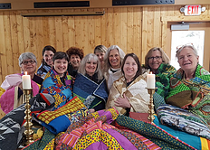
Grace Camp 2019 – Recognize some smiling face?

We pray for all people affected by COVID-19. We pray for health care workers and their families. We pray all who have died from it. 510,074 as of noon Friday the 26th. We pray for all whose lives are distorted by drastic weather and it's affects especially those in Texas last week. We pray for all who live under the dark cloud of racial injustice. We pray for this country dangerously divided by racism, lies, hatred, politics and corruption. We pray for justice in the wake of domestic terrorism in our nation's capitol and across the land. We pray for immigrants and their children. Wood Bank recipients and volunteers. We pray for veterans and their families. We pray for our Bishop, Marty Stebbins & her husband Bob, the Diocese of Montana, Holy Trinity/Troy, the Diocese of Jerusalem and peace in the Holy Land. Chrysalis School. Camp Marshall. All victims of violence, especially children, We remember the anxious and the fearful. We pray for this planet, our island home.
“O most mighty and merciful God, in this time of grievous sickness, we flee to you for help. Deliver us, we beseech you, from our peril; give strength and skill to all those who minister to the sick; prosper the means made use for their care; and grant that, perceiving how frail and uncertain our life is, we may apply our hearts to that heavenly wisdom which leads to eternal life; through Jesus Christ our Lord. Amen.”

What’s Happening?

Prayer Shawl Ministry
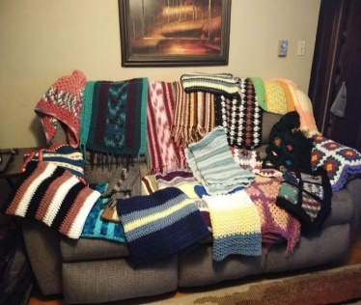 | 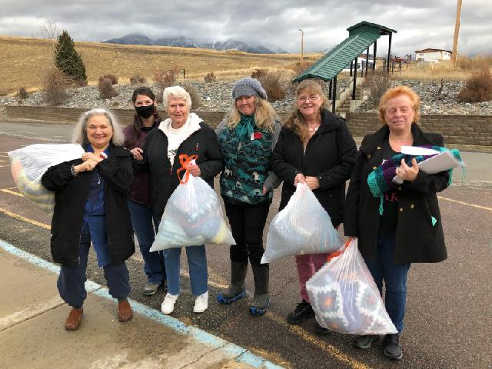

The Latest from The Happy Hookers – Jenny Bartlett

While much has changed in our world in the past year, one thing that has remained consistent and steadfast is the work and dedication of the Happy Hookers and the St. Michael and All Angels prayer shawl ministry. Despite our beautiful church building being closed to in-person worship services and the weekly Hooker gathering, the ministry continues to thrive. Not only do we create prayer shawls individually, but a small group has been meeting and gathering for food, fellowship, prayers and hooking since the end of April 2020. Where there’s a will, there’s a way! Dee Nance and Eliane Rasmussen have graciously opened their homes to those of us who have continued to gather weekly. To be sure, meeting once a week has been a real blessing and has kept us sane!
In addition to the regular work of making prayer shawls to supply the church, on November 23, Eliane responded to a request from Mountain View Manor to help provide Christmas gifts for the residents there. After discussions between Eliane and the Manor about what they would like our ministry to provide, the final request was for 20 prayer shawls for the ladies and 8 scarves for the gentlemen. In approximately 3 weeks’ time (and after many cramped hands and sore necks and shoulders) the Happy Hookers rallied and met the challenge! On December 17, we delivered bags overflowing with handmade blessings to Mountain View Manor. And as if that isn’t enough wonderful news, as of this writing, both St. Michael and All Angels and West Kootenai Community Church are well-stocked with beautiful prayer shawls ready to be given to those in need.

A Prayer of Gathering
(by Susan S. Izard)

Gracious God, God of Life, God of Love, God of Compassion,
We give You thanks for Your abiding presence and our shared joy that You are our God and we are Your people. We give You thanks for the gathering of our crocheting/knitting circle. We give You thanks for the shawls we create. We
give You thanks for each other and all those for whom we crochet/knit.
Bless, O God, our time together. Bless our hearts that they might be filled with Your Spirit. Bless our hands that they might be touched by Your creative power. Bless our crocheting /knitting that the shawls may be filled with Your love.
Gather us, O Holy One, in Your embracing arms. Fill us with Your tender mercy. Nurture us with your compassionate presence. Breathe in us the gift of your grace so that our hearts may be Your Heart, our hands may be Your Hands, and our work may be Your Work, now and forever more.
Amen.

Looking Back:
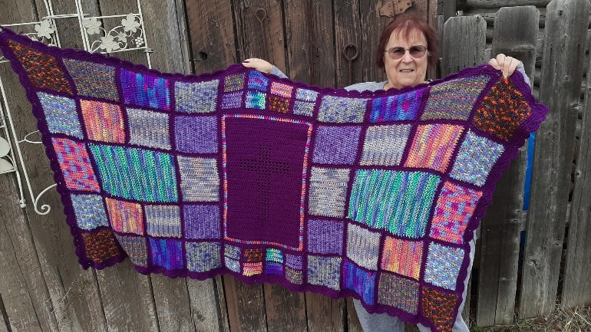
In preparation for Bishop Marty’s visit, scheduled for May 2020, the Hookers made a prayer shawl. Everyone made squares, except for Dee who made the cross for the center. Sharon put it together. Due to COVID, the visit got canceled but the shawl got mailed.
St. Michael’s Book Corner
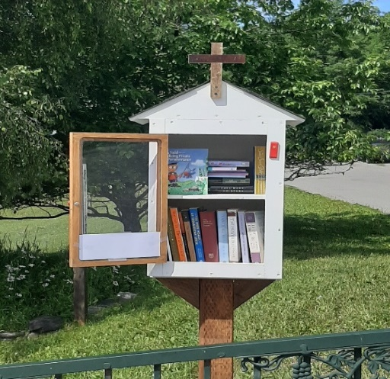 | Even though the lending library in the church basement is closed, the little library is OPEN!  Check out the books; take one / leave one!

Soup Café – Jim Pettit
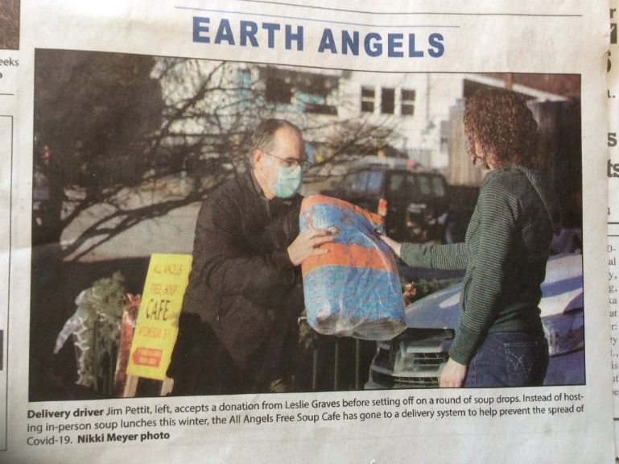
For the past several years Saint Michael has provided a Wednesday soup and bread lunch for all comers during the winter months. Our basement did not adapt well to COVID-19 spacing recommendations, and, of course, it is a small space with poor ventilation. This year adaptations were necessary to continue to share soup and bread/crackers to our friends who have for years come by and been with us each Wednesday in the basement of Saint Michael. Winter is still cold and people still need to eat. Being able to help provide hot soup as a sign of shared humanity and God‘s love was and is our continuing aim. Pattiann and JoAnn assumed responsibility for finding people willing to make soup. And what a lineup they found!!!: Nikki, Leslie, Sandy, Jeanne, John and Sharon, Becky, Dee, Jenny, Claudia, Kim, Ethel, and Julia. If anyone has been left out, please except my humblest apologies. These saints have provided enough soup and love to deliver 16 - 31 quarts each week for Doug and Jim to deliver. We have also had store-bought crackers, homemade bread, and homemade cookies on occasion to pass out. One week, Vivian created the most beautiful pieces of art that were distributed to each household.
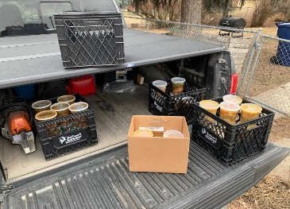 | 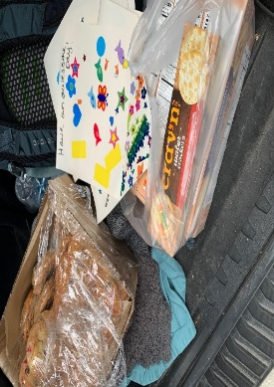
You know, if you give people a chance they tend to go that extra mile. We have been blessed with a group of people who have worked hard to continue the soup café tradition in difficult times. Our service continues through March. Anyone interested in helping provide soup, bread, or any other type of goodie, please contact JoAnn at 254.722.2444 or email jbristol42@gmail.com. Be safe and stay warm.

You can’t start too early!
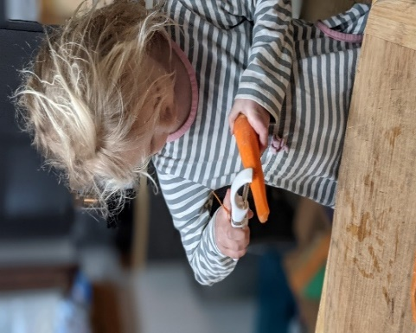 | Mom, you said I can peel carrots for the rest of my kid life right? (Yes) How about when I grow up and go to kindergarten? (Absolutely) Mom, when I’m in kindergarten, can I drive? - Vivian

A Lenten Blessing: The blessing of God, who creates life out of death, be with you today. The blessing of God who suffers with the sin of this world and blesses all humankind with grace, be with you always. The blessing of God who sanctifies our transformations and turnings, be with you as you reveal the power of God's love to save. Amen.
Some folks are always looking for the bright side – others roll up their sleeves and polish the dull!

Wood Bank
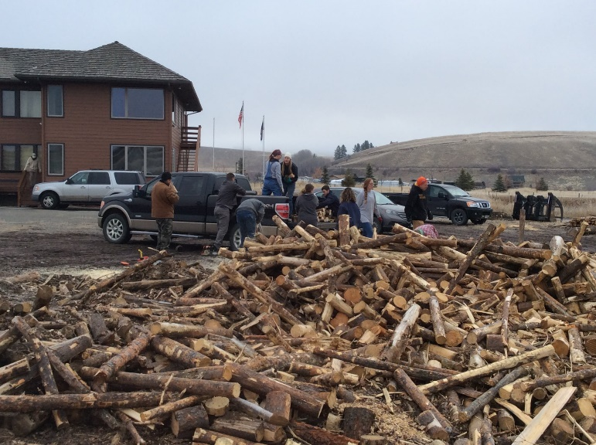
The morning of January 18th at the Pole Yard north of town, Joel Graves and his hardworking crew of Eureka teachers met for the 5th Martin Luther King Teacher’s Work Day to saw firewood and load trucks for the Wood Bank and in about 2 hours, 9 loads were delivered all over town. Another amazing day .. it doesn’t get any better than this .. we’re so lucky to live here.

Wood Bank Work Day January 30th brought 18 folks out to work the last of the log pile. What was left that day Tom Stafford worked during the week and by the next Saturday all was split, piled, stacked and raked up clean.
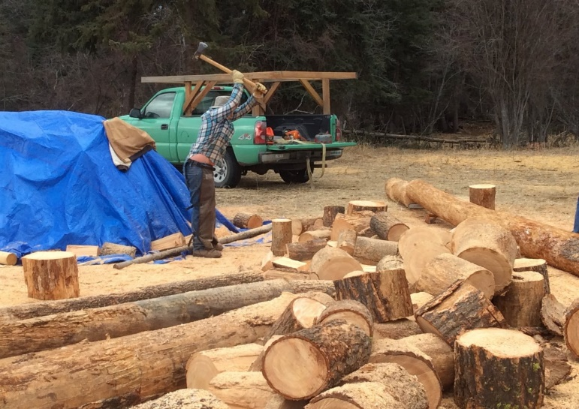
Connor Lord, LCHS senior worked all day splitting wood the old-fashioned way: with an axe!

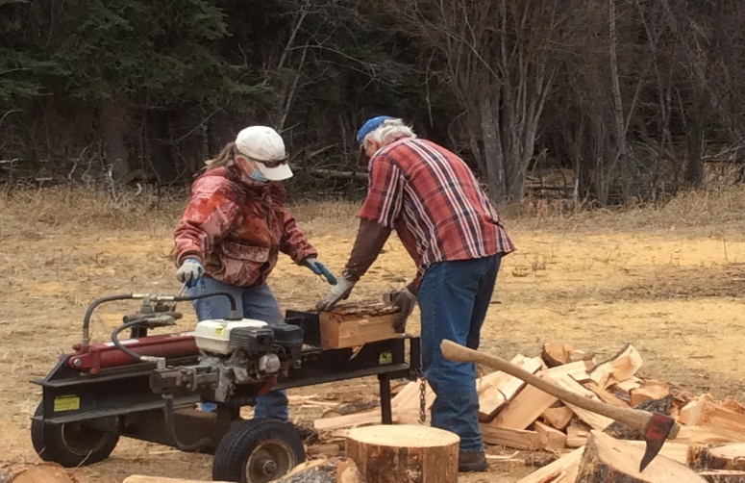
By February 20th, 100 loads had gone out. St. Michael & All Angels Wood Bank supplies supplemental firewood for low income, disabled, elderly, and veterans. The bank is completely accomplished by volunteers and donations.
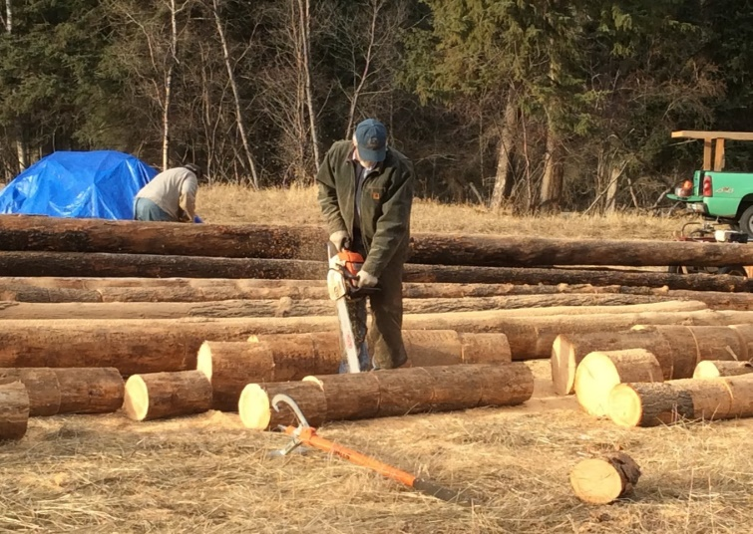
Note of interest: Someone in Libby desperately needed firewood so a young couple from Eureka loaded up their trailer Saturday (Feb. 13th) at the bank and drove it down.
FUND RAISER
Because of COVID we cannot gather at St. Michael & All Angels for fund raisers presented by Ray & Shirley Jacobs and Emerson, so they’ve created a video which Pattiann will post for us. In the past Ray & Shirley’s concerts have raised hundreds of dollars which we use to purchase log loads when we need to and fuel saws and trucks. She’ll include with the videos ways you can donate if you choose.

Birthdays / Anniversaries
January
February
15 Beth Sanderson
17 Jenny Bartlett
21 Ethel White
March
8 Sharon LaBonty
10 Doug Merrill
10 Jenny & Ron Komac
11 Emerson Roberts
14 John & Sharon LaBonty
April
12 – Leslie Graves
May
23 – Bruce Bennett
June
2 – Garrett Graves
30 – Pattiann & Bruce Bennett

Morning Collect
God our creator, yours is the morning and yours is the evening. Let Christ the sun of righteousness shine forever in our hearts and draw us to that light where you live in radiant glory. We ask this for the sake of Jesus Christ our Redeemer. Amen
St. Michael & All Angels
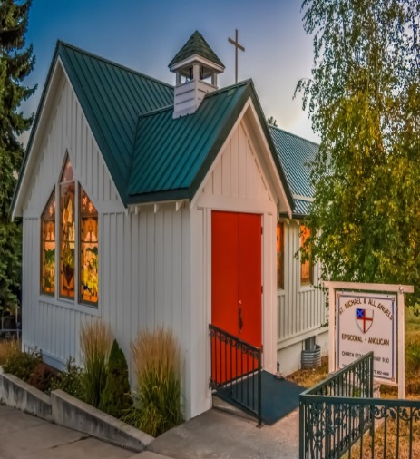
Episcopal Church
Cook Book
$15.00
For Sale at the Montana Market
Dates to Remember
March 28 – Palm Sunday
March 2 – Good Friday
March 4 – Easter Sunday

WANTED
Montana Writers for the Diocesan Newsletter!
Looking for Montana readers and writers! Read a book that informed your faith? Send us a book review and we will try to include it! Bloggers who would like to share their faith stories with the rest of the diocese, let us know! - Diocese of Montana Newsletter, 2/19/2021

Thank you
As most of you know, Sharon and I came down with COVID on Thanksgiving. At first we were both very sick. Too weak to even open a can of soup. But the scary part was not knowing who we could turn to. I was concerned, when do you make the call to go to the hospital? But we were not alone. Between Prompt Care, my oncologist, and Dr. Black at the Health Department we were checked on often. But also support came from our church family and our neighbors. A soup chain was set up, mail and prescriptions were picked up, and food was delivered. Because of health issues we had to endure isolation for three weeks. I would like to thank all of you for your prayers, your concern, and help. We are truly blessed to have such a loving church family. I wear a mask that says “Love Thy Neighbor” and I find it very appropriate. Thank you! John LaBonty

Purpose Statement

The purpose of “The Messenger” is to be in contact with all the members and friends of St. Michael & All Angels, near and far. That they may be involved and informed about the ministry, services, activities and opportunities.
Staff
Sharon LaBonty – Editor
Rev. Pattiann Bennett
Jenny Bartlett Jim Pettit
Jeanne Jankovsky JoAnn Bristol
Dee Nance

St. Michael & All Angels Episcopal
P.O. Box 342
Eureka, MT 59917

The Messenger Deadline

The deadline for the next issue of The Messenger is June 15th. Please send any news or happenings at St. Michael or an Op Ed to Sharon or hand it to her at church. E-mail: sharonlabonty@gmail.com

O God, you have loved each of us since before we were born, and you love each of us in equal and abundant measure. Yet we sometimes choose not to see ourselves in one another. We sometimes choose to live as though we were not the brothers and sisters we know ourselves to be.
Pour your blessing upon all the people in this country whatever our faith or ethnicity.
Preserve our lives, deliver us from the dangers of terrorism, violence and allegiance to what is not truth and when this is over, guide us in the way of reconciliation and peace.
Bring us a deepening sense of our oneness in the human family, that those things that unite us may be seen and felt as greater than anything that can ever divide us. Amen. - PB&RevBCrafton Women's Uncommon Prayers pg 361

A prayer for putting on a face mask, by The Rev. Richard Bott. Creator God, as we prepare to go into the world, help us see the sacramental nature of wearing this cloth. Let it be a tangible and visible way of living love for our neighbors, as we love ourselves. Christ Jesus, since our lips will be covered, uncover our hearts, that people would see our smile in the crinkles around our eyes. Since our voice may be muffled, help us to speak clearly, not only with our words but with our actions. Holy Spirit, as the elastic touches our ears, remind us to listen carefully to all those we meet. May this simple piece of cloth be a shield and banner, and may each breath that it holds, be filled with Your love. In your name and in that love, we pray. Amen.

