St. Michael & All Angels 2021 - #2
The Messenger
A LETTER FROM THE RECTOR + + + + + + + + The Reverend Pattiann Bennett
This morning's dawn on the porch meditation was this:
"God neither heeds nor needs vigils, fasting, prayer and all forms of mortification in contrast to repose. God needs nothing more than for us to offer him a quiet heart. Then he accomplishes in t
he soul such secrets and divine deeds that no creature can serve them or even add to them... The divine nature is repose and God seeks to draw all creatures with him back again to their origin which is repose". Meister Eckhart
"Eckhart tells us that spiritual practice is less about deeds than about repose, which is resting in Being itself. Being with being. It is about emptying ourselves, being unmoved, being at peace. Employing a "quiet heart" can take us deeper into the divine nature than elaborate rituals and practices. Repose is our origin. It calls us. We can and ought to return there regularly." - Matthew Fox. P137 Christian Mystics Matthew Fox
The mountain peaks across the valley, as the sun shines on them, light up. All the silent trees across the lake, a lost lone elk in the water, a hungry hummer overhead, happy robins singing, purple lilacs sending their scent and coloring the world are all in repose. Are all Being with being. Three devoted dogs lay by my feet in repose. The vegetable garden grows in repose. No flurries of activity, no expectations, no plans, no push, no noise, no bling.
I have much to learn about this state of Being. I thought I had the gist of it but this morning's meditation teaches me that I have more to learn. These past few weeks of Sabbatical, trying to do differently, to wind down, to let go, to just Be, I see I haven't made great strides in what I thought I would accomplish.
From today on, I offer God a quieter heart. I wish to rest in Being itself. I wish to be at peace. If repose is our origin and calls us, I wish to return with all my quiet heart.
~ ~ ~ ~ ~
For almost 5 years I was the supply priest for St Lukes in Libby and Holy Trinity in Troy. I served St Michael & All Angels each Sunday morning and every other week drove the beautiful 80 miles to Libby for the service at 5 then on 20 miles to Troy for the service at 7. I was always welcomed and supported by the most wonderful parishioners in those churches who greeted me with love, support and perfect preparation for worship and Communion. We became beloved communities and I will never forget my time with them.
I am deeply pleased that The Rev. Mikayla Dunfee is your supply priest while I'm away and would be very surprised if her experiences with you were much different from mine when I was supply. It was a challenging and growing time for me and I couldn't have done as well as I was able to without the love and support of the people in those parishes.
Supply priests are an important part of the history of the Episcopal Church and especially in Montana where many of our churches are small and far apart. Often there isn't a full time rector in these places so supply priests are integral to the activity of the Episcopal Church.
Lay leadership is as important as anything in the church's life, so Morning Prayer is what we do in between clergy visits. This service has an important history in the Episcopal Church, empowers the people of a parish and certainly has been a sustaining Spirit at St Michael & All Angels over the decades.
I encourage anyone who may feel called to lead Morning Prayer here at St Michael to please pray about it and if it is something you would like to try, call me and I'll teach you. The more the merrier...
Years ago, Mary Lou Peterson asked me if I would like to be a reader or even lead Morning Prayer... I said , "Oh God no I can't do that, I cry in church and I've never done anything like that in my life. I just can't do that".. Well, If I can do it anyone can do it.
Leading Morning Prayer is a precious ministry. It is the most beautiful prayer service and might become a spiritual discipline for you. I recorded Morning Prayer at least 50 Sundays last year during Covidtime, as you know, and because of that my own prayer life deepened. Who doesn't need such a thing in these hurtful and disturbing times.
Rev. Pattiann

St. Michael & All Angels Intercessory Prayers

For the special needs and concerns of this congregation and abroad: Aaron, Ann, Avery, Bill, Bonnie, Cam&family, Carol&family, Chez, Chloe, Dan&Patie, Dee&Sam, Derrick, Don&Linda, Erin, Ethel&family, Gwynn, Jillian, John&Sharon, Jordana, Kaye, Kerry, Megan&Sophia, Mike & Donna, Mike&JoAn, Mitch, Nathan, Nicole, Noel, Paisley, Pat, Rosemary, Ruby, Ruth, Sara, Shirley's family, Su, Sue&Family, Tom&Sandy, Tom, Vicky

St Michael and All Angels has been worshipping together since Easter with places marked for distance and wearing masks. It's easier than we thought it might be and wonderful to be together again even in the midst of new ways of doing.
The Rev Mikayla Dunfee [here] from All Saints Whitefish will preside at St Michael & All Angels. She started Sunday May 9th and will continue May 23rd, June 6th & 20th and July 4th & 11th. Morning Prayer will be led by lay leaders on the other Sundays as Rev. Pattiann continues Sabbatical ‘til end of July. We welcome you with open distanced arms...Come...

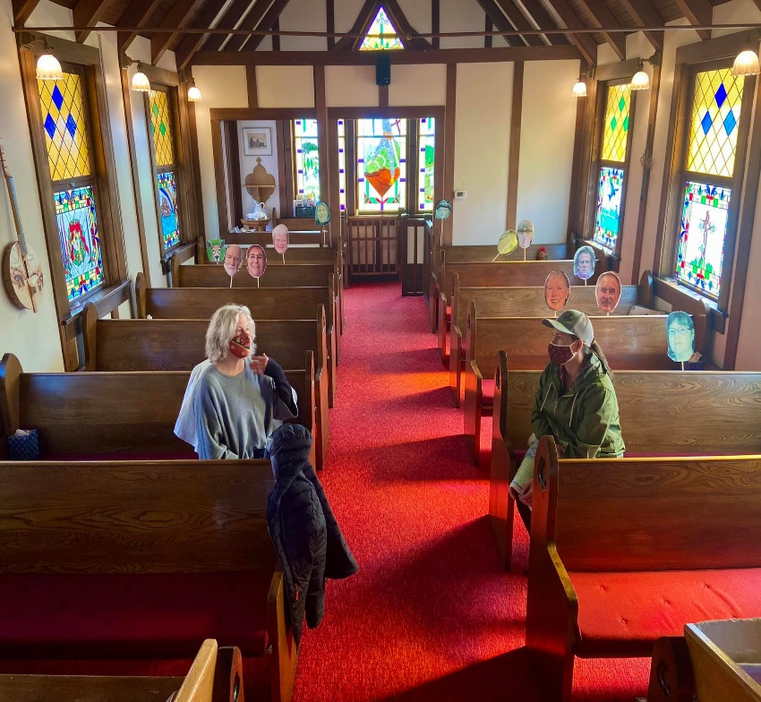
Pattiann meets with Mikayla prior to leaving on Sabbatical. See the smiling faces listening in? Right, behind Mikayla (front to back): Becky Gray, JoAnn Bristol and Jim Pettit, Nick Knolte*, Art Walters and Kathy Hawkins, and Vivian. Left, behind Pattiann: John and Sharon LaBonty, a friendly deer and Ethal White, and BeeGee Cole. Behind the photographer, out of pictures: Jenny Bartlett in cassis and Nikki Meyer at the piano. Thanks to Kathy and Art for your creativity in finding ways for the pews to be filled during Pattiann’s last two Morning Prayers. *Why Nick Knolte? Because “he needs to be in church!”
-2-
Meet Rev. Mikayla Dunfee
The Season of Pentecost
Dear St. Michael and All the Angels,
We’ve spent a couple of weeks getting to know each other at this point, but I’d like to share with you a bit (a lot) of my backstory.
I was born in a small town in the desert of California. My only lingering connection with that place is a strong resentment for humidity. When I was 6 years old, my parents moved us all home to Rapid City, SD. It’s the Black Hills and neighboring prairie that are in my blood… the former was nature, the latter nurture. It took me a long time to appreciate that rolling empty prairie, but that connection was forged while I attended the University of South Dakota for my undergraduate studies. I began college seeking to work for the CIA and graduated hoping to join the State Department. The trouble with that plan however, was that my mentor, the Reverend Rita Powell, had planted this seed of wondering in my mind: “Have you ever thought about being a priest?” The short answer: no. No, I had absolutely never considered ordination.

After college, I spent the summer bartending and waitressing to make enough money for one last adventure before devoting myself to study for the Foreign Service Officer exam. I wanted to spend some time with the monastic community in Taizé, France. That community was unique, as far as religious communities go, because it is ecumenical, and the monks there see their ministry primarily focusing on reconciliation efforts amongst young adults.
I spent the autumn of 2011 living amongst an international community of young adult volunteers, scrubbing, singing, cooking, and praying with and for the pilgrims visiting the monastery. It was one of the highlights of my life. As I discerned my time in France drawing to close, Taizé offered me one last gift: a week of silent retreat. This might sound innocuous to you, but 7 days of silence can be a dangerous thing for a spiritually susceptible person standing at a crossroads. It only took God two days to make it clear that I was on the path to ordination. The details are another story, for another day.
Naturally, I tried like hell to run away from this call. I went back home to Rapid, worked as an office administrator and tried to ignore what was happening. After almost a year of struggling with depression, I surprised everybody by accepting an invitation by the same Reverend Rita to start an ecumenical young-adult, intentional community on the Rosebud Indian Reservation. As a founding member, I lived in Mission, SD with other Lutheran and Episcopal young adults from across the country. We participated in reconciliation work and authored a Rule of Life, focusing on the tenets of Prayer, Listening, and Hospitality. By December of that year, I called my bishop, John Tarrant, and said, “I think I need to go to seminary,” he laughed and said, “Gee, you think?”

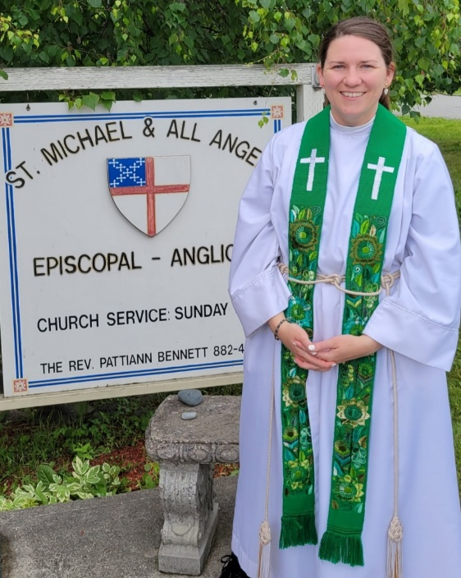

Before I knew it, I was moving to New Haven, CT to attend Berkeley Divinity School at Yale. As much as I had always longed to live in a more urban area, New England was not all it was cracked up to be. The academic work was rigorous, the weather was gray, there were people everywhere; but I got a job at the world-renowned Owl Shop… and that got me by. As I learned about Augustinian theology and pastoral care by day, I was tending bar and learning all about tobacco and brown liquors by night. I also met Charlie at seminary, which more than made up for my misery.

-3-
I spent seminary summers working at Thunderhead Camp (South Dakota’s diocesan camp) one year, and then doing a clinical pastoral internship at a behavioral health center in Sioux Falls the next. Graduation returned me home ready to be ordained a priest (I had been ordained a deacon in December of my senior year). My first call was perfect: serving as Curate on the Cheyenne River Episcopal Mission. My mentor, the Reverend Margaret Watson, and I served 10 congregations spread across a reservation the size of Connecticut. We prayed through many, many funerals. It was amazingly beautiful work, and very lonely. Charlie and I were still dating at the time; however we saw very little of each other, as he had been called to serve at a church in Folsom, CA.
After two years, I sought to head further west and was called to serve in a joint role as Canon for Education at Trinity Cathedral, Reno, and Program Director and Resident Chaplain at Galilee Episcopal Camp (Nevada’s diocesan camp). I absolutely loved working as a member of cathedral staff in such a vibrant city (Reno is better than everyone says it is!), and working at camp with young folks kept me flexible—plus, Folsom was only 2 hours away! Shortly after moving into Reno, Charlie proposed and we made plans to get married in September of 2019.
At this point, life was golden—an absolute dream! The only challenge now was that there wasn’t work for Charlie in Reno, and neither of us wanted to hitch our horse to the Northern California wagon, so we started looking. And what do you know, God was looking too! Montana—our dream diocese—had a perfect opening for Charlie and lots of potential for me. We took the leap together and found that we are absolutely smitten with our new home—and that was in a pandemic! We know it’s only going to get better from here.
Having written a small book by now, I would just like to finish by saying that I truly feel like God is guiding me deeper into the heart of my vocation and ministry. I can’t wait to see where we’re going, and I’m so excited to grow with you all.
Respectfully, Mikayla S. Dunfee
State of the Diocese
Change in Montana Canon to the Ordinary

It is with both sadness and joy that I announce a shift in personnel within our diocesan structure. The Rev. Canon Chris Roberts has asked to retire again, this time as Canon to the Ordinary. While I am reluctant to accept his resignation, he has asked that I do so. His last official day will be Monday, July 12th. Rev. Roberts will remain with the Congregational Development team and will be a consultant for our new Canon to the Ordinary. We do plan on celebrating his ministry with us as our Canon to the Ordinary at Convention in October.
Beginning on July 12th, our new Canon to the Ordinary will be the Rev. Mikayla Dunfee. Rev. Dunfee is currently a Chaplain at Kalispell’s Logan Health Medical Center and an area supply clergy. Her husband is the rector at All Saints’ in Whitefish/Columbia Falls. Rev. Dunfee began her ordained ministry as a curate at the Cheyenne River Episcopal Mission where she served 10 Lakota congregations in the Diocese of South Dakota. She was then hired by the Diocese of Nevada to serve as the Program Director and Resident Chaplain at their diocesan camp, Galilee Episcopal Camp. She was also the Canon for Education at Trinity Cathedral in Nevada. She is conversant in Spanish as well as liturgical language in Lakota. Like Canon Roberts, she will be half-time on the diocesan staff.
With Canon Roberts agreeing to be a consultant for Rev. Dunfee, I hope for a smooth transition.
Peace & Light,
Bishop Marty

-4-
Easter at the Wood Bank –

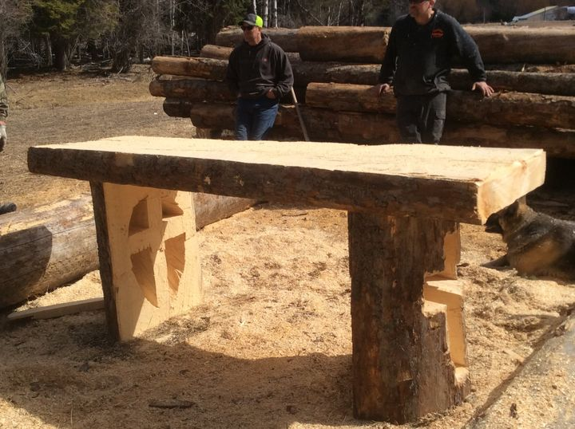
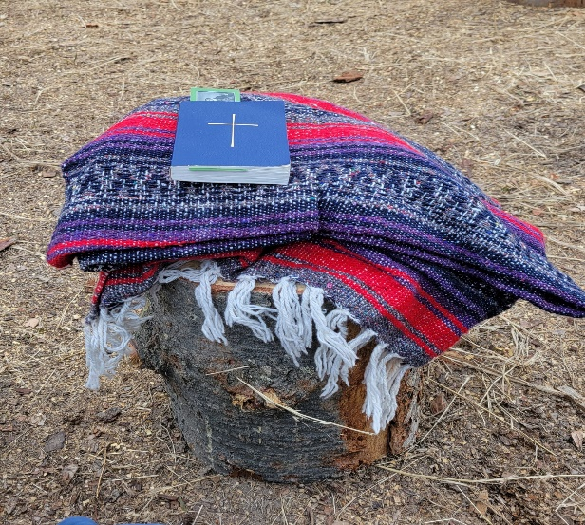

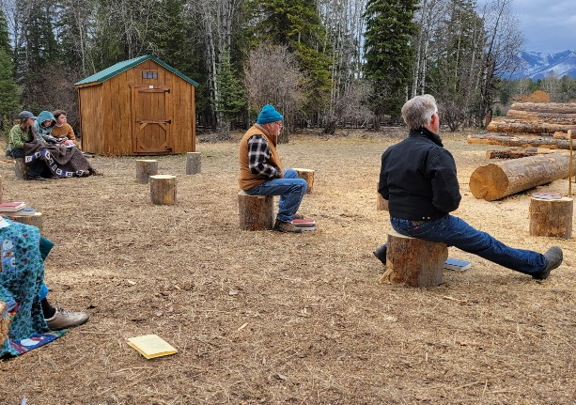

-5-
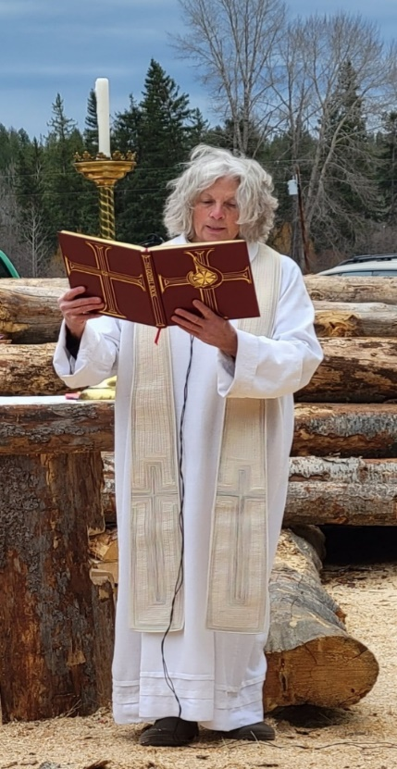

Our first time together in over a year was Easter morning. The service was held outside, at the Wood Bank. Pattiann’s son Chris and his friends made an altar – truly a piece of chainsaw art. A fire was lit in a fire pit, cuts of logs were placed for seating at social distancing, and prayer books and hymnals were stacked on the logs. We gathered for Easter service and a potluck. The weather changed, the wind blew, and it was COLD! Blankets appeared and the service went on. Barry Roose invited the congregation to take the potluck to the Koocanusa Brewery. It was a great day of fellowship. Thank you to all who participated in this holy day!
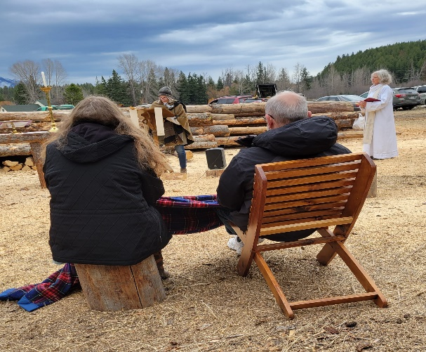

Vestry Views – Jim Pettit, Senior Warden
As a reminder, The Reverend Mikayla Dunfee will be leading our 0930 worship service on July 4th and 11th. Look forward to seeing you there.

This will be a more traditional service than we have seen recently. CDC has stated that fully vaccinated people have no more than a 1 in 10,000 chance of being infected by Covid-19. If infected, the fully vaccinated person has the same type of very small risk to transmit the virus to someone else. This is not no risk, but very very small. As a result, it seems that masks can be optional.

People who have chosen not to be vaccinated, for whatever reason, are not as well protected from the virus. The numbers indicate that people without vaccinations are still being infected at about the same rate as last January, a significantly higher risk.

Previously, our thought process was that there were some in the congregation who wanted to be vaccinated but did not fall into any one of the early priority groups, and so the vaccine was not available to them. We recommended all worshipers to wear masks to protect those of us at higher risk.

At this point the demand for vaccination has decreased to the point that there are more vaccine doses available than there are people asking for the vaccine. Our assumption, and this may be a flawed analysis, is that any member of St Michael's congregation who has not been vaccinated has made a conscious choice to take that approach. We recognize this as an individual's right to choose.

St Michael will never ask a person their vaccination status, whether a mask is being worn or not. After all, there are still some fully vaccinated people who continue to wear masks.

However you decide to dress your face, we welcome you all to worship at St Michael the Sundays in July with Mikayla Dunfee as our priest, giving a sermon, and administering the sacrament of communion.

New Vestry Member: John LaBonty replaces Julia Pruitt who has moved away.

Thanks to the parishioners of Saint Michael for continuing to support worship services each Sunday during Pattiann’s sabbatical. For two Sundays each month the Reverend Mikayla Dunfee provides worship service and communion. For the remaining Sundays we have morning prayer led by Doug Merrill, JoAnn Bristol, or Jim Pettit, and soon Becky Gray. We have had tremendous participation from others in the congregation to be lay readers, offering collectors, intercessory prayer prayers, and chalice bearers. We will continue to do this through the end of July. Any others who want to participate in leading, reading, or praying please speak up. My number is 254–644–7032. Go with God and be safe. – Jim Pettit

-6-

A View from the Pew – Editorial
In a recent sermon, Pattiann told about a presentation at the clergy conference. She said:
We listened to the early history of Episcopalians in Montana, what the diocese looked like a hundred years ago, how it functioned. Who were the Bishops along the way and what was their impact.
A most interesting segment was about women in the church in Montana and a wonderful fact is that every Episcopal church in this state was started by a woman. The church, the Episcopal church, is called to be a sanctuary in the world, a place of prayer and worship and inclusion, offering radical hospitality where community can safely gather, now in many new ways, to learn about God who is love, pure and simple.
This little church on the hill, has been here for 107 years because people like you and me have followed this shepherd. Because we have consistently worshipped here, have taken care of each other, because a woman named Mary Malkoff gave her last penny to have it built in memory of her husband, because God ordained that this little village in Eureka Mt. those many decades ago needed a shining example in the community of what it looks like to love God with all your heart and mind and soul and to love your neighbor as yourself. And because God sent shepherds along the way to guide and protect her flock. To love us and guide us and to share the vision of God at work in the world. And here we still are.
It caused me to reflect on women’s places in the Episcopal church during my lifetime. I remember being pointed out at a Bible study after church one Sunday with a visiting priest, for not wearing a hat. (Remember always carrying a small lace doily to put on your head in case you forgot your hat?)
In reading the history of St. Michael’s, I learned that the Ladies Auxiliary (Guild, Circle – a variety of names) was actually the vestry. They did the finances, etc. When I was growing up, the Episcopal women did Sunday School, the annual rummage sale, pot lucks, were the Altar Guild, and everything else. But weren’t on the Vestry. By the mid-1970’s, in Havre, little girls couldn’t be acolytes even though the Church was discussing ordaining women. I was on the Vestry and as the only woman was the clerk. We moved to Glasgow in 1979 and shortly I again was the only woman on the Vestry. The Sunday, we interviewed a priest candidate, I was assigned to serve breakfast while the men visited with the candidate. I suppose I could have said “no”. (These experiences reminded me of being the only girl on our street growing up. When the boys played cowboys & Indians, I had to be the cook. When they played army, I was the nurse.) In the early 1990’s, a woman priest was hired. And some men quit the church!
Fast forward to 2014 when we moved back to Eureka. A woman priest, women chalice bearers and lay readers. Wonderful! Now, Montana has our first female Bishop and even our Supply Priest is a woman. Amazing! Every Episcopal church in Montana was started by a woman and now women are fully leaders in our churches!
We pray for all people affected by COVID-19. We pray for health care workers and their families.
We pray all who have died from it. We pray for all whose lives have been distorted by drastic weather and its affects. We are thankful for the availability of vaccines and the change they are making in the world.
We pray for the victims and families of mass shootings. We pray for all who live under the dark cloud of racial injustice. We pray for this country. We pray for immigrants and their children. Wood Bank recipients and volunteers. We pray for veterans and their families. We pray for our Bishop, Marty Stebbins & her husband Bob. The Diocese of Montana Holy Trinity/Troy, the Diocese of Jerusalem and peace in the Holy Land. Chrysalis School. Camp Marshall. All victims of violence, especially children, We remember the anxious and the fearful. We pray for this planet, our island home.
O Lord, hear our prayer, and let our cry come to you. Psalm 102
-7-
Interview – Charlotte (Charla) Trotter
We ask the interviewee to address the following questions: 1) Please tell us about yourself (and your journey in Christ)? 2) How did you “find” St. Michael & All Angels and why did you come back? 3) What is your favorite part of this congregation / church? 4) What is your role in the congregation or how do you participate? 5) If there was anything else that you want to share?
My first experience / memories of church was an old dairy in rural Honolulu… rather dusty and still smelling of cows. Many of my friends attended Sunday school w/me. My daddy gave me a quarter to put in the offering plate but many times I would save it and go down the hill to buy ice cream after the service.
Eventually we moved into a real church. My father was instrumental in helping to build the church in Aina Haina. His father was a Unitarian minister in Boston. My grandmother would compose songs that I made up. I sang in the choir and since I can’t carry a tune they placed me in the back. After a while the choir mistress suggested that I just mouth the words. I attended confirmation classes and felt a happy part of the youth group.
As a teenager I was sent to a boarding school in New York and every day we had chapel and sang lovely hymns. Bible was also a required course w/a wonderful, warm teacher. All in all a very positive experience. Every Sunday we had to go to church in the village wearing stockings, gloves and hat.
When we found Fortine, Montana in the 70’s we also found Pattiann…”the crazy lady” who created wonderful berets and eventually found the beautiful little church on the hill in Eureka. I don’t think it was till we moved to Glen Lake that we started to attend. It was so familiar..the service, the hymns and we were touched by the persona of the minister, . her honesty, empathy and dedication. When she cried I cried too.
One fall I volunteered to clean the church,,,my family was not supportive..”you don’t do a good job in your own home.” When we returned to Honolulu we left some money to pay for a church cleaner.
~~~~
I, the Lord of sea and sky

I, the Lord of sea and sky, I have heard my people cry. All who dwell in deepest sin My hand will save. I who made the stars of night I will make their darkness bright. Who will bear my light to them? Whom shall I send?
Refrain: Here I am, Lord. Is it I, Lord? I have heard you calling in the night. I will go, Lord, if you lead me, I will hold your people in my heart.
I, the Lord of snow and rain, I have borne my people’s pain. I have wept for love of them, They turn away. I will break their hearts of stone, Give them hearts for love alone. I will speak my word to them. Whom shall I send?
Refrain
I, the Lord of wind and flame, I will tend the Poor and lame. I will set a feast for them. My hand will save. Finest bread I will provide Till their hearts be satisfied. I will give my life to them. Whom shall I send?
Refrain

Page 182
WONDER, LOVE AND PRAISE
-8-
Op Ed – Rummage Sale by JoAnn Bristol
Following the major concerns of Covid, including vaccinations, 6 foot distancing, and wearing of masks, Friday and Saturday, June 11 & 12, was the annual Saint Michael rummage sale. It felt as though all the clouds parted and sunshine shone on the Saint Michael congregation and volunteers. Some loaded trucks from the sheds at the church and unloaded them at the fairgrounds. Some brought loads directly from their homes. However things arrived we ended up with two years’ worth of rummage stock. It was amazing to see how everyone worked together. Within hours shelves were filled with tools of all condition. Tables were filled with clothes and books and nail polish. There were Christmas decorations and plates and cups and saucers of all colors and design. We were ready for Saturday morning.
There was a little conflict in our advertisements. One source said we opened at 9 AM. One source said we opened at 10 AM. Whatever the advertisements, the first couple of people were let in at 8:50 AM. Within half an hour they were joined by 50 more people and it stayed busy for most of the day. I’m not a professional crowd counter, but it seemed like there were hundreds of people that made her way through the rummage sale that day.
Sharon was our money manager and she knows how to do it! Claudia, in addition to arranging displays, made tomato soup for our hungry tummies. Doug, Art, Bruce, Jim, and Ethel‘s sons, Tim and Terry, along with Terry’s wife Beth, moved things around, and at the end of the day helped dispose of the leftover items, as well as the items to be saved for next year. John had his guitars and played music for us using an amplifier. Kathy, Jeanne, Ethel, JoAn Cuffe, and JoAnn Bristol arranged and rearranged and rearranged. Ethel also got in a little spin class and took home a stationary bike. It was amazing to see everyone working together, no one was the boss or acted bossy. We were just a well-oiled machine.

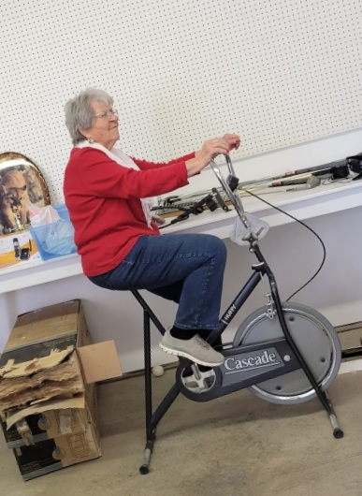

One of the families that came was a mom and her four children, aged nine, seven, four, and two. The nine-year-old girl found a cart with a platform on it and was in charge of the seven and four-year-olds. They took the cart around to every table, examined every item, and came away with many treasures that they knew were just for them. You could feel their excitement. They weren’t the only ones that were excited. Throughout the room you could hear laughter, animated discussion, and other sounds of joy.
At the end of the day $2200 had been collected. And this was after putting out signs saying items for free after 3 PM. Even then, people who found a special item wanted to give a donation to Saint Michael. It seems everyone left in a better mood than when they arrived. Things went from anticipation to satisfaction.
Once again we were reminded that raising money for St Michael was only one of the rummage sale’s functions. Everyone who helped organize and everyone who found a treasure left the rummage sale a little happier and joyful than when they arrived.

See you next year!!!

-9-
St. Michael and All Angel lost two parishioners during the pandemic – neither from COVID. I asked Jenny Bartlett to write an article about Leeann Nemec; instead she shared the oblituary that Leeann had written. Thank you Jenny!

LEEANN FRANCES DRENKHAN NEMEC

I was born on a hot summer day on July 18, 1956. I grew up on the beautiful shores of Lake Erie in Bay Village, Ohio. It was an idyllic life in many ways. I shared home with older sister Diane and younger brother Fred G. K. Drenkhan. Our parents, Johanna and Fred Drenkhan taught us to live by the Golden Rule. They also taught us the beauty of nature and the lake in its many seasons. One of my favorite memories as a family was driving down to the lake to watch a storm blow in off the water. Another cherished memory – tandem bicycle riding with my oldest, dearest friend Donna Coady. We rode from one end of town to the other. To my Ohio friends, you will always be “home” to me.
In 1983 I married Joe Nemec and we had a son, Jesse, in 1986. At the age of 30, in 1988, Joe died suddenly in a car accident. I raised our son with help from my parents who instilled in him all the good and solid values I learned as a child. My Dad provided the best male mentoring while my Mom provided extra comfort and love. Today Jesse is happily married to his beautiful wife, Nikki. October 31, 2020 brought my first grandchild, Leo Nicholas Nemec. I am so blessed to have them as my family.
In 2004, I met the incomparable Bill Gorham on the brand new eHarmony website. It really worked! Our relationship has flourished for more than sixteen years. I am incredibly fortunate to have a second chance at love. He has been my rock thru unforeseen illness. I refer to him as my HIH (husband-in-heart). Together we moved from Ohio to Montana in 2009 and settled in Eureka, a small friendly rural town on the Canadian border. New memories were made amidst beautiful mountains and crystal clear lakes. To my Eureka friends, thank you for showing me the Montana way of life and supporting me with faith-filled optimism.
I held many different jobs throughout the years, all of which taught me a new skill. Later in life, I earned a degree in occupational therapy and worked to help people regain their independence after illness or injury.
Perhaps my biggest joy in life, besides my son Jesse and his family, is a love and caring for animals. My dream was to open a shelter for aging dogs and cats whose owners had died. Please always treat animals kindly and donate your time or resources to your local shelter. A favorite verse by Emily Dickinson: “If I can stop one heart from breaking, I shall not live in vain. If I can ease one life the aching, or cool one pain, or help one fainting robin unto its nest again, I shall not live in vain.” I also love to read – a good book, a dog nearby, and Dove chocolates equals pure contentment!
Lastly, to my industrious nieces and nephew: keep grateful hearts and cultivate a relationship with God. Know that the Great Spirit lights the way with goodness even in the darkest of times. You just have to ask! Parting prayer: “Oh Lord, support us all the day long, until the shadows lengthen, and the evening comes, and the busy world is hushed, and the fever of life is over, and our work is done. Then in your mercy, grant us a safe lodging, and a holy rest, and peace at the last.”
Please support research for pancreatic cancer. And as always, Beatlemania Forever!

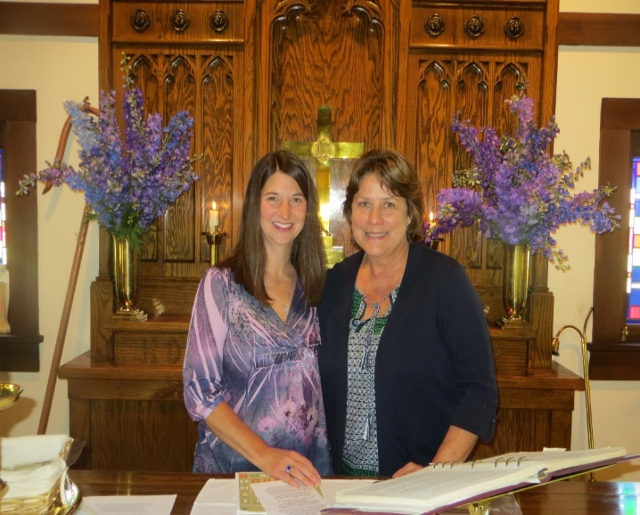

O God of grace and glory, we remember before you this day our beloved Leeann. We thank you for giving her to us, her family and friends, to know and to love as a companion on our earthly pilgrimage. In your boundless compassion, console us who mourn. Give us faith to see in death the gate of eternal life, so that in quiet confidence we may continue our course on earth, until by your call, we are reunited with those who have gone before; through Jesus Christ our Lord. Amen.
With love, pattiann+
<- Jenny and Leeann on Delphinium Sunday
-10-

Life in the Time of COVID – Part 2

We went into isolation in March 2020, just in time for the 2nd quarter newsletter. In that issue, entitled "Life in the Time of Covid", I asked for stories of what we're learning and how we're surviving. Many people responded. We all thought it would be a short term thing. In the 3rd quarter newsletter, there was a series of Daily QUARANTINE QUESTIONS. Again, several people responded, choosing which questions they wanted to respond to. These responses made the newsletter (both times) much more interesting and inclusive, more community based.
Now that 15 months have passed and we have finally come out of the pandemic and can be at church together again, it's time to reflect on this past experience. Pattiann and I would like you to think back over this past year and again share your thoughts. Below are some questions that Pattiann suggested. Or, you might just share how you survived or thrived and what made this possible.
1) Distancing and Deepening ... How might we turn this time of distancing into a time of deeper spirituality - and how might we keep that deeper conversation with God in the regathered church? Did the pandemic contribute to a closer walk with God? Was Jesus closer than usual because of it?
2) Virtual ... How might the virtual inform-or be-the actual future of the church? (There must be lots of thoughts about this.) What do you think of recording and live streaming services from here on?
3) What do people in the parish have to say about this past year at home with Morning Prayer in the garden on the computer or tv screen...How was it for them to be together though apart, for worship Sunday mornings?
4) How, if any, has the last year changed our connections to one another and the church. How did such a new way of being inform your relationship with God and one another?
Jeanne Jankovsky:
These past 14 months have not been a hardship for me. As Covid -19 impacted our lives, perhaps my limited medical background prepared me for the necessity of these lifestyle changes.
In acceptance, my thoughts and Attitude were “We will get through this, and this too shall pass. “Staying at home was energizing at times, trying new or different skills such as minor maintenance. However, it also contributed to laziness with no deadlines, no need for make up, or acceptable attire. Lots of time to read, rather than housecleaning.
Meanwhile, there was more time for intentional devotions. Alexa also helped with meditation music in the background.
Morning prayer videos, which were wonderful, could be watched over and over again. I felt that I was actually in the garden there with Pattiann. My brother in Ohio, also sent videos of his Church services.
However great the videos are, they cannot duplicate the peace and tranquility of being in our little closed sanctuary amidst the stained glass windows, where God’s presence is so intimately mine.
I did discover that as content of being alone has been these past months, the depth of joy and warmth of being with our caring community is real and has awakened my heart. I guess the saying, ”Absence makes the heart grow fonder” It’s true and timely. I am looking forward to Potlucks again.

-11-
Steven & Barbara Benson:
- The changes during pandemic for distancing required a bit more thought and effort to engage in worship. For some that might be a "roadblock," but for us it deepened our commitment to keep our faith nourished. It also gave us the opportunity to worship with other congregations with
which we have a personal connection. For us it was " both/and" rather than "either/or."
- Virtual church can never permanently replace in-person worship. We need the Sacrament and the personal connection with other members of Christ's body. But there are always times when personally coming to church is difficult for one reason or another. Having a virtual (live or recorded) option could be valuable at some times for some people. We think that most folk would not use it as an excuse for non-attendance, but would prefer in-person to virtual.
- We thoroughly appreciated Morning Prayer from the garden on our TV screen, and found it to be a deeply spiritual experience. Although we couldn't interact with other members, we would think of others in the congregation and think about how well-served everyone was to have such a deep spirituality available to us in these challenging times.
Jim Pettit and JoAnn Bristol:
A year - 365 days and more - sounds like a long long time, especially when isolation from others was mandated, encourage, and ultimately dismissed , sometimes what we were supposed to do became confusing.
Initially the time seemed overwhelming, but for us a the time of the cleaning out drawers, throwing away shredded papers, and not only looking at the garage, but tackling that project. During that time we felt a nudge to maintain a sense of quiet and we incorporated the quiet into our lives, was it God? Jesus? Holy Spirit? And maybe all three? Maybe all three in one?
The other major thing that occurred was that Jim didn’t go to Texas for a week every month, and that brought us closer. The stress of traveling turned out to be more stressful than Jim thought. This year of doing work through telehealth and staying in Montana allowed him to become calmer and more present at home. As a result, even though flying to Texas has become an option, Jim has decided to continue doing telehealth from Montana.
Sunday mornings we listened and participated in Saint Michael and All Angels Church services on YouTube. Not being a fan of technology, JoAnn was more than thankful for Pattiann and her weekly time and energy. This was a gift to all of us. Continuing to live-stream our service and archive it on YouTube is something that we ought to start doing. I doubt that the quality of the meditative aspect could improve on what Pattiann did. I think the live streaming and YouTube archiving is something to be done on a trial basis and see what the response from the community is. If we have a group of faithful people, who don’t attend the church service, who are tuning in to YouTube either live or later, then I think it’s a worthwhile effort. If over time we find that we don’t have a loyal following, then I’m not sure we should continue it.

Dee Nance:
To begin, I thank God that the pandemic is over! I, for one, am a person who needs to be with other people. When the church in West Kootenai re-opened in May of 2020, I began attending services there along with the service from St. Michael’s. Two sermons each Sunday! I am thankful to Pattiann for all those Sunday packets. I have kept them all.
As to the question of continuing the virtual services, I fear it will keep some people from the fellowship we need to nurture us. God calls us to be together, and I think that means physically.
I have missed you all and am happy and thankful that we can be together again. God bless St. Michael’s and each of us as we move forward. -12-
Kathy Hawkins:
Sharon, in answer to your email regarding survival of the pandemic. It was hard on everyone. It is certainly not over and all of us knows someone who lost loved ones during these trying times. Something that certainly was not on my list of things to experience was a pandemic. Even though I am somewhat of a loner or recluse being separated from family and from any social activity became stressful.
The pandemic has certainly changed the way we do business and for sure some of this will continue. Virtual reality is here to stay like it or not. How fortunate we are to have the technology. So many people were able to continue to work from home and support their families. Even the ability to order goods online and have them delivered to your doorstep. The positives of church online, are that it is wonderful for those who cannot go to church in person. It’s also nice to go to church on your own schedule at anytime and in your pj’s if you so desire. It certainly does not replace going to church in person and interacting with our church family. Even before the pandemic I think a lot of churches were and still are struggling to keep congregation numbers up. I would like to see the church service available online live and also recorded to be viewed when it is convenient for each individual. I think our small congregation did a good job of keeping in touch with each other.
As far as my relationship with God, certainly we all prayed a lot and still are, for the world and for our family and friends. It certainly is a confirmation that we are not in control. Also that mother nature will take care of the planet and that humans are disposable. But when the pandemic is truly over will we have learned anything?
Sharon LaBonty:
I discovered during the pandemic, that I could very easily become a happy hermit. As long as I had my cell phone close at hand – calling and texting friends! Staying in contact made this time possible. Oh, and that Montana Market delivered groceries – what a great service!
The first month or so, John and I set a worship place with a flowered napkin and lit a candle, joined Pattiann in the garden and followed the service. We loved being in the garden and beside the lake early in the morning! As time passed, our worship degenerated; we would watch it later in the day or week. Then we got so we just printed out the sermon and read it. Although we did not feel separate from God, prayers continued. We did feel separate from our church family. We really missed being together.
Now that we are together again, it’s wonderful! Incidentally, our daughter and her family live and work at Camp Galilee so we had heard many good things about Mikayla before she became our Supply Priest. We are happy to finally meet her in person.
Birthdays / Anniversaries  July  13 – JoAnn Bristol  21 – Jim Pettit  26 – Jim Bartlett  August  2 – Jeanne Jankovsky  12 – Bailey Bishop  25 – Pattiann Bennett  September  9 – James Bristol  13 – Claudia Evans | Purpose Statement  The purpose of “The Messenger” is to be in contact with all the members and friends of St. Michael & All Angels, near and far. That they may be involved and informed about the ministry, services, activities and opportunities.  Staff  Sharon LaBonty – Editor  Rev. Pattiann Bennett  Jenny Bartlett Jim Pettit  Jeanne Jankovsky JoAnn Bristol  Dee Nance – Proof Reader
-13-
What’s Happening?
Prayer Shawl Ministry
Prayer Shawl Blessing
Almighty God, whose will it is that all things should be done lovingly and in order and who does accept from the hands of Christian servants, things great and small.
Accept, Bless and Sanctify+ these prayer shawls which we now offer for the enfolding of your beloved children that they may be the recipients of your healing power.
Bless the hands of those who created these shawls.
May your grace be upon these beautiful covers, warming, comforting and enfolding the ones wrapped within them.
May these prayer shawls be safe havens, sacred places of security, comfort and well-being, sustaining and embracing in difficult times.
May each person be blessed as they are surrounded and held within these prayer shawls made for your love and glory, be cradled in hope, kept in joy, graced with peace and wrapped with love. Blessed be these pieces of love made.
In the Name of St. Michael the Archangel. In the name of You the Creator, The Giver of life,
the Holder of time. In the name of Jesus, the Savior, the Healer, the Lifter of pain.
In the name of the Comforter, the Consoler, the Sustainer of life. Amen.

Soup Café
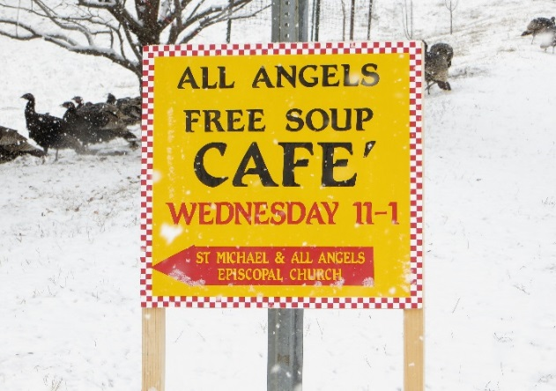
The Soup Café delivery system was closed down after a very successful run this past winter. Each week the parishioners of Saint Michael and other volunteers produced 15 to 31 quarts of delicious soup to be distributed to the community. In addition, people made bread and cookies and other wonderful things for the community to enjoy. The entire project was a resounding success! When the Soup Café reopens later this year, our hope is that society is still safe enough to return to the Saint Michael basement/kitchen to continue our long running service to the community of feeding those who walk through our doors in the cold of winter. God bless all who participated in providing and receiving.

-14-

)

Wood Bank

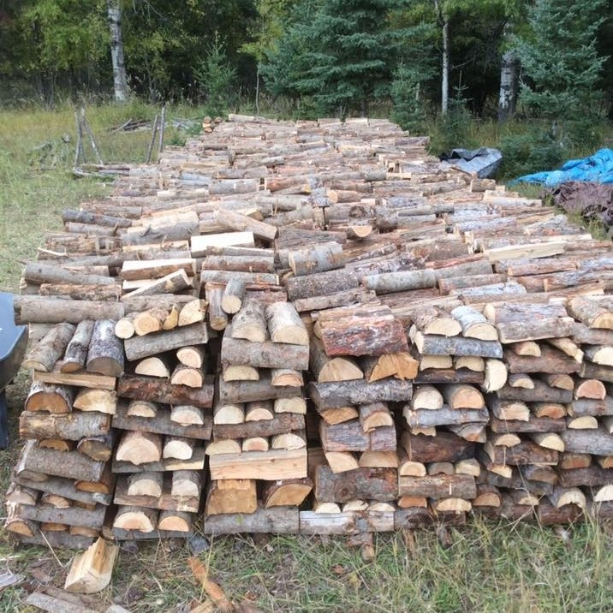

About 160 loads went out… a few folks loaded up on their own a couple times for themselves or someone else and I didn't tally those up... but...sawyers, splitters, stackers, deliverers, cookie
& soup makers make it feel like a bee hive or ant hill...
As always it is amazing and fun and so satisfying to gather as we always do to work for hours together...We never know who will come but it is always just exactly right.
Stolt Lumber in Columbia Falls donated a magnificent load from a sale behind Murphy Lake and from that load of some very huge logs came the altar my son Chris and his friends made with chainsaws.
Ethel's daughter in law Beth, brought her trailer to the pole yard north of town and delivered to the Wood Bank site 10 bales to be cut next work day.
We'll call a work day probably in September when it's cooler and we're all gearing up for cold weather again. When Town Pump posts it's grant days, I'll apply for another grant to buy logs when we need to.

St. Michael’s Book Corner

Check out the books sometime when you are in the undercroft of the church. Borrowing is on the honor system; just return when you have finished reading the book. The Little Library out front is a “take one, leave one” book exchange.
From Jeanne :
Located in the outside kiosk, are some good books by Marilynn Robinson: “Giliad” - Pulitzer prize winner, “Home”, and “Lila”
“Live in each season as it passes -
Taste the fruit
Breath the air”
Henry David Thoreau

From Pattiann:

JoAnn asked me for a reading list..so here is a small list that have been very important and formative for me along the way...[there are many more]
Am presently on my third reading of The Wisdom Way of Knowing by Cynthia Bourgeault
Braiding Sweetgrass Robin Wall Kimmerer Threads of Life Clare Hunter
Life in the Garden Penelope Lively
The Life of Meaning Reflections on Faith, Doubt and Repairing the World Bob Abernathy & William Boyle
The Substance of Faith and other Cotton Patch Sermons Clarence Jordan
Original Blessing Matthew Fox
Christian Mystics ~ 365 Readings & Meditations ~Matthew Fox
You are the Beloved Daily Meditations for Spiritual Living Henri Nouwen
Anything by Barbara Brown Taylor, esp. An Altar in the World and Learning to Walk in the Dark
-15-
St. Michael & All Angels Episcopal
P.O. Box 342
Eureka, MT 59917

The Messenger Deadline

The deadline for the next issue of The Messenger is August 15th. Please send any news or happenings at St. Michael or an Op Ed to Sharon or hand it to her at church. E-mail: sharonlabonty@gmail.com

Dates to Remember
Ongoing
Pot Luck – 4th Sunday of each month
Bring food to eat, but above all, bring yourself and your family. See you then.

July 11 – Mikayla’s last Sunday
July 25 – Potluck
August 1 – Pattiann’s first Sunday back
August 22 – Potluck
September 26 - Potluck
Upcoming
Bishop’s Visit – September 26th
2021 Diocesan Convention – October 8-10 at St. Luke’s and St. Stephen’s in Billings

