

**OUTREACH PROJECTS**

Of the congregations of the Episcopal Diocese of Montana

2021

# **St. Patrick’s, Bigfork**

By MACKENZIE REISS   
**Bigfork Eagle** | May 12, 2021 2:10 AM

Tucked behind St. Patrick’s Episcopal Church in Ferndale is the Bigfork/Ferndale Community Garden. Its 80-plus plots are largely bare this time of year, but in a matter of weeks, will be teeming with new life as summer gardening gets underway. They’ve got an area reserved for blooms that attract pollinators, planters for raspberries, others for the food bank and a handful of elevated boxes for gardeners who can’t work on their knees. Each plot also comes with a set of hoops for members to hang protective cloths on in the event of an unexpected frost.

Gardeners can retire from the heat of the day under a shelter near the entrance and retrieve tools from a greenhouse toward the front of the space. The garden has well, grown, a great deal since its inception over 10 years ago and currently is on the lookout for new members.

Talk about starting a garden began in 2007 but the first seeds weren’t planted until 2009. Founding member Michelle Patterson said St. Patrick’s Episcopal Church was kind enough to donate the land, but without funding for a proper fence, they began the Bigfork/Ferndale Community Garden with a single plot and 100 square feet of potatoes. A picture containing tree, sky, outdoor, green

“We had the room and we had the wherewithal and that’s how we started to do it,” she said.

The garden was a joint effort between church members, community volunteers and members of the grassroots effort, the Essential Stuff Project.

“Even though [the deer] ended up eating all the tops off the potatoes, I still knew where they were,” Patterson said, smiling. “We still find the odd potato which is really funny. They’re still cropping up every now and then.”

That first test plot was tended to by the Sunday school children and measured just four feet by four feet, in line with Mel Bartholomew’s “Square Foot Gardening.” The methodology is about growing a more efficient garden by planting in blocks instead of traditional rows.

“You can basically plant everything you need for one family in one four-by-four,” Patterson said, noting that the smaller plots are also a lot easier to weed and maintain.

While many hands helped to get the garden off the ground, there was one pair that was notably absent — that of Patterson’s husband, Jim. He was the more avid gardener of the two and they had hoped to begin the community garden project together. However, Patterson learned that her husband’s cancer returned one year after getting the all-clear from his doctor. And it came back with a vengeance — scans revealed that the cancer had metastasized to his lymph nodes and throughout his entire body.

“August 18 was when we found out from the scans that that’s what happened …. And he passed away on September 5,” she said. “I almost walked away [from the garden], but I just needed to keep on going. It was something we were looking forward to doing — and doing together.”

That first plot has since become a memorial plot for Jim Patterson and is seeded with flowers each year.

The rest of the garden continued to blossom and over the years, gardeners added infrastructure developments along with plots. An anonymous donor put up funds for the fence which were matched by the church and not long afterwards, drip lines were installed to lessen the burden of watering. The church also helped with big-ticket items like the greenhouse and shade area, Patterson said.

“Financially, the church has been our savior,” she noted.

Giving back to the local area has been a cornerstone of the garden since its inception. They used to plant spare plots for the Bigfork Food Bank, but now, each gardener is assigned a food bank plot to plant and care for when they reserve their own growing space to help share the workload. And for those who want to get involved but aren’t ready to take on the responsibility of their own plot just yet, the garden welcomes volunteers to help intermittently.

Gardener Regina Browne said working at the community garden is just plain fun.

“I can’t grow some of the things [at home] that I can grow here,” Browne said. “It’s just nice — it’s doing something for somebody, it’s talking with people … It’s fun being with people who like to do this.”

Patterson said she enjoys the inner peace that comes with working in the earth.

“It’s very healing. It grounds you as a person, I think, to grow things and see things live because you started them,” she said. “And there is nothing like a fresh tomato!

Tom Cahill, Senior Warden  
coogan1966@gmail.com

# **All Saint’s, Big Sky**

**Gallatin River Task Force's Annual Cleanup Campaign**

The weekend of August 27-29 was the Gallatin River Task Force's annual clean up campaign.  All Saints participated for the second year in a row, but this year 18 volunteers showed up.  In addition to our assigned area of a portion of Lone Mountain Trail's road and bike path, we expanded our clean-up area considerably, to include the Chapel to the Community Park and along the pond, around the outside perimeter of Meadow Village center, Little Coyote Road from the Chapel to Lone Mountain Trail, Lone Mountain Trail for about two miles, all around the Medical Center and its parking lots and a trail to the river and a park along the river.

The attached picture shows the frame of a recliner chair found near the bridge by the Community Park which was the most interesting thing we found!

It was a great day--we all had a wonderful time.

### Pam Rempt - prrempt@aol.com

# **St. Michael & All Angel’s, Eureka**

**Woodbank**

St Michael & All Angels Woodbank provides supplemental firewood to low income elderly, veterans, disabled and families. The Wood bank began in 2011. We are run completely by volunteers who cut, split, stack and deliver. The bank has been awarded a number of grants from Town Pump to buy logs or fuel and many people in the community have gifted us with log truck loads of logs and finances. The last 4 years the number of deliveries has been 150+ each winter. St Michael's Wood Bank began after the Diocesan Convention [2011?] where we shared our ministries and I learned about Rev. Harry Neeley's Woodbank Ministry.

Our first Wood Bank work day this year (2021) will be in October.

**All Angels Free Soup Café**

St. Michael & All Angels Free Soup Cafe has been serving free soup and bread for 6 years. Open Wed. 11-1 Advent through end of April. All volunteer. People from St Michael & the community make the soups, bread and cookies. Because of Covid it became a delivery system last year & the format is not clear right now because of the variant & numbers up in our county.

# **Happy Hookers Prayer Shawls**

St Michael & All Angels Happy Hookers Prayer Shawl Ministry began about 18 years ago.

I learned about the prayer shawl ministry from my mother way back then, who kept track of how many and where they went from her church Trinity Episcopal in Seymour Ct. Trinity sent more than 3000 in her years there...we may be close to that...

The ladies meet each week to crochet and knit and pray.

Jim Pettit, Senior Warden  
jpettit48@gmail.com

# **Trinity, Jeffers/Ennis**

**Jeffers Community Garden**

**By**

**JOLENE PALMER**

[news@madisoniannews.com](mailto:news@madisoniannews.com)

Hey, what’s all the buzz about? By 8 a.m. on an early August morning honeybees were in full force at the Jeffers Community Garden, alighting upon poppies, cosmos, tomato blossoms – if it’s blooming, those bees were pollenating.

Communing with the bees amidst the rows and plots of the gardens was community gardener Burleigh Leonard, watering hose in hand. His wife, Jamie, is the rector of Trinity Episcopal Church. He was doing his husbandly duty, watering Jamie’s plot of wildflowers bursting with color and abuzz with pollinators. Their plot also includes sunflowers just readying to pop as well as carrots and squash prime for the picking.

Soon gardeners Melissa Smith and Margaret Chaika arrived on the scene. Smith manages a personal plot a visitor to the garden can’t miss: her spectrum of snapdragons, cosmos and sunflowers are loud and proud. They’re destined for bouquets to be sold at the garden’s next evening market and concert.

“We have a great time out here, it’s such a beautiful setting, with the vegetables and flowers growing,” said Smith, in reference to the live music and market events new to the garden this summer. “We think it makes a great venue.”

Many veggies are sold straight from the garden at the summer evening markets, but a large portion of the harvest is given to the Madison Valley Caring and Sharing Food Bank – they’re highly sought-after items that don’t linger on the food bank’s shelves for long.

Chaika tends to the church’s plot. She started her Monday morning spraying bird droppings off the band stage that’s blanketed in hops vines, followed by a big harvest of veggies destined for a drop off at the food bank at noon.

"I enjoy giving back to the community, and meeting wonderful people,” said Chaika, who has labored with love at the garden for over a decade.

Chaika is not a Master Gardener by study, but rather by life experience. This year she did soil studies and seed viability tests before planting in the spring, with much success and some shortfalls. The short corn stalks went in a little late, the carrots are struggling with clay-thick soil and the spinach has bolted in the heat, but all in all the plot is teeming with edible delights.

Across the way community gardeners Brian and Dawn Conklin have a large plot that’s hard to miss, teeming with blue-flowered annual herb known as borage – you can eat it, but it’s most useful as a landing pad for the bees. The Conklins have worked as missionaries in Africa, teaching students how to farm, so it’s no surprise their plot is thriving.

The garden is the place to be for Thursday concert and market nights from 6 p.m. to 7:30 p.m. The next will take place on August 5 at 5 p.m. with a performance under the hops by the Ennis City Ramblers. The garden will be ready for the picking and marketgoers can expect to find peas, beans, cucumbers, zucchinis, swiss chard, lettuce, fresh flowers and more.

The next gathering, held August 19, includes music by the Recession Special, and the last event on September 2 will present live music from Brian Conklin and Peggy Giblin.

The concerts are free and guests are invited to set up lawn chairs amidst the garden rows. Kids are welcome as well – the garden is an excellent opportunity for exploration.

Finding all this grassroots gardening inspirational? The garden has open plots and can always use some helping hands for weeding and watering.

“You know how they say it takes a village to raise a child? Well, this is a community of gardeners that actually do all this, it’s not just one person,” said Chaika. Reach out to her via text at 801- 631-5848 for more information on how to get involved.

Even those who don’t have the time to officially volunteer are welcome to drop by and stroll through the rows. “We are trying to appeal to everyone, to get people to come out and garden and enjoy the beauty of it,” said Smith.

# The Rev. Jaime Leonard rev.jaimeinmt@gmail.com

# **Christ Church, Kalispell**

**Red Door Pantry**

Christ Church provides a no barrier food pantry that is open on Friday afternoons from 3pm – 4pm. The pantry is stocked by the generous food and monetary donations of parishioners.

Since it’s beginning on February 17th 2012 the pantry has served numerous adults and children.   The Pantry is open to anyone in need.   Motivated by our faith, the Christ Church Episcopal Red Door Pantry continues God’s work by fostering a caring atmosphere, treating each guest with dignity, respect, and care, as an individualry stocking needs are:

* Chili and Peanut butter
* Veggies and crakers
* Any variety of canned fruit or vegetables
* Money and/or Prayers

These items can be left in the narthex on Sunday morning. Placing a check marked for the pantry in the offering is also a way to participate in this ministry. As always, anyone is welcome to come by the pantry on Fridays between 3-4pm. to see how it all works.

**Sparrow’s Nest**

Sparrow’s nest provides safe and sustainable housing for unaccompanied homeless high school students. We are proud to provided office space for their cooperate offices since their inception in 2014.

**Warming Center**

We welcomed the Flathead Warming Center into our basement for the winter of 2019 and were blessed by their presence.

**Community Kitchen  
Feeding the Flathead**

We provide a home for 1 week a month to Community Kitchen – Feeding the Flathead to support their mission in providing warm healthy meals to the hungry.

**St. Nicolas School in Haiti**

We support an Episcopal school in the mountains of Haiti, in the village of St. Nicolas.

In 2017 the vestry voted to enter into a relationship with an Episcopal school in the mountains of Haiti, in the village of St Nicolas. The school meets in the parish church and is the only school in the village, population 5000. St Nicolas School now has 80 students and 6 teachers. Christ Church takes a special collection on the Sunday nearest St Nicholas Day, which is December 6. The funds are transferred via the Partnership Program of the Episcopal Diocese of Haiti

Julie Crandell, Senior Warden  
jncslp@gmail.com

# **St. Paul’s, Hamilton**

**Community Meals**

St. Paul's became involved with Community Meals about four years ago. We serve a free nutritious meal to the community every second Tuesday of the month. Before Covid, we served an average of 75-80 meals when the guests would come in for a sit-down meal. During Covid, we served meals to-go through the car door windows and the numbers dropped to an average of 45-55 meals. The meals vary from pork tenderloin to casseroles, but we always try our best to give these folks in need a delicious and balanced meal. We remember that we are the hands and feet of Jesus.

**Narnia's Wardrobe**

In 2005, an Outreach ministry began at St. Paul’s Episcopal Church in Hamilton based on the premise that the economic difficulties of a family shouldn’t limit a teen’s opportunity to dress elegantly and have fun at their prom. Although it has gone through several name changes from Queen’s Closet to The Dancing Queen to Narnia’s Wardrobe that basic idea has not changed.

Started in January of 2006, with the support of Priest Jean Collins, the second floor of the Guild House was converted into a dress shop.  At the beginning, with the approximately 100 originally donated dresses, there was more of an overstuffed attic feel; however, in 2015, with the help of some other community members, it was converted into an inviting space with a “boutique”, inviting atmosphere. Over the years, the inventory has grown to well over 200 gowns, dresses, and tuxedos. Several years ago, when a local dress shop was going out of business, the store owner donated about 85 gowns and dresses to the cause. There are also shoes, jewelry, and other items to complete the ensembles. We have reached the stage where donations are not as desperately needed for dresses, but tuxedos and suits are still welcomed.

What hasn’t changed is the cost. Young people, and adults, can rent a dress or tuxedo for a deposit of $5.00. When the dress or tuxedo is returned, the person receives their deposit back.  Listening to the excitement and joy in the voices of the young people who come to Narnia’s Wardrobe, it is evident that this is an Outreach project that continues to meet needs in the lives of our community members in a positive and meaningful manner.

The Rev. Gretchen Strohmaier  
revggstroh@gmail.com

# **Holy Spirit, Missoula**

Holy Spirit Missoula is engaged in a variety of Outreach efforts, but two of these are primary: The Parenting Place and Hellgate Cares. Our focus on children and families in need grew out of intentional consultation with a broad group of Holy Spirit Parishioners and reflects their concerns for our community.

**The Parenting Place, Missoula**

The Parenting Place, a non-profit child abuse prevention agency, is one of two key Community Ministries for Holy Spirit Missoula.

The Parenting Place offers a comprehensive approach to child abuse prevention through long term home visiting, parenting classes, children's programs, respite childcare, advocacy and supportive services. They work from a strength-based perspective, which means finding a strength within a family (no matter how hard it is to find) and building on that. Their program serves over 1200 parents and children each year.

Holy Spirit’s involvement includes financial support, multiple annual volunteer opportunities to maintain their facilities and occasional participation in the Board of Directors of the organization.



*The Parenting Place, Missoula*

**Hellgate High School**

Hellgate Cares is the second key Community Ministry for Holy Spirit Missoula, focused on the High School which is our neighbor in the city.

Holy Spirit coordinates with the Family Resource Center (FRC) at the High School to identify and assist students with a variety of needs: haircuts with a nearby salon, laundry with a neighborhood laundromat, driver’s education training and start of school year welcomes, to name a few.

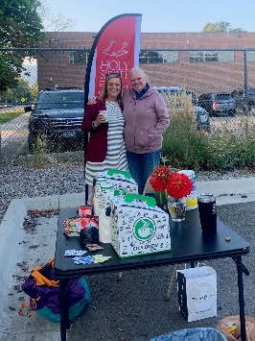

*Welcoming students to Hellgate High School, August 31, 2021*

**Habitat for Humanity**

Holy Spirit Missoula has a long history supporting Habitat for Humanity and continues to provide support in three areas: financial support, work crew support and meal support for volunteers. In 2021, Holy Spirit worked with Habitat for Humanity on three new house building projects in/near Missoula. This was especially heartwarming for Holy Spirit, as one of the 2021 houses is being built for a member of our Congregation!

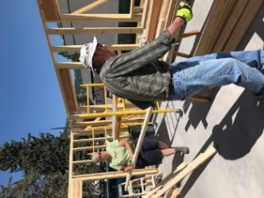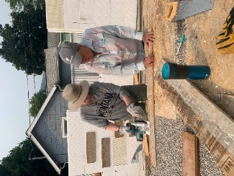

*Holy Spirit Parishioners hard at work for Habitat for Humanity*

**Mexican Student Scholarships**

Supporting students in El Golfo, Sonora, Mexico is another long term outreach project undertaken by Holy Spirit Missoula. The scholarships are provided to support students who have finished “junior High” and do not have the resources to complete “High School,” which clearly gives them more resources and experience as they become adults. Holy Spirit has supported two students a year (and several Holy Spirit parishioners provide support for additional students). The program was started by two Holy Spirit Parishioners, Maggie and Chuck Teague!



*Two of the Mexican high school students in El Golfo who have been sponsored by Holy Spirit*

**Myanmar Education Support**

Building on projects in 2015 and 2018, when a dozen Holy Spirit volunteers worked with teachers in rural Myanmar to improve English language education, they spearheaded a public fund-raising effort in 2021 to build a school in Myanmar’s Nagaland, raising more than $22,000.

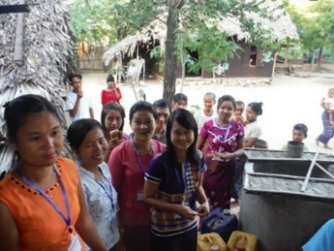

*English teachers and students in rural Myanmar*

**Red Cross Blood Drives**

Holy Spirit sponsors two Blood Drives a year, in the winter and fall. In coordination with the Red Cross, Holy Spirit has donated an average of 42 pints of blood per year, the vast majority from Holy Spirit Parishioners.

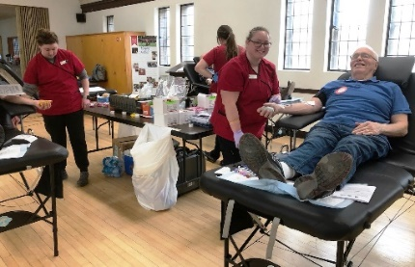

**Freedom in Christ Prison Ministry**

**S**upporting the efforts of one of Holy Spirit’s Deacons, annual contributions have been made to the Prison Ministry at Deer Lodge. Their Mission is: Transforming lives at Montana State Prison through the power and presence of Jesus Christ.

**Rio Grande Borderlands Ministry**

The Borderlands Ministry of the Diocese of Rio Grande (New Mexico and Western Texas) is an on-going effort to minister to those who have been affected by US immigration policy changes, especially over the past several years. Working with the Anglican Diocese of Northern Mexico, they support shelters on both sides of the border and, independent of any political issue, support the humanitarian needs in that area.

Holy Spirit is in the process of becoming a “Partner” with the Diocese of Rio Grande in this effort. This will include some level of financial support and, just as important, both prayer support and personal visits to the borderlands area to see, feel and understand the issues involved.



*Rio Grande Borderlands Ministry at work*

**Creation Care Ministry**

Holy Spirit started its Creation Care Ministry in 2020 with the following objectives:

* Looking at our operations at Holy Spirit with the goal of becoming more sustainable
* Providing information and resources to members to help us live more sustainably at our homes
* Becoming more active in our Community by addressing issues of climate change and other environmental issues
* Provide fun opportunities to learn about and explore the wonderful natural world we live in

To date, most of our effort has been focused on the first, second and fourth objective. As we learn from these, Holy Spirit will use that experience to further focus on Community, and that has started with opening communication with the UCC congregation in Missoula for collaboration. **However, one very important outcome of this ministry has been the creation and approval of a plan for solar panels at Holy Spirit, to be accompanied by community education about our use of solar energy.**

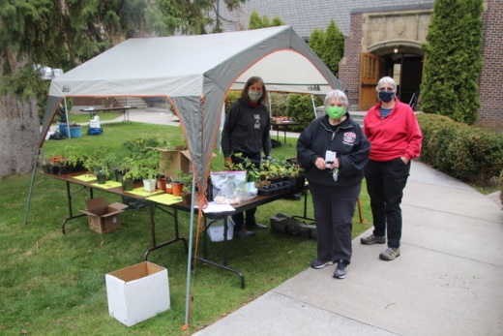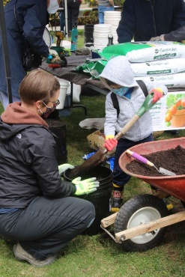

*How does your garden grow? Helping Holy Spirit families and the community learn about gardening!*

**Missoula Interfaith Collaborative**

Holy Spirit is a founding member of this community organization, which has slowly grown into a broad coalition of community groups focused on all manner of local issues. MIC has specifically worked on:

* Missoula Works – a home handyman service which primarily employs returning citizens (those released from prison who have completed their term)
* Recycling Works – the leading glass recycling program in Missoula
* Welcome Back -- a support group for returning citizens (those released from prison who have completed their term)
* Homeless Advocates Network – a support group for homeless to help them navigate issues related to finding and getting into a home

Several Holy Spirit Parishioners are active in one or more of the above activities. Holy Spirit sponsors glass recycling at the Church; over 15 Parishioner families participate.

**Butterfly Grants**

A concept put forth by Holy Spirit’s Social Concerns Committee, Butterfly Grants are donations of between $200 and $300 to causes or projects proposed by Holy Spirit Parishioners. Examples of groups or issues addressed by Butterfly Grants recently include:

* Welcome Back – a support group for returning citizens (those released from prison who have completed their term)
* Hygiene supplies for the Poverello Center – for Missoula’s homeless shelter
* Montana Natural History Center – financial support for youth and family naturalist education
* Family Promise – financial support for homeless families
* Fort Belknap Reservation – shipment of unsold Rummage Sale items to donate to the Reservation

In addition to the above, many Holy Spirit Parishioners participate as individual volunteers in several Community organizations, including Partnership Health Care and the Missoula Food Bank.

Beyond our immediate Community, Holy Spirit has been an active contributor to Episcopal Relief and Development for hurricane and flooding relief in the southeastern United States and hurricane relief in Honduras and Guatemala.

The Rev. Terri Grotzinger  
revterri@holyspiritmissoula.org

# **Holy Trinity, Troy**

**The outreach projects that our church is involved in routinely are:**

* We give up to 5 scholarships, $1,000 each to Troy seniors for continued education.
* We give a gift each Christmas and donate 3-5 Thanksgiving dinners and Christmas dinners each year to the Troy Food Pantry. We also donate canned and packaged foods all year long.
* We donate at Easter and do a special matching donation to Gifts for Life to Episcopal Relief & Development.
* We provide local vouchers for food, motel, or gas.

Jill Wilson, Senior Warden  
holytrinity59935@gmail.com

# **NOTES**

# **NOTES**