St. Michael & All Angels Third Issue 2021
The Messenger
A LETTER FROM THE RECTOR + + + + + + + + The Reverend Mikayla Dunfee
Hope amid the din Autumn always leaves me feeling a bit conflicted: the array of colors and sunshine ushering in the season of dying and sleep. As the summer has wound down to a close these last days, I am welcoming – perhaps more eagerly than ever before – the return of peace and quiet. There was a time in early August when I couldn’t focus for noise – both internal and external. There was the last surge of summer tourists and the ongoing fear of Safeway running out of milk. There was the lament of Afghanistan falling back to the Taliban and uproar as the forests of the Western mountains burned down. And then there was this never-ending pandemic that has rendered our hospital ‘over capacity’ for weeks on end. There was so much to care about … so much to pray for. It was too much. And the cacophony of worry seemed so loud, I couldn’t find my footing, let alone try to guide folks along the way of hope at the hospital. Then I found something that helped: a blog post by Nadia Bolz-Weber dated August 17th (thecorners.substack.com) entitled “If You Can’t Take It Anymore”. There’s a reason I highly encourage you to read it, because within those few lines, I heard, quietly at first: You are not alone. We’re all overwhelmed. Your exhaustion, and weakness, is nothing Christ can’t handle. And my shoulders relaxed for a few moments. I could hear the birds again. And the wind. And the river. And the song sung “without the words” (as Emily Dickenson wrote): the song of hope. So if you’re the one who needs it today: you are not alone. These are hard, very hard times, that is a fact – but you can get through this. You’ve done hard things in the past and you can do them again. You know why? Because Jesus is right here with us. I leave you with these lines from Malcom Boyd: It’s morning, Jesus. It’s morning, and here’s that light and sound all over again. Where am I running? You know these things I can’t understand. It’s not that I need to have you tell me. What counts most is just that somebody knows, and it’s you. That helps a lot. So I’ll follow along, okay? But lead, Lord. Now I’ve got to run. Are you running with me Jesus?
St. Michael & All Angels Intercessory Prayers
Aaron, Avery, Bonnie, Cam & family, Carol & family, Chez, Chloe, Chys & children, Craig, Dan & Patie, Dee & Sam, Don & Linda, Emerson & family, Erin, Gwynn, Jake & Pam, Jillian, John & Sharon, Jordana, Joy, Kaye, Lois, Marty & Darla, Marlene, Megan & Sophia, Mike & Donna, Mike & JoAn, Misha & family, Nathan, Nicole, Paisley, Rosemary, Ruby, Ruth, Sara, Steve & Barbara, Tom & Sandy, Tom, Toni,Vicky

A View from the Pew – Sharon LaBonty, Editor This issue of The Messenger is a “love letter” to The Rev. Pattiann Bennett who has served St. Michael & All Angels for 20 years. Included throughout you will hear her voice celebrate her time with us starting with her last sermon and excerpts from previous articles. Many pictures also. We will all miss Pattiann and Bruce but wish them happiness in this new phase of life. And as she said: Retired, I have become Rector Emeritus, meaning I'll continue the Wood Bank & w/ community needs on behalf of St Michael & All Angels. I'll be around...
September 19, 2021 Pentecost 17 Mark 9:30-37 James 3:13-4:3, 7-8a Grant us Lord, not to be anxious about earthly things, but to love things heavenly; and even now while we are placed among things that are passing away, to hold fast to those that shall endure. Through Jesus Christ our Lord, who lives and reigns with you and the Holy Spirit, one God, for ever and ever. Amen.
Today is my last preaching day.
On October 9, 2001, Bishop Charles Lovett Keyser ordained me to the diaconate right here at St Michael & All Angels. The church was full to the brim that night and friends overflowed to the basement where they watched on a big screen tv. Almost a year later on September 20, 2002 I was ordained to the priesthood at Christ Church in Kalispell and a bag piper played Amazing Grace. Much has happened here these 20 years. Time is a funny thing. All at once tomorrow has become yesterday. Twenty years later have become today. I could talk about all the things you and I have done together these 2 decades but you know all that. We have shared the love and loss of so many beloved people along the way. We've rebuilt this church physically. We have responded to needs in the community in hundreds of ways because we follow Jesus Christ. You and I have laughed and cried many times together. We've learned how to be a beloved community in the midst of differences, for one thing knowing to not talk politics, religion or about each other. I have grown from a critically shy person, who sat for years always where Art & Kathy sit, without any involvement here at all or desire for it. I have found my voice along the way. It has been a challenge. I have become fearless, ferocious when necessary. My understanding of who Jesus is, who we are called to be and what we are called to do by him has deepened beyond any measure I can give. I continue to grow and blossom and am amazed every day about who I have become because I stepped into the unknown with faith and fear and trembling all those years and experiences ago. St Michael & All Angels adjusted and learned a new way of being who we are this last year of Covid and will continue to, as the Covid progresses in ways we do not know yet. We are witnesses to an insanity of no common sense in the masses and struggle with that reality every day now. There is danger all around from attitudes that have no knowledge or care of a loving God who has given us everything we could ever need to live safe, wise and loving lives for each other. And thankfully we have each other here at St. Michael who, though we have different ways of being, the core of who we are is love and we endeavor to live what that looks like. All because we follow Jesus Christ who taught us to love God with all our heart and mind and soul and to love our neighbor as ourself. It is hard to see this call to humanity at work in the world right now. The author of James fleshes this out clearly. St Michael & All Angels is a healthy congregation, spiritually and otherwise. The Bishop and Mikayla see this. It is obvious and unusual. When Jesus says, "whoever welcomes one such child in my name welcomes me and whoever welcomes me welcomes not me but the one who sent me", he is talking about you. When the author of James speaks about true wisdom, that it is peace loving, gentle, full of mercy, good fruits, considerate and reasonable, that the church must live by the values of the gospel, not of the world, he is speaking about you. When the psalmist sings: "They are like trees planted by streams of water, bearing fruit in due season, with leaves that do not wither, he is singing about you. Wisdom & love abound here. The Bishop and Mikayla are blessed by you. They can see by the out-ward seeking activity of this little church and by the joy you extend that you are serious about the business of being Christian. They see how you offer hospitality to them and to the world. You have much to offer, not only to this community, but to this diocese as an example of outreach, hospitality and willingness to do what must be done even when you might not want to do it. You're willing to go the extra mile to make things run, to keep the peace, to be a beloved community. That's what you do because that's what it takes and that's who you are as the parish of St Michael & All Angels Episcopal Church in Eureka Montana. No other church in this town, as far as I know, comes anywhere close. In your quiet ways you boom like thunder, shine like the sun. You raise the bar. The Bishop and Mikayla see the potential for every church in the diocese, to empower its laity, which has not been done really or encouraged by any bishops previous and you'll be learning about this new chapter in the life of this diocese and your part in the vision. St Michael has strong leadership in a fairly new vestry. You, the laity, are already richly invested so when new opportunities to learn and grow are presented to you, which they will be with gusto, you won't have to reinvent any wheels, you'll be led and guided by the best of the best. This is a very exciting time for St Michael. I'm excited for you. There are wonderful things ahead here under the wise, strong and loving leadership of our new Bishop and Mikayla. Grant us Lord, not to be anxious about earthly things, but to love things heavenly; and even now while we are placed among things that are passing away, to hold fast to those that shall endure. Through Jesus Christ our Lord, who lives and reigns with you and the Holy Spirit, one God, for ever and ever. Draw near to God and God will draw near to you. Amen. - The Rev. Pattiann Bennett
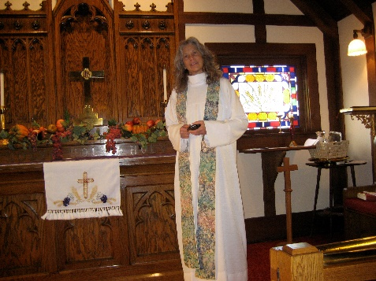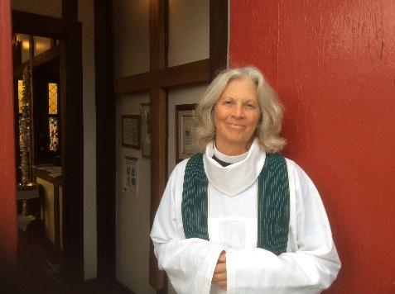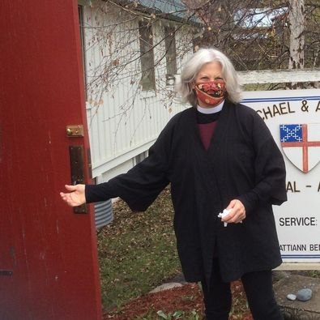
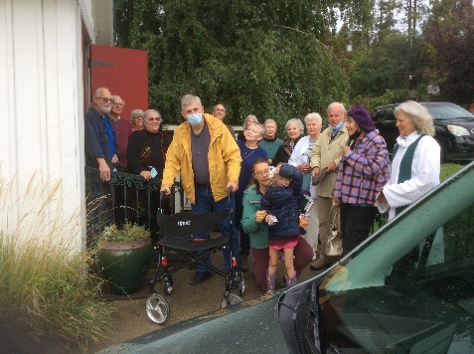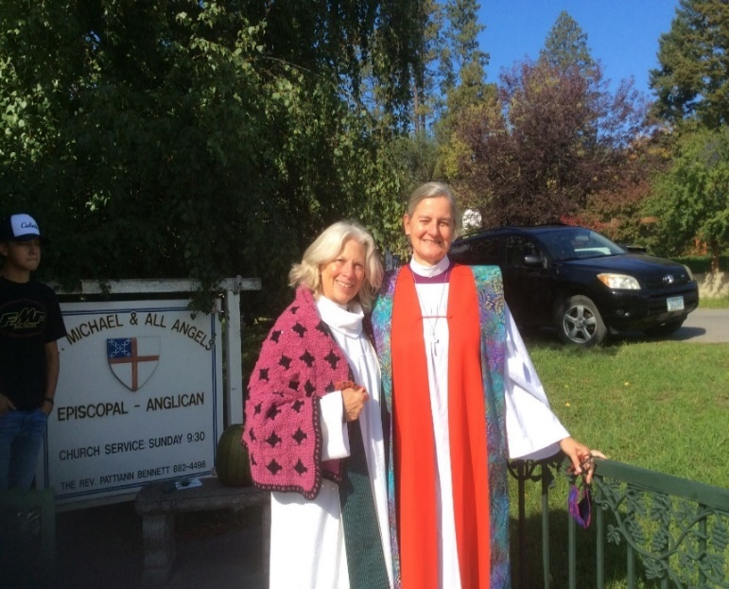
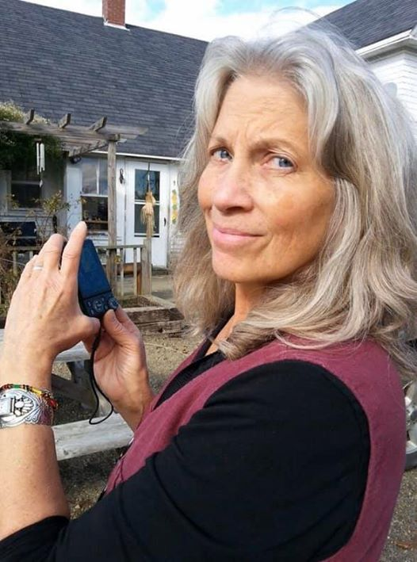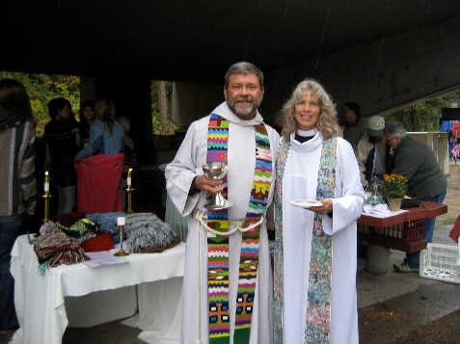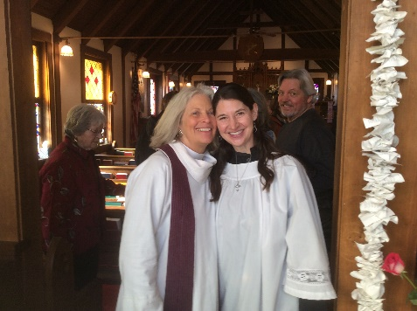
Op Ed – Mike Cuff
Happy Transformation – To the new butterfly we call Pattiann Bennett, who is stepping away from the Rector’s pulpit at St. Michael and All Angel’s Episcopal Church at Eureka, Montana: In the coming days, take time to enjoy your many blessings, challenges, and opportunities! You are a special person with a special gift of ministry that doesn’t end when you step back. Just like the butterfly emerging from the cocoon, you will carry old wisdom with you as you fly into a new life. We thank you, and we thank God for Blessing our lives with more than two decades of your ministry. As I cast my eyes around our little church, my mind drifts to many memories of parishioners including the Chrysalis girls and many others who have passed on including my sister Edna and Bill Gwynn, my brother Hubert and Bonnie McKenzie, Dave and Mary Lou Peterson, Joe and Carol Gibbons, Joe Jankovsky, Lee Ann Nemec, Jack Smiley, Jim and Mary Sauerman, Virginia Donaldson, Marilyn Mason … Memories of personal blessings, of Vestry Meetings, of funding challenges when it seemed I was the only one who would stand up and ask for dollars in the plate. Of your personal growth and Christmas services and my favorite sermons like the allegory of Christ’s birth when the farmer wouldn’t go to Christmas service because he didn’t understand why God would send Jesus down to earth just for our salvation. Then a storm came up and stranded a flock of wild ducks or geese in the farmer’s field. Fearful they were about to freeze the compassionate farmer tried to herd or drive or lure them to safety, but the geese couldn’t understand, until he took a tame farm duck or goose out to lead the stray visitors to safety inside the barn. Then the wild birds understood, but more importantly, the farmer understood. The farmer still understood decades later when he moved on to another stage of life, perhaps as a teacher or writer or house builder or truck driver or something else. Who knows? God may use you (tears, smiles, giggles and sincerity included) to help lead future Rectors to His or Her service. I wish you well in your new journey of this thing we call life!
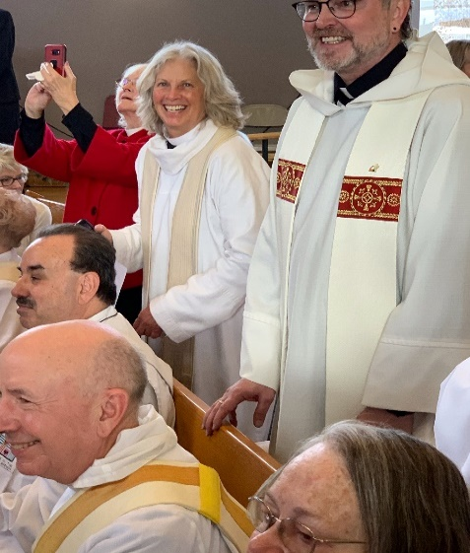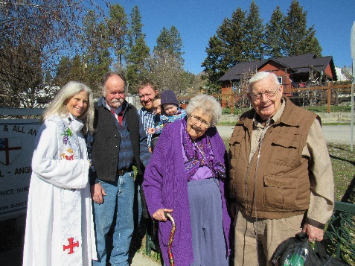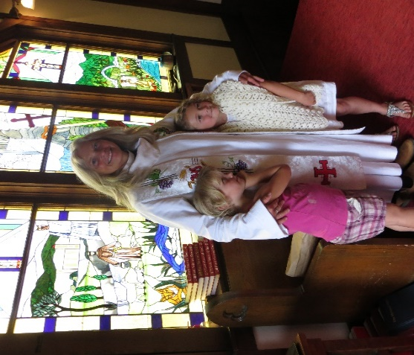
I have known Pattiann since the days of Crazy Woman. I don’t really have any stories to tell. I can only say what a blessing she has been to this community. She not only "talks the talk" but she "walks the walk". I started going to St. Michael's because I knew Pattiann and wanted to see the inside of the church. I needed to reach out and create a new life for myself. I became a part of the church family and found new friends. It certainly is going to be a big change for St. Michael's I hope we are up to the challenge. Pattiann will be sorely missed. – Kathy Hawkins

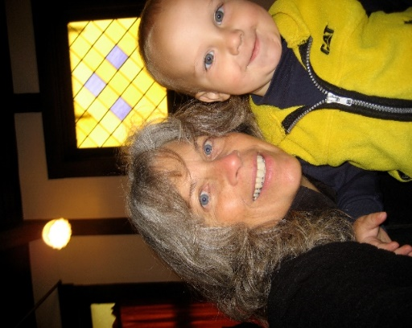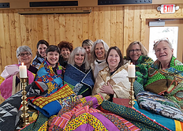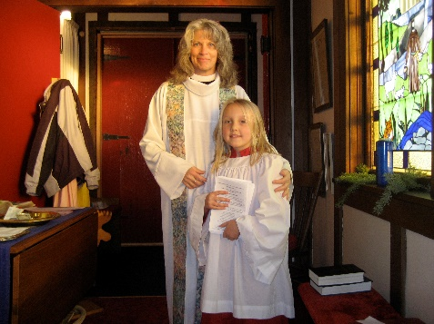

Our crochet group was meeting for lunch at the soup café before crocheting prayer shawls. Following the close of the Soup Café, the ladies went upstairs to crochet while Pattiann finished straightening the kitchen. We were tossing around a name for our group. One of the ladies said, “How about the Happy Hookers?” We burst out laughing and joking; laughing so hard that Pattiann came up to see what was so funny. When we told her the name we had chosen, the look on her face was priceless! Shock first and then she was laughing as hard as we were. A memory I will always cherish!
I would be remiss if I didn’t also add a note of appreciation for all the work that Pattiann went through to make sure that those of us who were unable to access YouTube got a complete print out of each and every service during the time we were shut down due to Covid. She delivered them to our doors each Saturday evening. God bless you, Pattiann! – Dee Nance

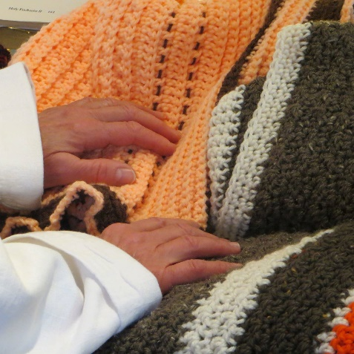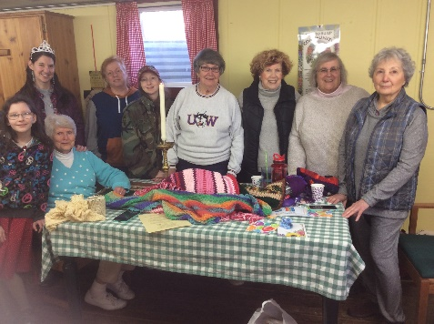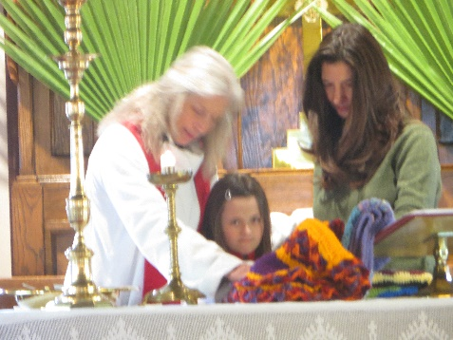

Dear Pastor and Friend Pattiann,
My first impression of you at church was this beautiful, mysterious woman with her elegant classic clothing and demeanor. You have remained all of that and more. We have been through joyous times and sad times together. Always you have spoken from the heart with honesty, respect and empathy. May our Lord continue to bless you and yours – and hold you in the palm of His hand – and remember: “No tears – No sighs – no Sad Good byes – Just … So long for a while” Love, Jeanne (Jankovsky)

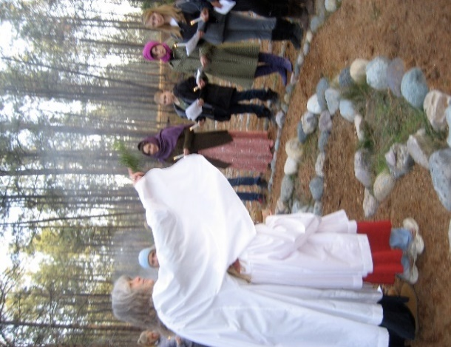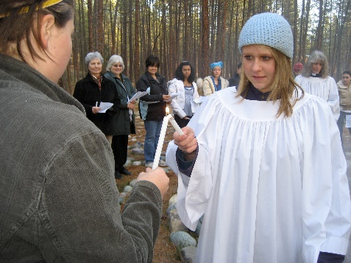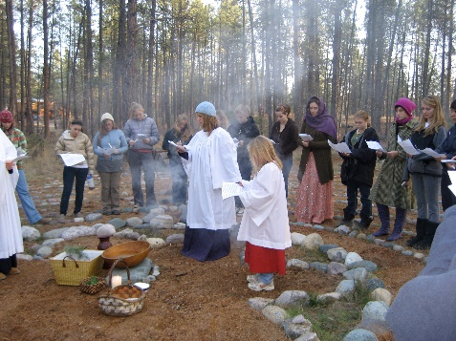

Well, Missie Pattiann, we’ve had this conversation before, but the time has come… YOU ARE RETIRED! And along with that brings all sorts of thoughts. First just joy for you and Bruce to be able to spend more time doing what you wish and when you wish.
Second, as I look back on how far we’ve come: Pension fully funded, wood bank, soup night, angel café all from a mere dream to reality.
Third ,how beautiful is the little church on the hill!
ALL UNDER YOUR LEADERSHIP. We are so proud to have been a part of all this over the past 23 years.
I think back on how hard you worked to become our fulltime priest. I think back on how much work we (you & I together) worked on your pension. And I think back on the MANY financial challenges we’ve been thru. My biggest lesson has been to BELIEVE. WE CAN DO THIS.
I WANT TO SAY THANK YOU for your perseverance, your commitment, and your dedication. To say that I will miss you is an understatement, but I thank you for assuring us that WE CAN DO THIS!

GO IN LOVE AND PEACE
JoAn H. Cuffe

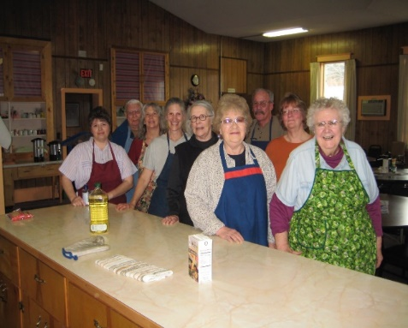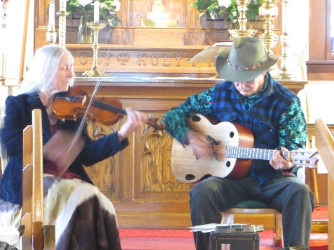

Dear Pattiann and Bruce,

I moved my family back to Eureka in 2014. It took me a few years to decide to attend St. Michael’s. I was not raised in the Episcopalian church so I wasn’t that familiar with the routines and rituals. However, I can safely say that most of the decision was made for me when I heard such glowing reports from others in the community about Pattiann. Many of those reports came from people who weren’t members of the church, but had such positive things to say about how kind, welcoming and loving Pattian, Bruce and the local Episcopalian church is, that it made the decision easy for me. Jeff and I have two children, Stella and Declan, and one of the most important things that we want them to learn is how important it is to be kind, loving and accepting towards all people, no matter what. Pattiann and Bruce both emanate this from their core and I am so grateful that you model this and that you are a part of this community. Bless you on your new journey.

Love, Amy Driggs, Jeff Peterson & Stella and Declan

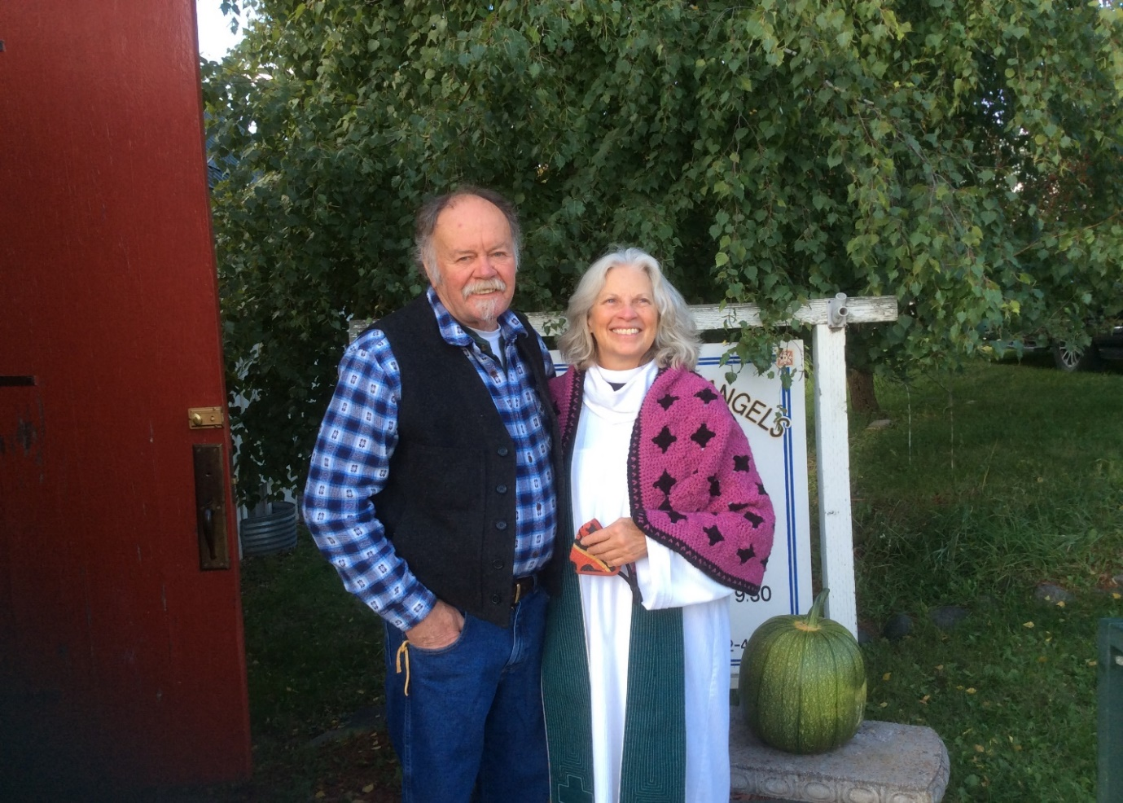

Four years ago this week we drove up from Texas trailing a U-Haul with 3 dogs in the back seat. We had a plan to move into the house that we had built with JoAnn‘s son Jim in Eureka Montana. We had been here a couple of times previously, but our principal exposure to Montana was a 10 year run of Glacier National Park day hikes while based in Saint Mary’s near East glacier. The three of us would rent a cabin at the KOA in St. Mary’s during the first or second week of September each year and hike the heck out of Glacier.

From the time the three of us had decided to build a house together in Eureka, Jim and I, that is Jim Pettit and I, would look at references to Eureka with great interest. I think the first thing we did was to look up Episcopal Churches in Eureka Montana. There we became came acquainted with Saint Michael and All Angels. The sign out front said Episcopal-Anglican. We weren’t quite certain what that Anglican meant because in Texas Anglican churches use the 1426 prayerbook.

So we looked further. We found a website with photographs and explanations of the types of outreach that this church did. I was certain, in my arrogance (this is Jim Pettit speaking), that there was a typo describing your Food Bank. Then came the photos of logs and chainsaws and the description of providing needed basic fuel to those who had none in an area that became very very cold. We thought, “Jesus lives here.” It is hard to find enlightenment when a person is cold and hungry. And speaking of hungry, there was the Soup Cafe. It also lasted throughout the cold months. These seem to be people after our hearts. What cinched the deal, though, was that in several of those pictures JoAnn noticed this woman with a white collar wearing Birkenstocks and blessing the animals.

So, we did move to Eureka, and found a more than welcoming church that treated us like family. Bruce and Pattiann have been instrumental in making us feel welcome. All we can say is thank you to Bruce and Pattiann and the entirety of the Saint Michael congregation for welcoming us as you have and continue to support and love us.

Eureka would certainly be a much different place for us without the St Michael and All Angels family.

JoAnn (Bristol) and Jim (Pettit)

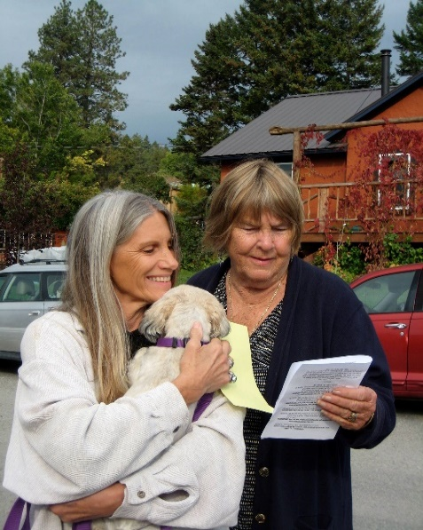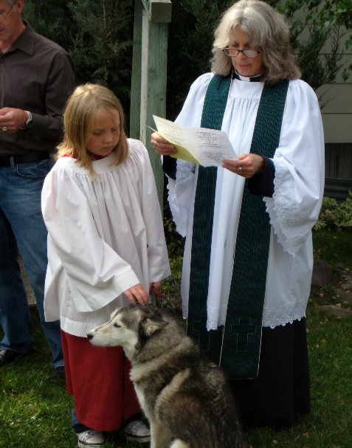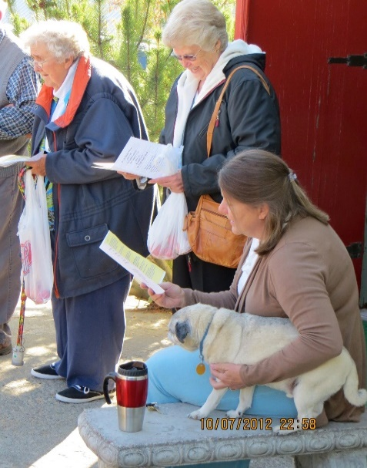

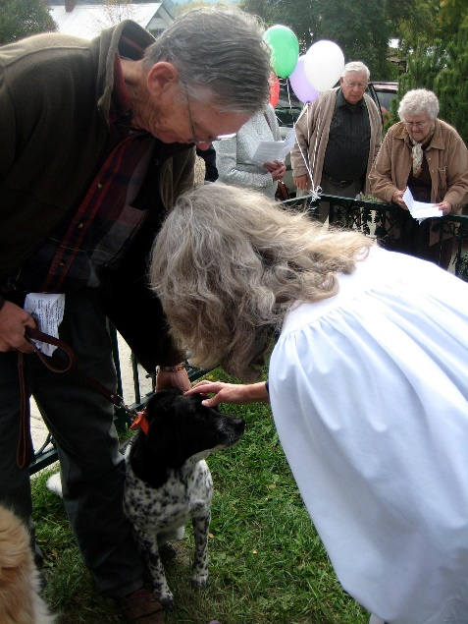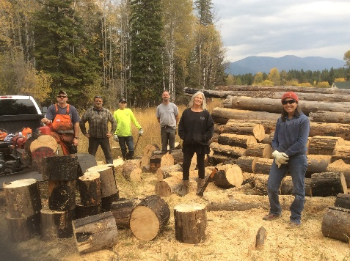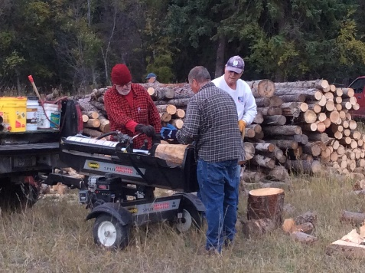
For Pattiann, from an admirer

How is it you move with such gentleness? Like a petal on water.
How is it your clothes are always soft and forgiving? Like the mossy bed under sycamore.
How is it your embrace is full and warm? Like opening the oven door on a frosty morning.
How is it you shine Christ’s joy so radiant and unflinching? Like the glow of snow on the mountain.

Pattiann, you display quiet strength and sound wisdom – the epitome of holding things loosely, while never letting them fall.
You are the kind of woman I want to be. Compassionate. Thoughtful. And Kind.
With depths, bravery, and power all your own.
And style. So much style.

Keep touching this world with your healing hands.
Keep dancing across our Mother Earth.
We’re still watching … still learning … the lessons you have to share. – Mikayla Dunfee

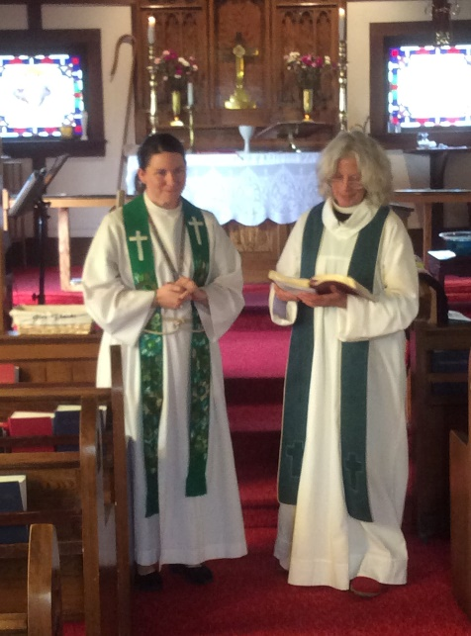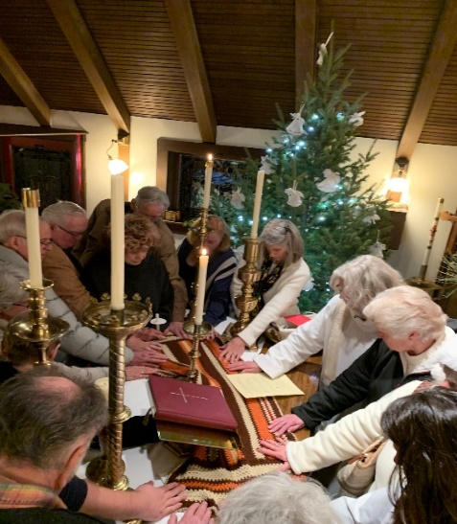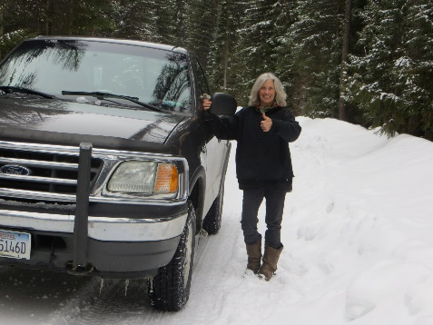
State of the Diocese – STEVEN BENSON
SOME NOTES ON THE 118TH DIOCESAN CONVENTION - 2021
I was pleased to represent Saint Michael and All Angels (virtually) at the annual convention in Billings. Hopes had been high that this year’s convention could be completely in person, but due to the Delta
surge across Montana many folks weren’t comfortable traveling or attending in person. The Diocesan staff put a valiant effort into producing a “hybrid” convention - some of us online via Zoom and some in person at the Billings hotel. This is much more complicated than either an in-person or an online only convention. There were some glitches, but the staff is to be commended for persevering in an admirable way.
Friday evening began with a healing Eucharist with the Lutheran bishop of Montana giving the sermon. The service included all of us joining in a litany of laments and commitments around the ways that our world cries out for healing. After the Eucharist a short business meeting laid the groundwork for the weekend, heard reports from a few committees, and elected officers. One item of “practical” interest is that congregational assessment will not change for 2022 (although PPE grants received by any congregation will be counted as income for assessment purposes).
Saturday was more densely packed. We heard an address from Bishop Marty and voted on necessary minor changes to our governing documents (some of which dealt with the need to not only refer to the bishop as “he” or “him”). Some reports and actions which I found particularly meaningful:
+ The Diocese has a “Congregational Development” team which is specially trained to work with congregations to understand changing circumstances and society so that each church can adapt and re-tool to
meet new challenges and remain healthy and strong in a changing world. This service is offered free-of-charge for up to four churches per year.
+ A presentation and workshop addressed the Bible’s vision of “Beloved Community,” in which divisions in society are healed and God’s people forge a community built on God’s grace and our sharing of that grace.
+ Many of those present were able to participate in a Saturday noontime service project of packing meals to be sent out to people trapped by hunger.
A traditional Saturday evening banquet was (unfortunately) available only to those attending in person. The Convention closed appropriately with a Sunday morning Eucharist which was again attended both in-person and online. It was encouraging to see the dedication of faithful congregations and members across our Montana Diocese.
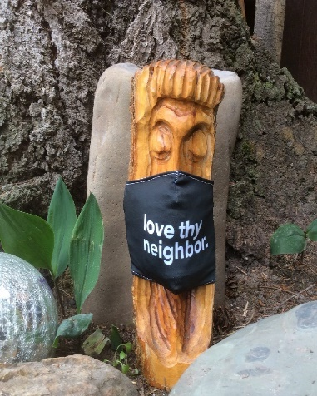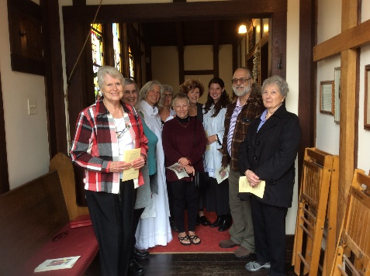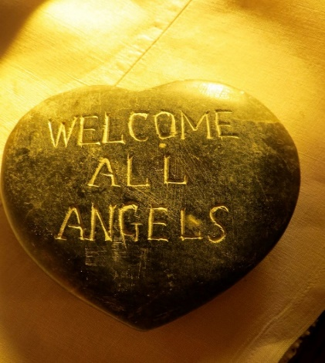

Vestry Views
Starting October 24, Sunday services at St. Michael will be 10:30 a.m., rather than 9:30 a.m.
Since Rev. Mikayla will be driving to Eureka for services and Winter / short days are rapidly approaching, it was decided to start Sunday services later. The Vestry has set the 2nd Sunday each month for Vestry meetings. The 4th Sunday will continue to be the monthly potluck. Rev. Mikayla will be serving St. Michael both those Sundays. The Vestry is currently contacting other supply priests about coming to Eureka for other Sundays, until this is completed the 1st, 3rd, and 5th Sundays will be Morning Prayer.
A Look Back…or Around
Editor’s note: This column is designed to answer some of our questions. Let us help answer those questions – or better yet, you do the research and we’ll print it. Please contact Sharon.
St. Michael & All Angels celebrated it’s 106th birthday on October 3rd. There have been many changes, especially during the past 20 years. The following is an excerpt from Rev. Pattiann’s sermon of April 27, 2014:
“Our worship has ended, our service begins… Ninety-nine years ago, a woman named Mary Malkoff took those words seriously and gave every last penny she had to have the Episcopal Church built in Eureka, Montana in memory of her husband Michael. In and from this beautiful little church that meant so much to her, hundreds of people have been Baptized, married and buried over these many years.
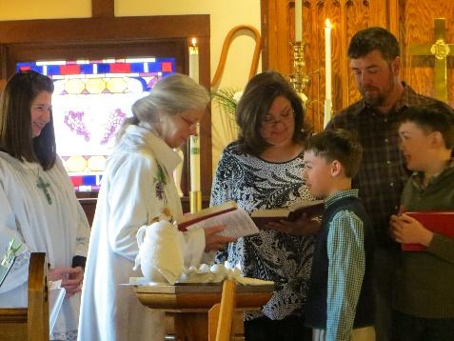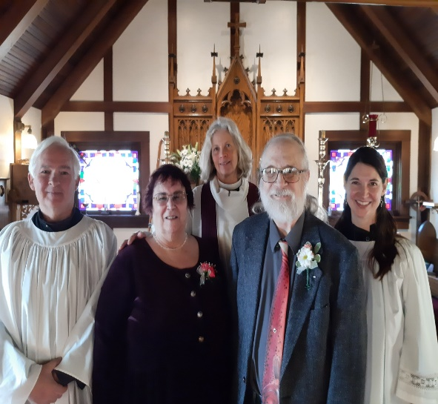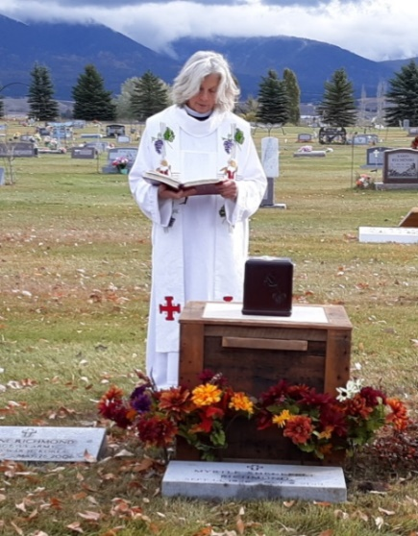
Ninety nine years later this parish is going strong following Mary’s example of faith and service. Perhaps the next hundred years will show that what we’re doing now will also make a difference. Not too many of us will be building churches with our last penny, but what we’re doing matters and will be remembered. What we do together every Sunday makes all the difference for the rest of the week. Worship, prayer and love for one another in this holy place make the rest of the week kind and sacred. Being here helps us remember who we are, who we belong to and what we are to be about, and that is loving God and loving our neighbor. Pretty simple things and not always easy, but we try. For example, the people in this little church have made and given hundreds & hundreds of prayer shawls over the years to people who are ill or in therapy or dying or grieving or recovering or moving, all kinds of tender heart places. The shawls are held and prayed into by everyone, blessed on the altar, sent with love and have tremendous impacts on the ones who receive them. This church supports the Millennium Development Goals, a United Nations Initiative. The goals are: 1. to eradicate extreme poverty and hunger; 2. achieve universal primary education; 3. promote gender equality and empower women; 4. reduce child mortality; 5. Improve maternal health; 6. Combat HIV/AIDS, malaria and other diseases; 7. Ensure environmental sustainability; 8. Develop a global partnership for development… We’ve sent $5000 over the years gathered each Sunday in a simple basket $1 at a time… For those closer to home we have a wood bank that helps supplement wood needed to heat the homes of low income veterans, disabled, elderly and single parents. The ministry is tended to completely by volunteers, not only from St. Michael but by members of the community as well, people who love to work the wood and haul truck loads to the wood bank site or deliver to people’s homes. They bring their chain saws, log splitters, axes, mauls and wedges, the youth stack it, we form caravans of pickups. Some come from afar to bring lunch, coffee and lemonade. Amazing things happen.
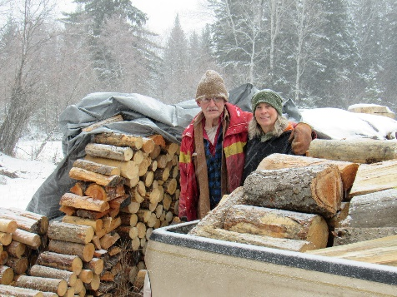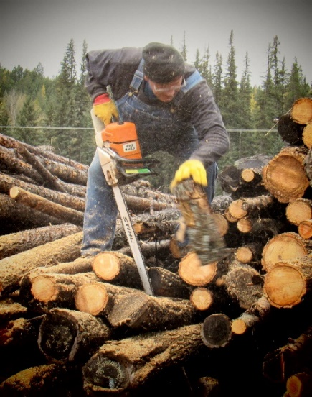
The last 20 years have been very busy ones for St. Michael & All Angels and its parishioners. Having the stability of a resident priest has allowed the congregation to follow the words of James 1:17-27 (excerpt):
Every generous act of giving, with every perfect gift, is from above, coming down from the Father of lights, with whom there is no variation or shadow due to change…. But be doers of the word, and not merely hearers who deceive themselves… But those who look into the perfect law, the law of liberty, and persevere, being not hearers who forget but doers who act—they will be blessed in their doing…. Religion that is pure and undefiled before God, the Father, is this: to care for orphans and widows in their distress, and to keep oneself unstained by the world.
Some of the outreach activities were mentioned in Pattiann’s message above; others include: Community Soup Night which was held weekly at the Tobacco Valley Senior Center for many years prior to ending during the pandemic; the girls attending the Chrysalis School chose to become part of St. Michael’s congregation – they actively participated by helping with the Wood Bank, Soup Night, being lay readers, caroling at Christmas and making prayer shawls; supporting the Food Pantry; and adopting Christmas families.
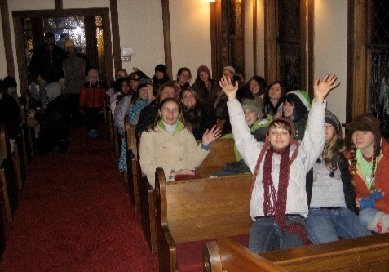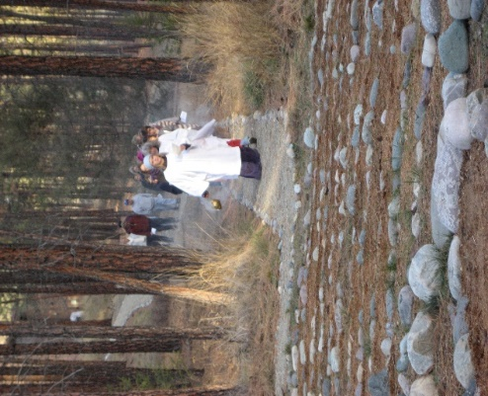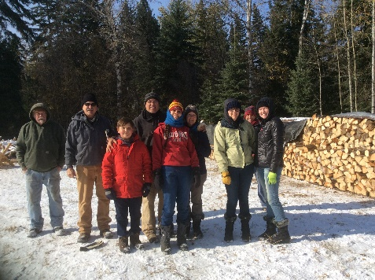

Renovations or Labors of Love: Improvements to St. Michael & All Angels have primarily been donations from members of the church. The exterior has gone from the original rustic brown, through a brief sojourn as green, to a new white siding. A new roof with rain gutters and a fire exit completed the renovation. A flower garden by the front door lends a welcoming sight, a garden bench was added as well as a handrail along the sidewalk. The original church did not have a bell tower. The tower and bell that tolls every Sunday was donated in memory of MaryAnn Gwynn and Barney and Eva Olson. The interior also has undergone an update. The most notable are the stained glass windows. But the walls were also painted for the first time which brightened the interior. The back wall was partially removed and two sets of swinging doors were taken down. This made for an open floor plan with more seating. The altar was moved away from the wall and the cross meant for the altar peak which was lost for 95 years was found. A new altar rail was installed and the 100+ year stairs were replaced. With all these renovations, our beautiful little church is truly spectacular!

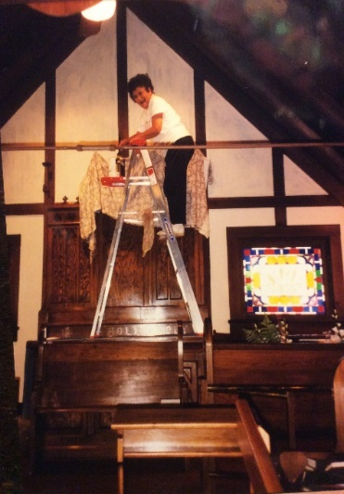
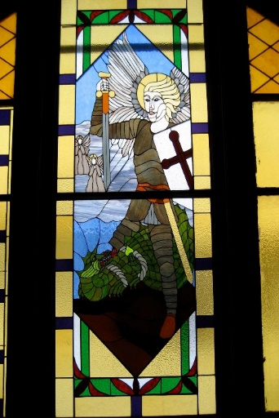
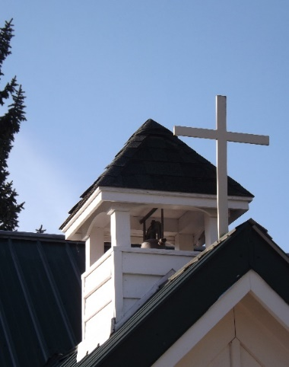

A Party in the Garden

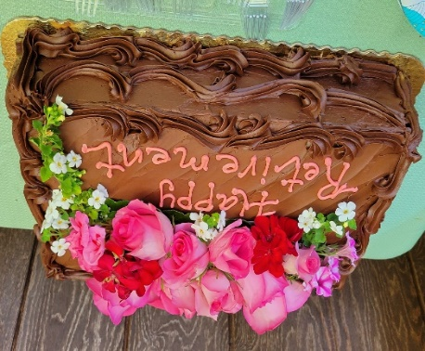
Today, the people of St. Michael and All Angels in Eureka gathered to celebrate the ministry of (the most fabulous!) Pattiann Bennett, which has spanned 20 years and many seasons in the fields of the Lord. Pattiann, your quiet confidence, cleverness, and appreciation of our tradition's materiality and sacraments are a buoy to the church and its ministers. "Well done, good and faithful servant." – All Saints’ Episcopal Church, Columbia Falls / Whitefish

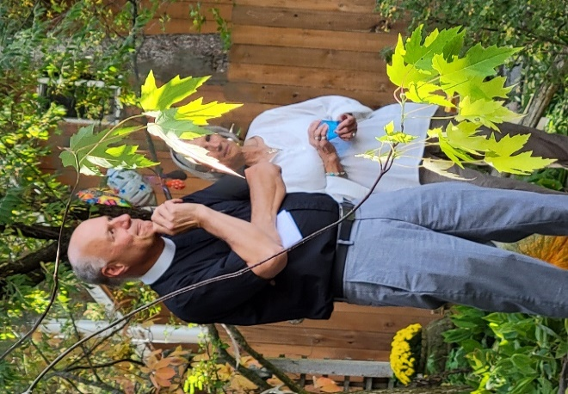

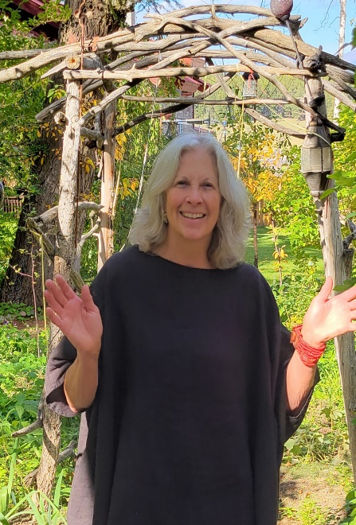

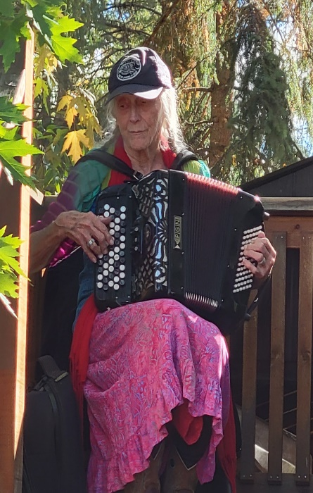

"Thank you to all the angels who made our last gathering in the garden so wonderful.
And thank you to everyone for the abundant gift for my retirement.
Bruce and I will think of your love for us with such gratitude when we travel to the coast.
I'm calmed to know that 'in the background' I'll still organize the wood bank, tend to community
needs on your behalf and be here for you when needed.
This journey with you has been and will continue to be a blessing of love and growth in my life.
Thank you for all we have shared in so many ways. God Bless Us Every One." Rev. Pattiann

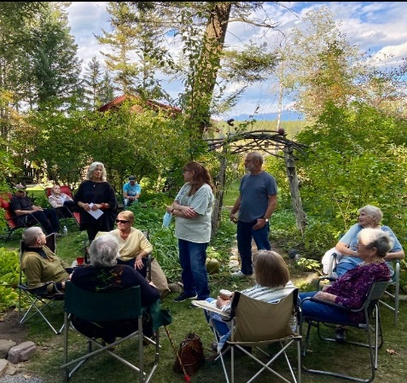
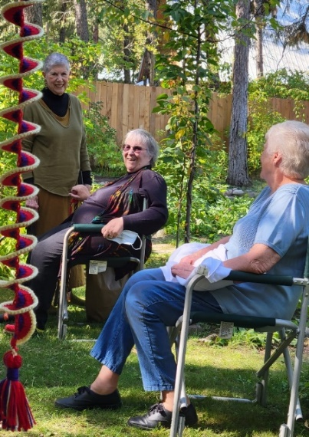

What’s Happening?

Prayer Shawl Ministry

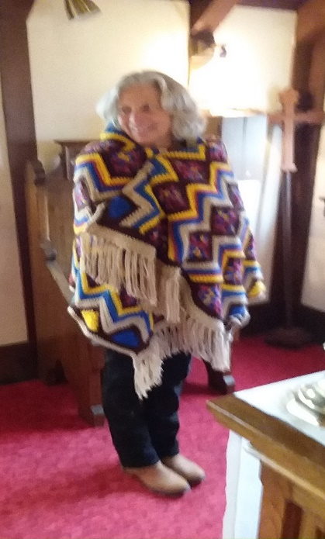 | HAPPY HOOKERS  The Prayer Shawl Ministry meets at noon every Wednesday at St. Michaels. Bring a sack lunch and join us.  ALL ARE WELCOME! Don’t know how to knit or crochet? We love to teach!  If you can’t join us on Wednesday but would like to be part of this Ministry, please contact Sharon at 406/263-9208. We have LOTS of yarn!
Size? Pattiann originally said to make the shawl “up to your chin”. Well, some of our chins are vertically challenged (we’re short!) so an easy
crochet pattern: With J hook, chain 160 and work 35 rows in double crochet. Or, chain 55 and work until shawl is 5-6 feet long.
Soup Café
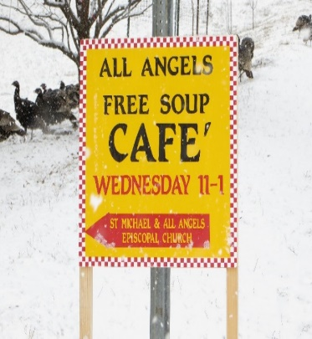 | Due to the mask mandate, the Soup Café is not opening this season.  Immediately following the mandate being lifted and people can gather, the Café will open.

St. Michael will be open for a quiet break from the frenzy of Christmas bazaar shopping on December 4th.

Wood Bank
Next Work Day:
October 23rd
9:00 a.m. – noon
Corner of Grave Creek Rd & Hwy 93
~
Sawyers, splitters and stackers are needed… cookies are welcome!
Watch the TV News and Facebook for the upcoming dates.
St. Michael’s Book Corner - Jeanne Jankovsky
A new book has been added to the shelf downstairs: The Gentle Art of Blessing by Pierre Pradervand. “To Bless means to wish, unconditionally and from the deepest chamber of your heart, unrestricted good for others and events ---- To bless all without distinction is the ultimate form of giving, because those you bless will never know from whence came the sudden ray that burst through the clouds of their skies, and you will rarely be a witness to the sunlight in their lives. It is impossible to bless and judge at the same time ---” Deuteronomy 28: 3-8 Blessed shalt thou be in the city, and blessed shalt thou be in the field … Blessed shalt thou be when thou comest in and blessed shalt thou be when thou goest out …
The outside Book Nook: Take a book – read & enjoy it – return it to pass on to others.
Estate Planning?
Consider including St. Michael & All Angels in your will.

Food Pantry – Ethel White
The Tobacco Valley Food Pantry had a busy month of September with an increase of 10 households. Thanks to sales at the Thrift Store and generous donations we have been able to purchase healthy food. This includes frozen chicken, hamburger, pork chops, hot dogs, sausage links, and chicken patties – much of it pre-cooked. Some of our households are living in RVs or tents and need pre-cooked food. Thanks to Jim Finley and the Community Garden, we have had fresh vegetables. Town Pump is again doing it’s annual matching cash donation program and offers a grant for non-profit food banks. The program started Sept. 1st and runs through the month of November. During the holiday season churches and other non-profits have fund raisers and non-perishable food collections. These efforts are greatly appreciated. Our manager, Mary Duram is stockpiling up for the holiday distribution. This allows households to enjoy a traditional holiday meal. The Whitefish Food Bank and Flathead Food Bank have delivered produce boxes. Items that are not available from our regular providers are purchased from Montana Market and Stiens. Our community is blessed to be able and willing to contribute to the Food Pantry. Thank you!
Birthdays / Anniversaries
October
4 - Sam Strand
4 – Jim & Jenny Bartlett
13 – Dee Nance
November
11 – Jim Pettit & JoAnn Bristol
December
9 – Kathy Hawkins
30 – Mason Bishop
31 – John LaBonty

CHRISTMAS
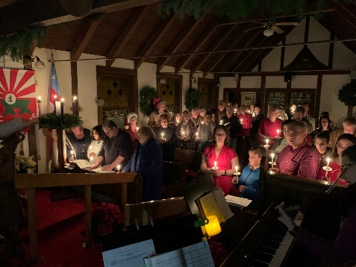
Christmas Eve Service
December 24th – 8:00 p.m.
Lessons & Carols
December 26th – 10:30 a.m.
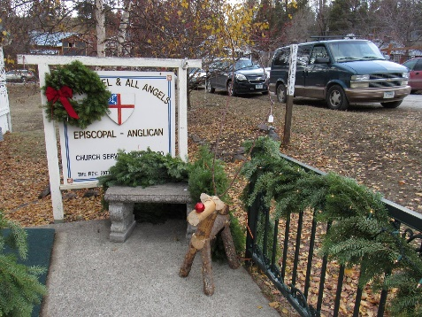
A Great Christmas Gift:
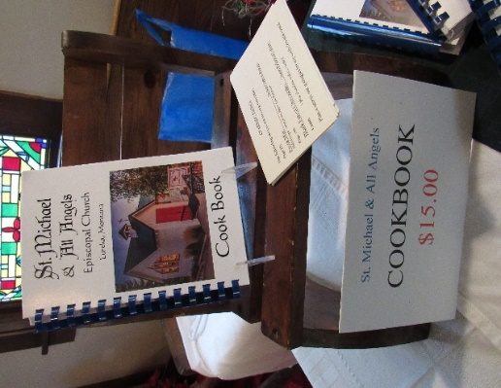
For Sale at the Montana Market or at St. Michael & All Angels

St. Michael & All Angels Episcopal
P.O. Box 342
Eureka, MT 59917

The Messenger Deadline

The deadline for the next issue of The Messenger is December 15th. Please send any news or happenings at St. Michael or an Op Ed to Sharon or hand it to her at church. E-mail: sharonlabonty@gmail.com

Dates to Remember
Ongoing
Vestry – 2nd Sunday of each month
Pot Luck – 4th Sunday of each month
October 24th; November 28th; and December 26th

Upcoming
Time Change: October 24th
Sunday Services at 10:30 a.m.

Purpose Statement

The purpose of “The Messenger” is to be in contact with all the members and friends of St. Michael & All Angels, near and far. That they may be involved and informed about the ministry, services, activities and opportunities.
Staff
Sharon LaBonty – Editor
Rev. Pattiann Bennett Rev. Mikayla Dunfee
Jeanne Jankovsky JoAnn Bristol
Dee Nance – Proof Reader

CHRISTMAS FAMILY
Each year St. Michael’s adopts a family (or 2) to help provide Christmas. We sign up to buy pajamas, snow boots, games, blankets, etc. Then we wrap them and Pattiann plays Santa on Christmas Eve. Pattiann is currently finding a family and will be making the list soon. Tags will be posted soon at church for us to select a recipient.

