December 2021
Calvary Episcopal Church Update
Red Lodge, Montana

Dear Members and Friends of Calvary,

We have arrived at the end of the Advent Season. Such great hope and joy await us. The birth of the Christ Child was a promise from God that we are to be filled with his Spirit. Angels, shepherds, wisemen, and Mary knew the significance of His birth. May we know, too, and be filled with hope, joy, and love.

The Greening of the Church Sanctuary will be this coming Sunday, December 19. All are invited to help decorate for the Christmas Season. This is the last Sunday in Advent.

Christmas Eve Service at Calvary is on Friday, December 24 at 6:00 pm.

Thank you from Suzi and Randy Pendergraft:
11.24.21
Dear Friends,
Bless your big and Generous Hearts!
Thank you for the lovely brunch and the amazing gift of NYC.
Know that we carry you in our hearts wherever we go…
Love,
Suzi and Randy

Pledge Drive—If you have not already turned in your pledge card for 2022, please try to do so before December 31. This helps the Vestry develop a budget for the coming year.

Search Committee Process—Here is the ad for a new full-time rector that we have placed in the Episcopal News Service (an on-line and hard copy publication for Episcopal Churches in the United States). We asked for a cutoff date of February 18 for receiving applications:
Calvary Episcopal Church in Red Lodge, Montana, seeks a full-time rector to lead our congregation and to bring a spiritual presence to our historic and scenic mountain town. We are a caring and committed church family with a congregation that actively responds to the needs of our members and to the needs of the community at-large. Typically, 35+ parishioners gather each Sunday to worship in Calvary’s beautiful 120-year-old church. We are searching for a rector who is warm and caring, one who will deepen our faith and who will help us grow our congregation. Red Lodge, pop. 2500, is a resort town and the gateway to Yellowstone Park via the magnificent Beartooth Highway and Absaroka-Beartooth Wilderness.
Please send cover letter, resume, and OTM Profile to Search Committee, Calvary Episcopal Church, mitzivorachek@yahoo.com

Save the date: Sunday, January 30 is Calvary’s Annual Meeting. All are encouraged to attend. Rumor has it that the men of the church will be cooking pancakes and sausages for this auspicious occasion.

Priest Schedule
December 19—Pastor Robert Leaverton
December 24 (Christmas Eve service at 6 pm)—Pastor Robert Leaverton
December 26—Morning Prayer
January 2—Pastor Robert Leaverton
January 9—Pastor Robert Leaverton
January 16—the Rev. Warren Murphy
January 23—Pastor Robert Leaverton
January 30—Pastor Robert Leaverton

From The Book of Common Prayer (p. 256), For the choice of fit persons for the ministry
O God, who didst lead thy holy apostles to ordain ministers in every place; Grant that thy Church under the guidance of the Holy Spirit may choose suitable persons for the ministry of Work and Sacrament, and may uphold them in their work for the extension of thy kingdom; through him who is the Shepherd and Bishop of our souls, Jesus Christ our Lord, who liveth and reigneth with thee and the same Spirit, one God, for ever and ever. Amen.

Peace to you all,
Dan Coolidge, Senior Warden
Mitzi Vorachek, Newsletter Editor

Calvary Episcopal Church
9 N. Villard
PO Box 348
Red Lodge, Montana 59068
406-445-3202

Calvaryredlodge@gmail.com
www.calvaryepiscopal-Redlodge.org

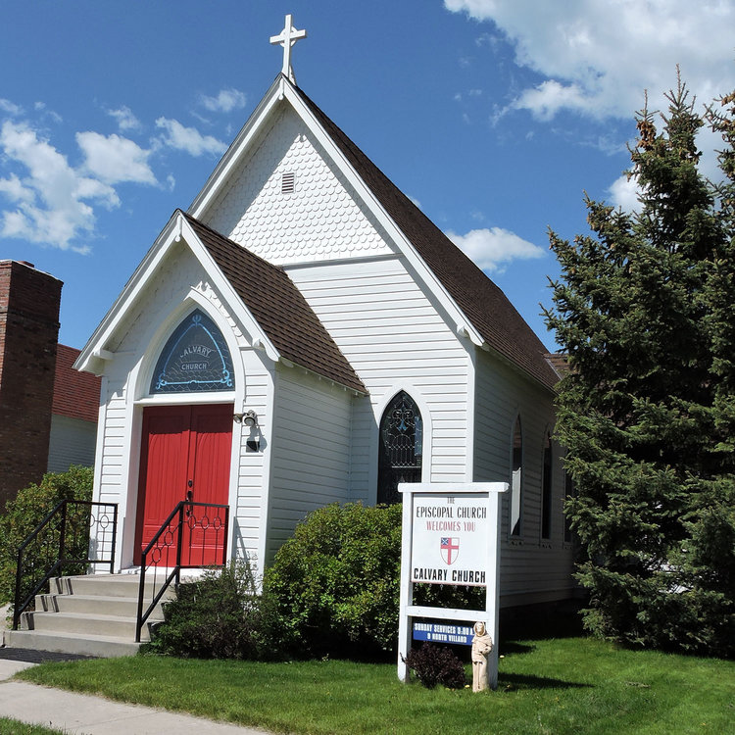

Calvary Episcopal Church, Red Lodge, MT

Whoever you are and wherever you are on your journey of faith,
We welcome you to Calvary Church

