Guide to the Four Gospels
Adapted from Jeffrey Kranz | Jul 6, 2018 |

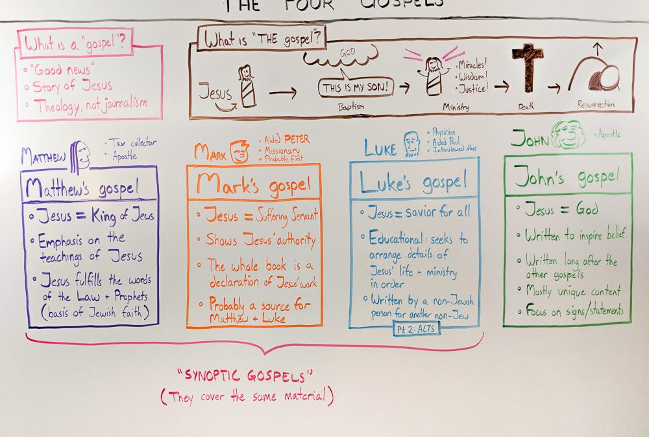

The first four books of the New Testament are known as the Gospels Matthew, Mark, Luke, and John. Each book tells us about the life, ministry, death, and resurrection of Jesus Christ.

Let’s get a high-level overview of these four books, what makes them different, and how they’re similar.

All 4 gospels focus on the story of Jesus
The Gospels are where we find all the famous Bible stories about Jesus. Because each Gospel is about the same main character, they all share several elements.

For example, each of the four gospels follows this general progression:

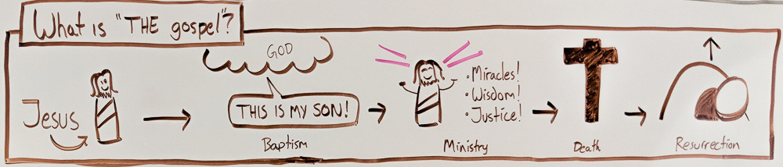

- A statement of Jesus’ divine status
(Mt 1:23; 3:13–17; Mk 1:1, 9–11; Lk 1:32–35; 3:21–22; Jn 1:1, 29–34)
- Jesus’ miracles and teachings
(Mt 4–25; Mk 1–13; Lk 4–19:27; Jn 2–17)
- Jesus’ betrayal, trial, and death
(Mt 26–27; Mk 14–15; Lk 19:28–23:56; Jn 18–19)
- Jesus’ resurrection and encouragement to his followers
(Mt 28:1–15; Mk 16:1–8; Lk 24:1–12; Jn 20:1–10

Why do we need four gospels?

Many people have asked, “Do we really need four gospels in the Bible? That seems redundant. Shouldn’t one do the trick?”

Maybe that would be the case if Jesus were a regular person who just did regular things. But he isn’t, and he didn’t.

John says that the world itself couldn’t hold all the books that could be written about Jesus’ ministry (Jn 21:25). He’s probably being hyperbolic, but if there’s that much to say about Jesus, then we shouldn’t be surprised that we have multiple accounts of him in our Bible.

We have four gospels because during the early church period, four people found it necessary to tell the story of Jesus from four different perspectives. Each gospel was written for a different (original) group of people, by a different author, who was trying to accomplish a different purpose.

Let’s take a closer look at each one:

The Gospel of Matthew

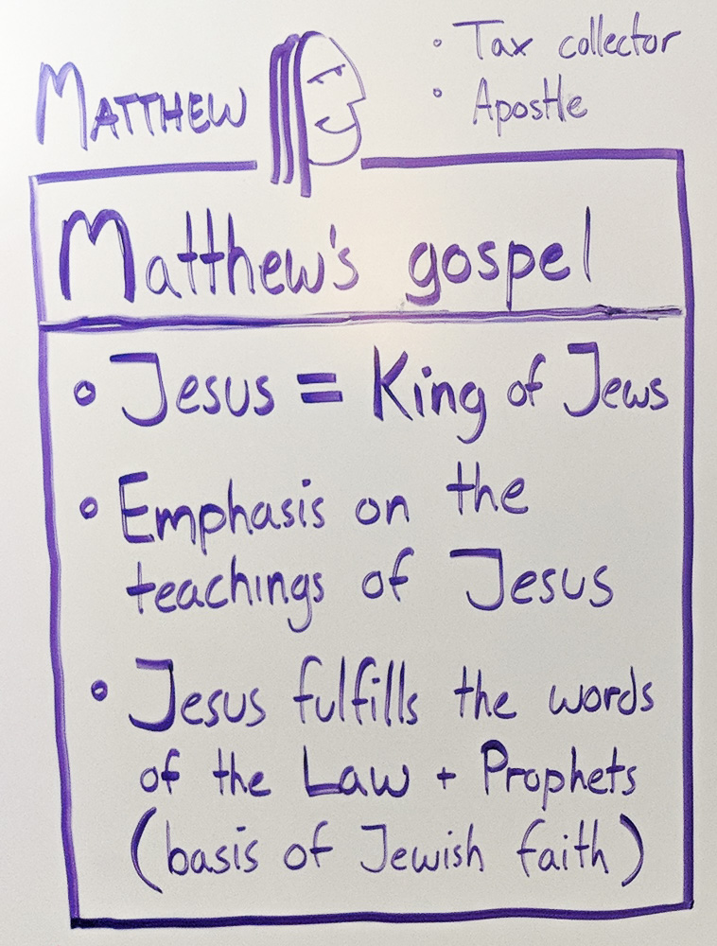

Traditionally penned by the apostle of the same name, Matthew is the first gospel of the four. This gospel was written for people familiar with the Old Testament, both the Law of Moses and the prophets. Matthew makes more references to the Old Testament than any other gospel.
Matthew takes great care to show how Jesus fulfills the prophecies made about him earlier in the Bible—especially focusing on Jesus’ role as the Messiah. (The promised king descended from David.)

Today, Matthew is the perfect book to bridge the gap between the Old Testament and the New. In the famous Sermon on the Mount, Jesus says, “Do not think that I have come to abolish the Law or the Prophets; I have not come to abolish them but to fulfill them” (Mt 5:17).
You can read an overview of Matthew here.

Gospel of Mark

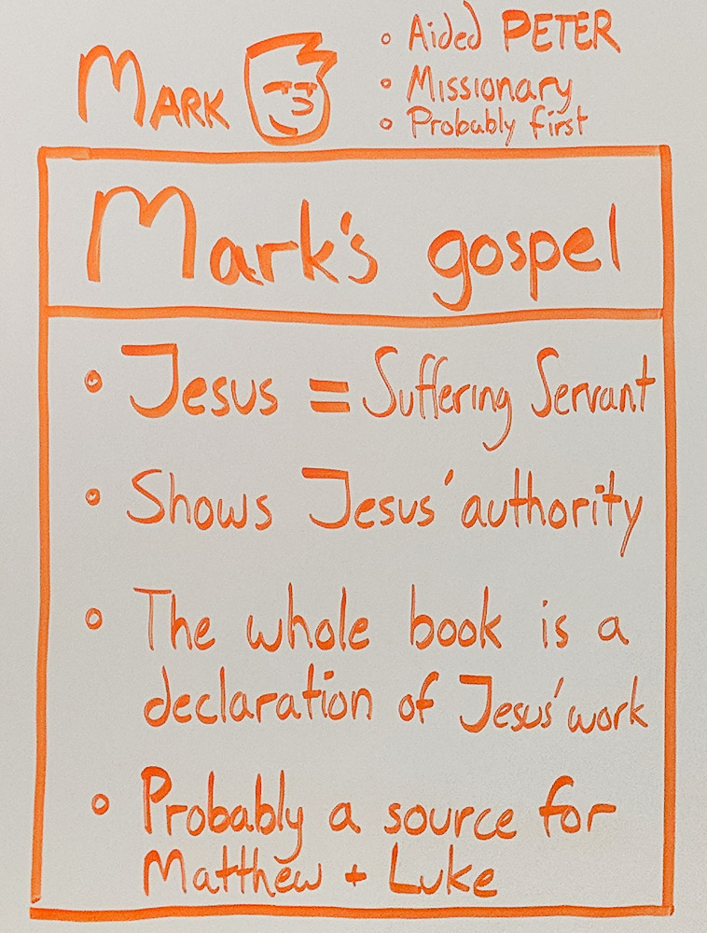

This is the shortest gospel. In fact, it’s possible that this gospel was written so that it could be easily memorized and told aloud—written to “go viral,” if you will.

According to early church tradition, this gospel was written by John Mark, the same guy who backed out of his missionary journey with Paul and Barnabas (Ac 15:37–39). Mark purportedly aided the apostle Peter later in life, and this gospel is an arranged collection of Peter’s memories of Jesus.

Mark was written for a wide audience. This gospel focuses on Jesus’ role as the suffering servant and son of God. While the other gospels contain long discourses and sermons of Jesus, Mark is all about action. This is where we see Jesus doing things, and then doing more things. It’s very action-oriented (the word “immediately” shows up frequently), and of the four gospels, Mark reads most like a story.
You can read an overview of Mark’s gospel here.

The Gospel of Luke

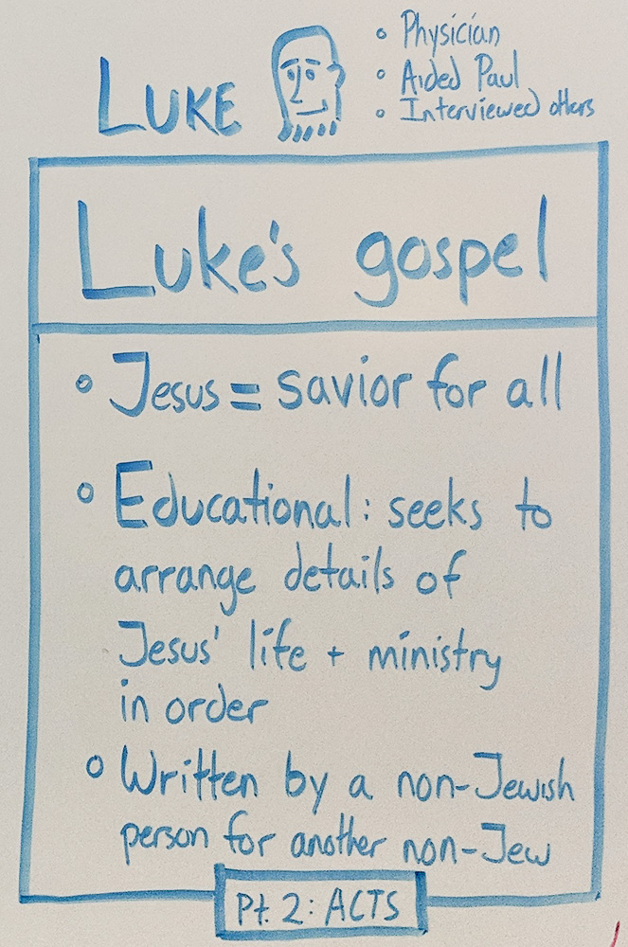

This is the longest of the four gospels—in fact, it’s the longest book of the New Testament for that matter. Luke is the historical, journalistic Gospel: a thorough account of the episodes in Jesus’ life arranged in chronological order. This gospel was written to establish believers in the teachings of Jesus (Lk 1:1–4).

Church tradition recognizes the first-century physician Luke as the author and editor of this book, which is how it gets its name. Luke may be one of the only non-Hebrew authors of the Bible based on a few clues we pick up in the New Testament. This gospel presents Jesus as the seeking savior of all nations (Lk 2:30–32). It was and continues to be a rich story of Jesus’ life and ministry for both those who don’t know much about Jesus and those who have a great deal of familiarity with the Old Testament.
You can read an overview of Luke’s gospel here.

The Gospel of John

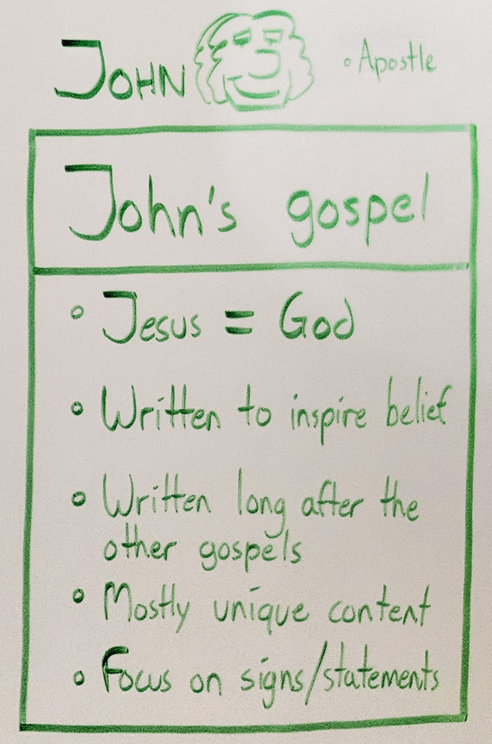

John is the persuasive Gospel. It’s written to show the miracles of Jesus, so that those who read his story will believe in him and have everlasting life (Jn 20:30–31).
John’s account of Jesus’ teachings and miracles emphasize the divine nature of Jesus Christ. To John, Jesus is the cosmic Son of God, come to destroy the works of the devil. The whole book is arranged to present Jesus this way.

That means the gospel of John has a very different feel from the other three. The way the gospel starts is a good example. Mark begins with Jesus’ baptism. Luke begins with the happenings surrounding Jesus’ birth. Matthew begins with Abraham, and traces the generations down to Jesus. But John takes us all the way back to the very first words of the Bible: “In the beginning” (Jn 1:1). John is telling the story of the divine being who became flesh, dwelt among us, and died so that we might have everlasting life.
You can read an overview of John’s gospel here.

How to read the gospels:

The gospels, like the other books of the Bible, were intended to be read in one sitting. That doesn’t mean every time you read from John you need to read the whole thing. But it does mean that if you want to know one of them better, you should set aside an hour or so to read the whole gospel in one go.
This gives you a feel for the general “flow” of the gospel’s narrative. You’ll notice different recurring motifs. You’ll see how the tone shifts in different movements.

As you read the gospels, ask these questions:
- What does Jesus say about himself?
- Whom is Jesus talking to? (This is vital. Is he talking to his disciples, his enemies, a massive crowd?)
- What does Jesus say about God?
- How does Jesus react to different situations? What pleases him? What upsets him?
- What does Jesus tell people to do?

