**First Presbyterian Church**

300 Market Street, Warren, PA 16365-2360

Following Christ So All May Thrive

Office Hours: Monday-Friday 9:00AM-2:00PM

Phone: (814) 723-9200 Fax: (814) 723-6049 E-mail: admin@presbyterianwarren.com

Rev. Rebecca Taylor: (814) 313-1136 (h) (814) 596-8682 (c) Email: rebecca@presbyterianwarren.com

Website: www.presbyterianwarren.com

**April 5, 2020**



**THE SERVICE FOR THE LORD’S DAY**

Palm Sunday

**April 5, 2020 10:00 AM**

*Thank you for silencing your electronic devices.*

**We GATHER in God’s GRACE**

CALL TO WORSHIP (Responsive) (verses from Psalm 31)

L: In you, Lord, I have taken refuge; let me never be put to shame; deliver me in your righteousness.

**P: Turn your ear to me, come quickly to my rescue; be my rock of refuge, a strong fortress to save me.**

L: I trust in you, Lord; I say, “You are my God.”

**P: My times are in your hands! Let your face shine on your servant; save me in your unfailing love.**

*HYMN *All Glory, Laud, and Honor* #196

CALL TO CONFESSION: (based on Acts 10)

If we think that God favors certain people over others, we are mistaken. God accepts everyone who honors and lives for Christ – who is Lord of all. But we know that our lives do not always line up with God’s desires for us. We need God’s grace! Trusting that God wills us to be free in Christ, let us pray together:

PRAYER OF CONFESSION (Unison) [adapted from Prayers for a Privileged People by Walter Brueggemann]

**We look to you, O God, because the world trembles out of control. We confess that we doubt your management even as we claim you as Lord. We confess that we are anxious in this trembling, out-of-control world and so we pray for the strength to move beyond fear to caring, beyond self to neighbor, beyond preservation to growth. We submit our lives to you, O Lord, so that we may be a sign of faithfulness in the world’s unsteadiness. Hear us as we ask for your mercy in Jesus’ name. Amen.**

TIME FOR PERSONAL CONFESSION

**WE RESPOND TO GOD’S GRACE**

WORDS ASSURING US OF GOD’S GRACE (Responsive) (based on Acts 10)

L: Receive this Good News: Christ alone is judge of the living and the dead!

**P: All who believe in him receive forgiveness through his holy name!**

L: Believing that God raised Jesus from the dead, we bear witness to the new life we receive in him!

**P: Praise God! In Christ, we are forgiven and made new!**

*RESPONSE *Glory to God, Whose Goodness Shines on Me* #582

**WE RECEIVE GOD’S WORD**

PRAYER OF ILLUMINATION (Unison):

**Only with the help of your Spirit, O God, can we receive your Word for us today! We ask that you provide us with understanding so that we may live and love and serve in response to your life-giving Word! Hear us as we pray in Jesus’ name. Amen.**

FIRST SCRIPTURE READING Matthew 21:1-11 (Common English Bible)

When they approached Jerusalem and came to Bethphage on the Mount of Olives, Jesus gave two disciples a task. He said to them, “Go into the village over there. As soon as you enter, you will find a donkey tied up and a colt with it. Untie them and bring them to me. If anyone says anything to you, say that their master needs them.” He sent them off right away. Now this happened to fulfill what the prophet said, *Say to Daughter Zion,* “*Look, your king is coming to you, humble and riding on a donkey, and on a colt the donkey’s offspring.*”The disciples went and did just as Jesus had ordered them. They brought the donkey and the colt and laid their clothes on them. Then he sat on them. Now a large crowd spread their clothes on the road. Others cut palm branches off the trees and spread them on the road. The crowds in front of him and behind him shouted, “*Hosanna* to the Son of David! *Blessings on the one who comes in the name of the Lord!* *Hosanna* in the highest!” And when Jesus entered Jerusalem, the whole city was stirred up. “Who is this?” they asked. The crowds answered, “It’s the prophet Jesus from Nazareth in Galilee.”

SECOND SCRIPTURE READING Matthew 27:11-14 (Common English Bible)

Jesus was brought before the governor. The governor said, “Are you the king of the Jews?” Jesus replied, “That’s what you say.” But he didn’t answer when the chief priests and elders accused him. Then Pilate said, “Don’t you hear the testimony they bring against you?” But he didn’t answer, not even a single word. So the governor was greatly amazed.

THE WORD EXPLORED: “Shaken *and* Stirred” Rev. Rebecca Taylor

HYMN *My Song Is Love Unknown* #209

**WE RESPOND TO GOD’S WORD**

PRAYERS OF THE PEOPLE AND THE LORD’S PRAYER (traditional)

**Our Father who art in heaven, hallowed be thy name, thy kingdom come, thy will be done, on earth as it is in heaven. Give us this day our daily bread; and forgive us our debts, as we forgive our debtors; and lead us not into temptation, but deliver us from evil. For thine is the kingdom, and the power, and the glory, forever. Amen.**

*WORDS AFFIRMING OUR FAITH (Unison) (from *A Declaration of Faith*)

**In Christ God gave us a glimpse of the new creation he has already begun and will surely finish. We do not know when the final day will come. In our time we see only broken and scattered signs that the renewal of all things is under way. We do not yet see the end of cruelty and suffering in the world, the church, or our own lives. But we see Jesus as Lord. As he stands at the center of our history, we are confident he will stand at its end. He will judge all people and nations. Evil will be condemned and rooted out of God's good creation. There will be no more tears or pain. All things will be made new. The fellowship of human beings with God and each other will be perfected.**

*HYMN *Ride On! Ride On In Majesty* #198

BENEDICTION: Romans 10:9 (Common English Bible)

Because if you confess with your mouth “Jesus is Lord” and in your heart you have faith that God raised him from the dead, you will be saved.

Remember: you are never alone. You are always held in the love of God, kept in the grace of Jesus the Christ, and accompanied by the Holy Spirit!

  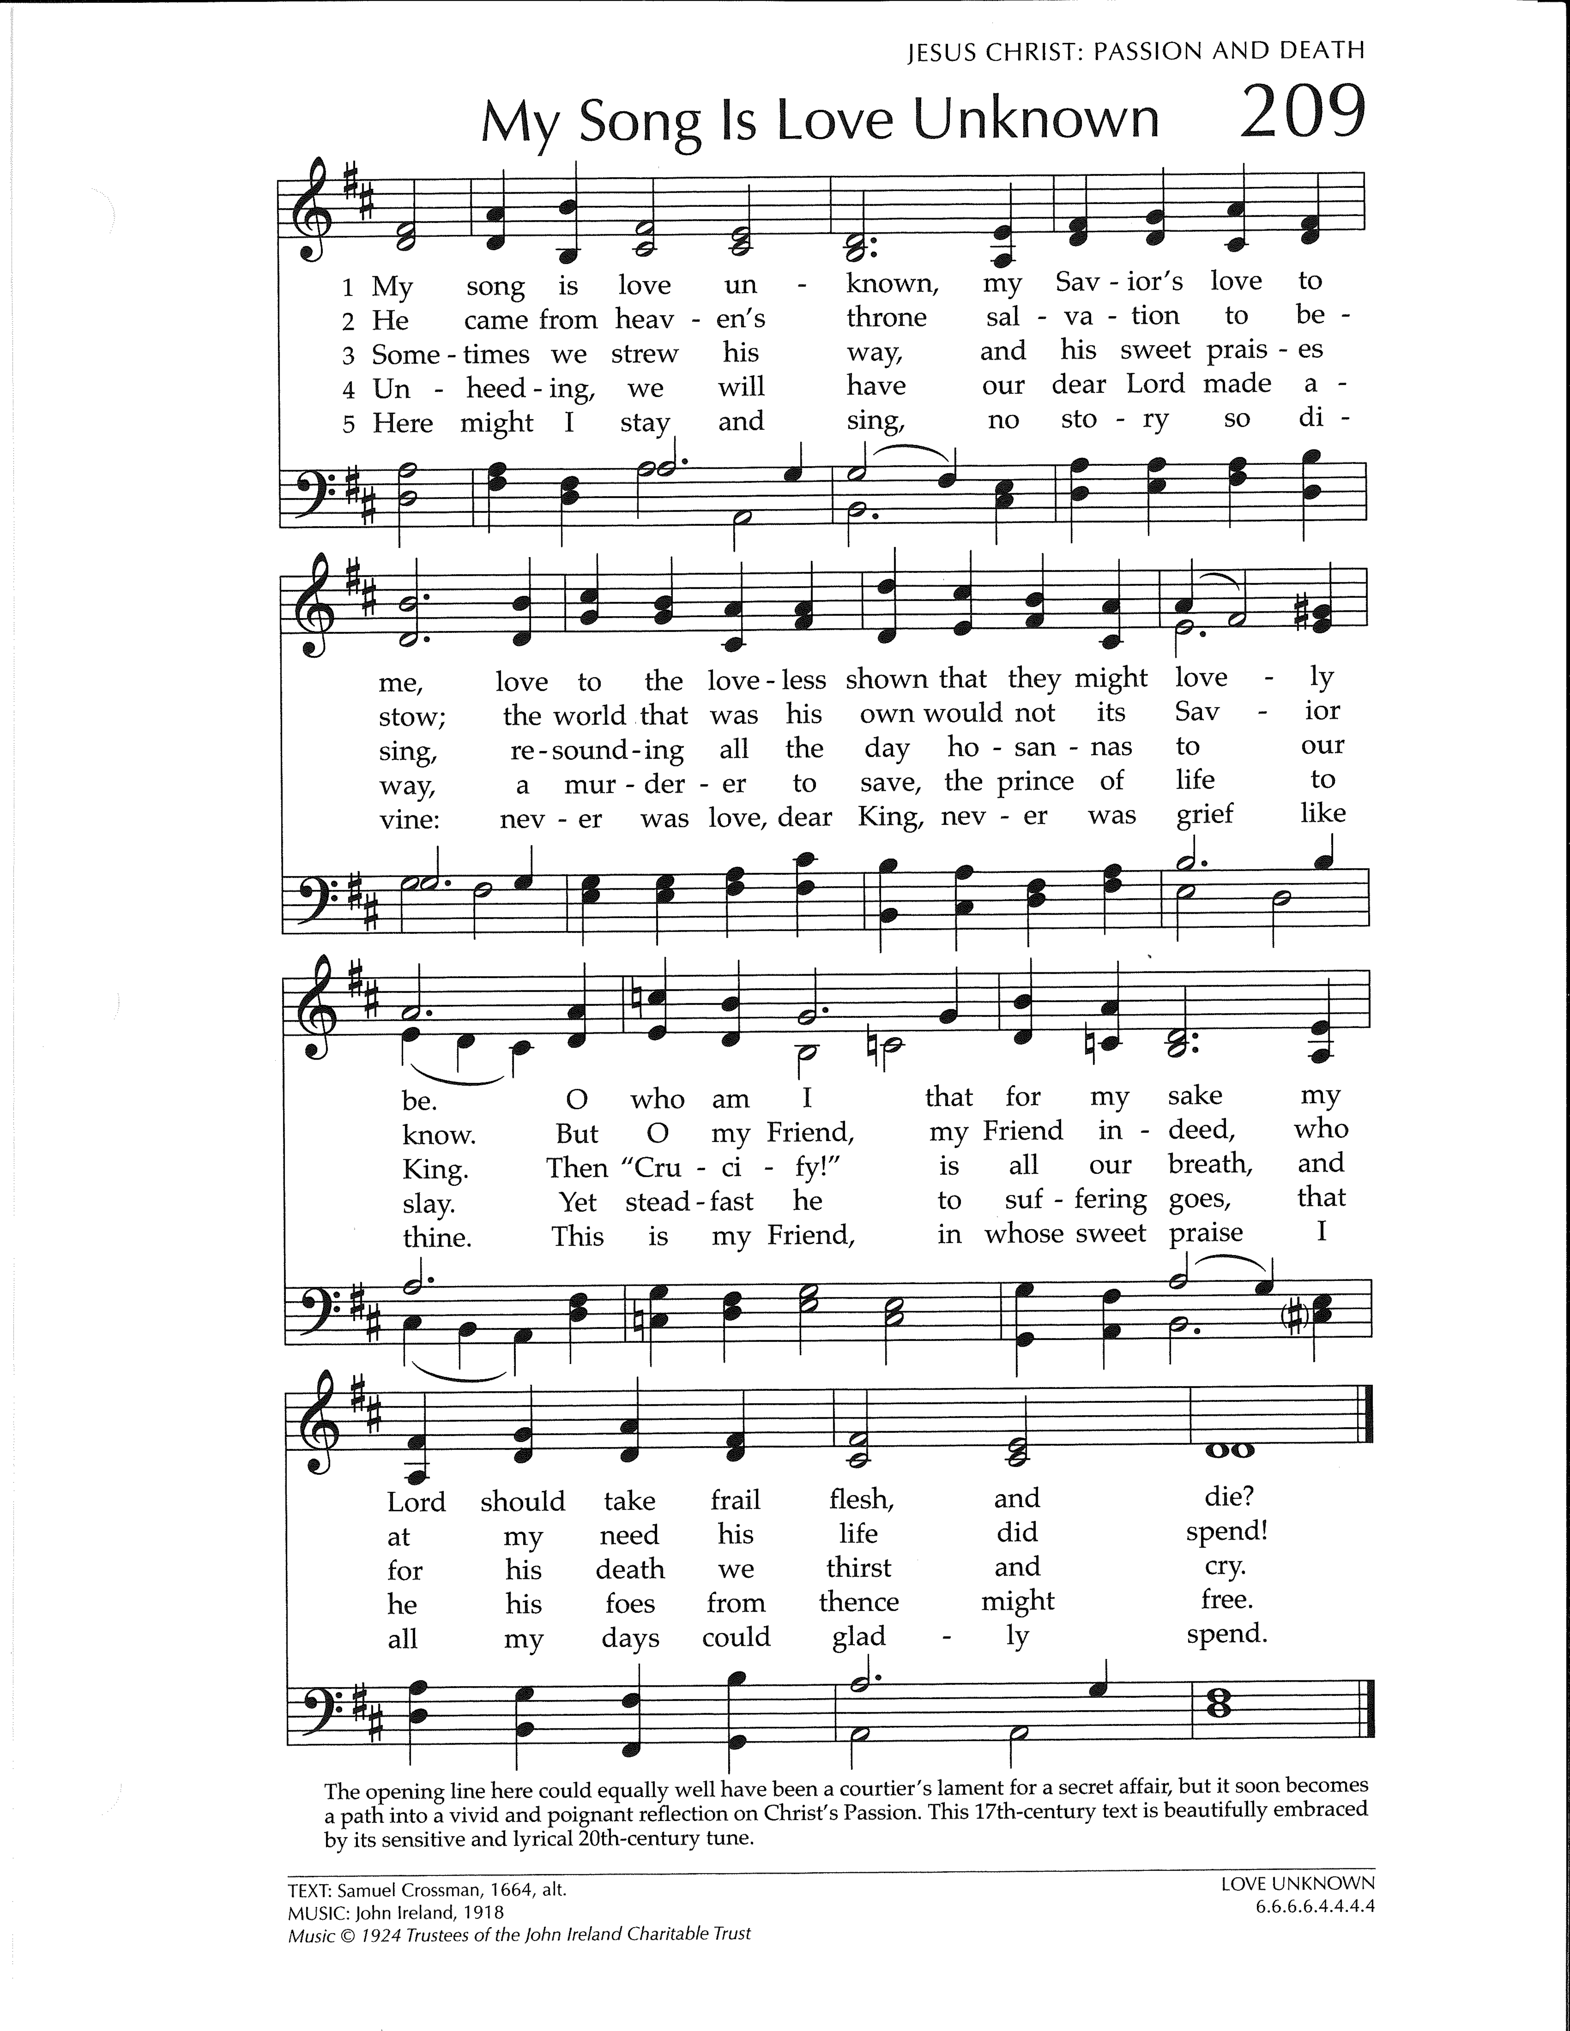 

* THE LECTIONARY READINGS FOR THE NEXT WEEK***

Acts 10:34–43 Colossians 3:1–4

Jeremiah 31:1–6  Acts 10:34–43Psalm 118:1–2, 14–24 John 20:1–18

**Matthew 28:1–10**

Questions for Reflection

When Mary Magdalene first saw the resurrected Jesus, she did not recognize him, even though she knew the tomb was empty. Have you ever experienced the presence of the risen Christ, even when you were not expecting him? Are there times you have been in the presence of the risen Christ but have not recognized him? How would you know?

Household Prayer: Morning

Jesus, victorious Lord, I exult in your resurrection. As I sing “alleluia” with my voice, let my life embody “alleluia” as a testimony to your love and a witness to your eternal life. Amen.

Household Prayer: Evening

Lord, the days of sadness are over, for you have risen from the dead. As you conquered the grave, free your servant from fear of harm or death, that I may rest in peace this night and in the morning rise to sing “alleluia.” Amen.

**Taken from *Feasting on the Word Worship Companion: Liturgies for Year C, Volume 2*. © 2014 Westminster John Knox Press. All rights reserved. Used by permission



**OUR STAFF**

Rev. Rebecca Taylor, Pastor rebecca@presbyterianwarren.com

Hunter Peterson, Director of Music hmpeterson100@gmail.com

Barb Hill, Administrative Assistant admin@presbyterianwarren.com

Betsy Griffin, Financial Secretary [finance@presyterianwarren.com](mailto:finance@presyterianwarren.com)

Events and Communications Coordinator [connect@presbyterianwarren.com](mailto:connect@presbyterianwarren.com)

Kyle Brecht, Property Manager Ben Check, Assist. Property Manager

Courtney Robillard, Childcare Curtis Tyler, Childcare

Lori VanOrd, Childcare Terri Shaw, Childcare

**THE SESSION**

Ross Bryan Joanna Elletson

Rene’ Davis Ann Ferguson

Gale Dyke Ray Pring

Larry Dyke Carrie Salapek

Jim Eggleston Lynn Sears

Vickie Eggleston

**\*\*\* ANNOUNCEMENTS AND EVENTS \*\*\***

**PALMS**-will be available outside the Market Street doors beginning Saturday morning, April 4th for you to take one per household as long as supplies last.

**EASTER HOLIDAY HOT MEALS**-have been postponed. Information will be published once a new date has been set.

**ADDITION TO THE CHURCH DIRECTORY**-

Lila and Jim Hookins Lila (cell) 727-271-1255

Warren Apartments, #102 Jim (cell) 727-271-1155

209 Market Street

Warren, PA 16365

**ONE GREAT HOUR OF SHARING-**Join in God’s call to share our bread with the hungry, to aid and shelter people overcoming catastrophe and conflict, and to resource communities working to cast off the bonds of poverty and oppression. Gifts will be received through Sunday, April 12, 2020. Online donations may be designated for One Great Hour of Sharing.

**BEING RESCHEDULED:** A BEAUTIFUL DAY IN THE NEIGHBORHOOD!

**SHARING PLACE-**For the foreseeable future we are not having the host churches send their teams. If you’d like to provide something, cookies would be great! We’ve decided that they are the easiest and most ‘adaptable’ dessert.

**PRESBYTERY HOLY WEEK DEVOTIONALS-**The Lake Erie Presbytery will be offering brief daily videos from Palm Sunday, April 5th to Easter Sunday, April 12th. You can access the website at www.pbylakeerie.org. Rev. Rebecca Taylor will be providing the devotional on Monday, April 6, 2020.

**\*\*\* JOYS AND CONCERNS \*\*\***

**Joys:**

The Caring Connection that gathers monthly at Warren Apartments

**Concerns:**

Prayers for Janice & Don O’Neil, Lila Hookins’ sister & brother-in-law, hospitalized with Coronavirus

Prayers for Connor and Christian

Prayers for Joyce Hill who suffered a fall

Prayers for Dorothy Collins, who is now home

Prayers for Bill

Prayers for Mary Schorman, recovering from surgery

Prayers of healing for Wanda Monts

Courage, Strength and Faith to Larfay Austin Jr during his incarceration

Prayers for Sherry Walter who is now residing with her daughter, Kim

Prayers for Carinne Palm, Vickie Eggleston’s sister, undergoing radiation treatments

Prayers for Trevor, recovering from shoulder surgery

Prayers for Susan Wenzel, who has health concerns

Prayers for Lynda Slocum’s son Andy and grandson, Brayden

Prayers for Lois Buerkle, Lynn Sears’ sister, as she undergoes treatments for cancer

Prayers for Andy Yurick

Prayers for Tristan Dolan

Prayers for Louise Crozier and family

Prayers for Katie Roth Spiegel, who is undergoing treatment for cancer

Prayers for Wally Post

Prayers for Lisa Huey Hochberg and others struggling with dementia and alzheimer’s

Prayers for Seth

Prayers for Margaret Taylor, Rebecca’s mother, under Hospice care

Prayers for our members and friends residing in care facilities

Prayers for those affected by the Coronavirus.

Courage, strength, and faith to all those affected by violent crimes.

Those serving in our military, people struggling with addiction, and those in jail

Those facing famine and hunger in remote and desolate places.

Let the Light of the Lord shine on all peoples in all nations

**\*\*\* PRESBYTERY JOYS AND PRAYER CONCERNS \*\*\***

We pray for the churches and ministerial staff that constitute the Lake Erie Presbytery. This week we pray for Endeavor, Commissioned Pastor, Roger Snyder and Co Moderator of 222nd General Assembly Rev. Cindy Kohlman and Elder Vilmarie Cintron-Olivieri.

Coronavirus — What You Need to Know

The 2019 Novel Coronavirus (COVID-19) is a virus first detected in Wuhan, China, that has caused an outbreak of respiratory illness. The current outbreak has spread internationally, impacting an increasing number of countries. In the United States, imported cases of coronavirus infection in travelers have been detected and person-to-person spread of the virus also has been seen among close contacts of returned travelers from China. On February 25, 2020, the CDC confirmed COVID-19 in an individual who reportedly did not have relevant travel history or exposure to another known patient.

According to the [Centers for Disease Control and Prevention (CDC)](http://www.cdc.gov/ncov), most people in the United States have little immediate risk of exposure to this virus. The virus is not currently spreading widely in the United States. However, it is likely that person-to-person spread will continue to occur and that, at some point, widespread transmission of COVID-19 in the United States will occur.

**Action Steps**

1. Stay informed – the situation with the coronavirus is fluid and the [CDC](http://www.cdc.gov/ncov) is updating its website daily with the latest information and advice for the public.
2. Remember to take everyday preventive actions that are always recommended to prevent the spread of respiratory viruses:
   * Avoid close contact with sick people.
   * While sick, limit contact with others as much as possible. Stay home if you are sick.
   * Cover your nose and mouth when you cough or sneeze. Avoid touching your eyes, nose and mouth. Germs spread this way.
   * Clean and disinfect surfaces and objects that may be contaminated with germs.
   * Wash your hands often with soap and water for at least 20 seconds. If soap and water are not available, use an alcohol-based hand rub with at least 60% alcohol.
3. The CDC and State Department have issued advisories asking people to avoid all nonessential travel to China and South Korea at this time. Travel alerts have also been issued for Japan, Italy and Iran.

Given the rapidly-evolving situation with COVID-19, it is prudent to revisit your organization’s emergency preparedness plans, including any pandemic planning. The CDC has made [pre-pandemic planning guides](https://www.cdc.gov/nonpharmaceutical-interventions/tools-resources/planning-guidance-checklists.html) available for community and faith-based organizations, educational institutions, workplaces and individual households.