**THIRD SUNDAY**

**OF EASTER**

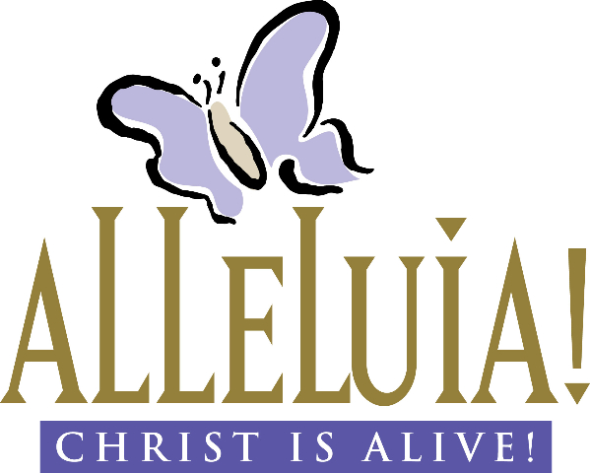

**First Presbyterian Church**

300 Market Street, Warren, PA 16365-2360

Following Christ So All May Thrive

Office Hours: Monday-Friday 9:00AM-2:00PM

Phone: (814) 723-9200 Fax: (814) 723-6049 E-mail: admin@presbyterianwarren.com

Rev. Rebecca Taylor: (814) 313-1136 (h) (814) 596-8682 (c) Email: rebecca@presbyterianwarren.com

Website: www.presbyterianwarren.com

**April 26, 2020**

**THE SERVICE FOR THE LORD’S DAY**

Third Sunday of Easter

**April 26, 2020 10:00 AM**

_______________________________________________________________________________________

*Thank you for silencing your electronic devices.*

**We GATHER in God’s GRACE**

PRELUDE:

CALL TO WORSHIP (Responsive)

L: Let the people assemble; God calls each one of us by name.

**P: The promises of God are to us and our children, and to sisters and brothers near and far.**

L: We gather as a community of faith, united in mutual concern and caring.

**P: Here we break bread, learn, and pray together, and join in outreach to a needy world.**

L: May our eyes and ears be open to the special message this hour holds for us.

**P: We will listen for God’s living and abiding Word and strive to be obedient to the truth.**

*HYMN *Sing Praise to God Who Reigns Above* #645

CALL TO CONFESSION: (based on Acts 10)

If we think that God favors certain people over others, we are mistaken. God accepts everyone who honors and lives for Christ – who is Lord of all. But we know that our lives do not always line up with God’s desires for us. We need God’s grace! Trusting that God wills us to be free in Christ, let us pray together:

PRAYER OF CONFESSION (Responsive) (adapted from Prayers for a Privileged People by Walter Brueggemann)

L: We confess before you, O God, that we set out to be your faithful people and then we fall into an unintended brokenness.

**P: We are aware of our alienation from you, our sense of shame and loss in our relationships with others, and we feel deep remorse.**

L: We know that we have no secrets not already known to you, so we face you without pretense of innocence.

**P: We ask forgiveness and wait, even a very long time.**

L: We trust your unfailing love, your willing generosity, your readiness to remember our sin no more!

**P: We ask that you give us yourself again without judgment – after we have judged ourselves.**

L: Enable us to hear and respond to your invitation anew: to your presence, to the table of your feast, to your walk of companionship, to your mission of wellbeing.

**P: Be our Easter this day, drawing us from death to new life, and we will begin again in obedience, in wonder, and in love! Hear us as we ask for your mercy in Jesus’ name. Amen.**

TIME FOR PERSONAL CONFESSION

WORDS ASSURING US OF GOD’S GRACE (Responsive) (based on Acts 10)

L: Receive this Good News: Christ alone is judge of the living and the dead!

**P: All who believe in him receive forgiveness through his holy name!**

L: Believing that God raised Jesus from the dead, we bear witness to the new life we receive in him!

**P: Praise God! In Christ, we are forgiven and made new!**

**WE RECEIVE GOD’S WORD**

*RESPONSE *Glory to God, Whose Goodness Shines on Me* #582

PRAYER OF ILLUMINATION (Unison):

**Only with the help of your Spirit, O God, can we receive your Word for us today! We ask that you provide us with understanding so that we may live and love and serve in response to your life-giving Word! Hear us as we pray in Jesus’ name. Amen.**

FIRST SCRIPTURE READING Luke 24:13-17 (Common English Bible)

On that same day, two disciples were traveling to a village called Emmaus, about seven miles from Jerusalem. They were talking to each other about everything that had happened. While they were discussing these things, Jesus himself arrived and joined them on their journey. They were prevented from recognizing him. He said to them, “What are you talking about as you walk along?” They stopped, their faces downcast.

SECOND SCRIPTURE READING Acts 2:36-42 (Common English Bible)

“Therefore, let all Israel know beyond question that God has made this Jesus, whom you crucified, both Lord and Christ.” When the crowd heard this, they were deeply troubled. They said to Peter and the other apostles, “Brothers, what should we do?” Peter replied, “Change your hearts and lives. Each of you must be baptized in the name of Jesus Christ for the forgiveness of your sins. Then you will receive the gift of the Holy Spirit. This promise is for you, your children, and for all who are far away—as many as the Lord our God invites.” With many other words he testified to them and encouraged them, saying, “Be saved from this perverse generation.” Those who accepted Peter’s message were baptized. God brought about three thousand people into the community on that day. The believers devoted themselves to the apostles’ teaching, to the community, to their shared meals, and to their prayers.

SERMON: To the Church of God That Is in Warren Rev. Dr. David Oyler

**WE RESPOND TO GOD’S WORD**

PRAYERS OF THE PEOPLE AND THE LORD’S PRAYER (traditional)

**Our Father who art in heaven, hallowed be thy name, thy kingdom come, thy will be done, on earth as it is in heaven. Give us this day our daily bread; and forgive us our debts, as we forgive our debtors; and lead us not into temptation, but deliver us from evil. For thine is the kingdom, and the power, and the glory, forever. Amen.**

*WORDS AFFIRMING OUR FAITH (Unison) (from *A Declaration of Faith*)

**Gathered around the Word and sacraments, those who confess Jesus Christ as Lord and Savior, together with their children, have formed a corporate, visible body in pilgrimage with God across the centuries. The church has sought to order its life and ministry in obedience to the teaching of the first apostles. It has attempted to carry out Christ's commission in various institutional forms and structures that demonstrate both continuity and change.**

**We acknowledge that Christ chooses to be known in the world through this community of ordinary people, therefore we dare not despise or abandon the church. Christ is the head of the church; therefore we are responsible to Christ when we make policy and decisions in the church. Christ is the foundation of the church; therefore it will not fall despite our weakness. We are confident that the Lord of the church will judge and defeat our sinful intentions and actions, help us in our weakness and blindness, and use the church to accomplish his purposes.**

*HYMN *Come! Live in the Light!* #749

*BENEDICTION

Remember: you are never alone. You are always held in the love of God, kept in the grace of Jesus the Christ, and accompanied by the Holy Spirit!

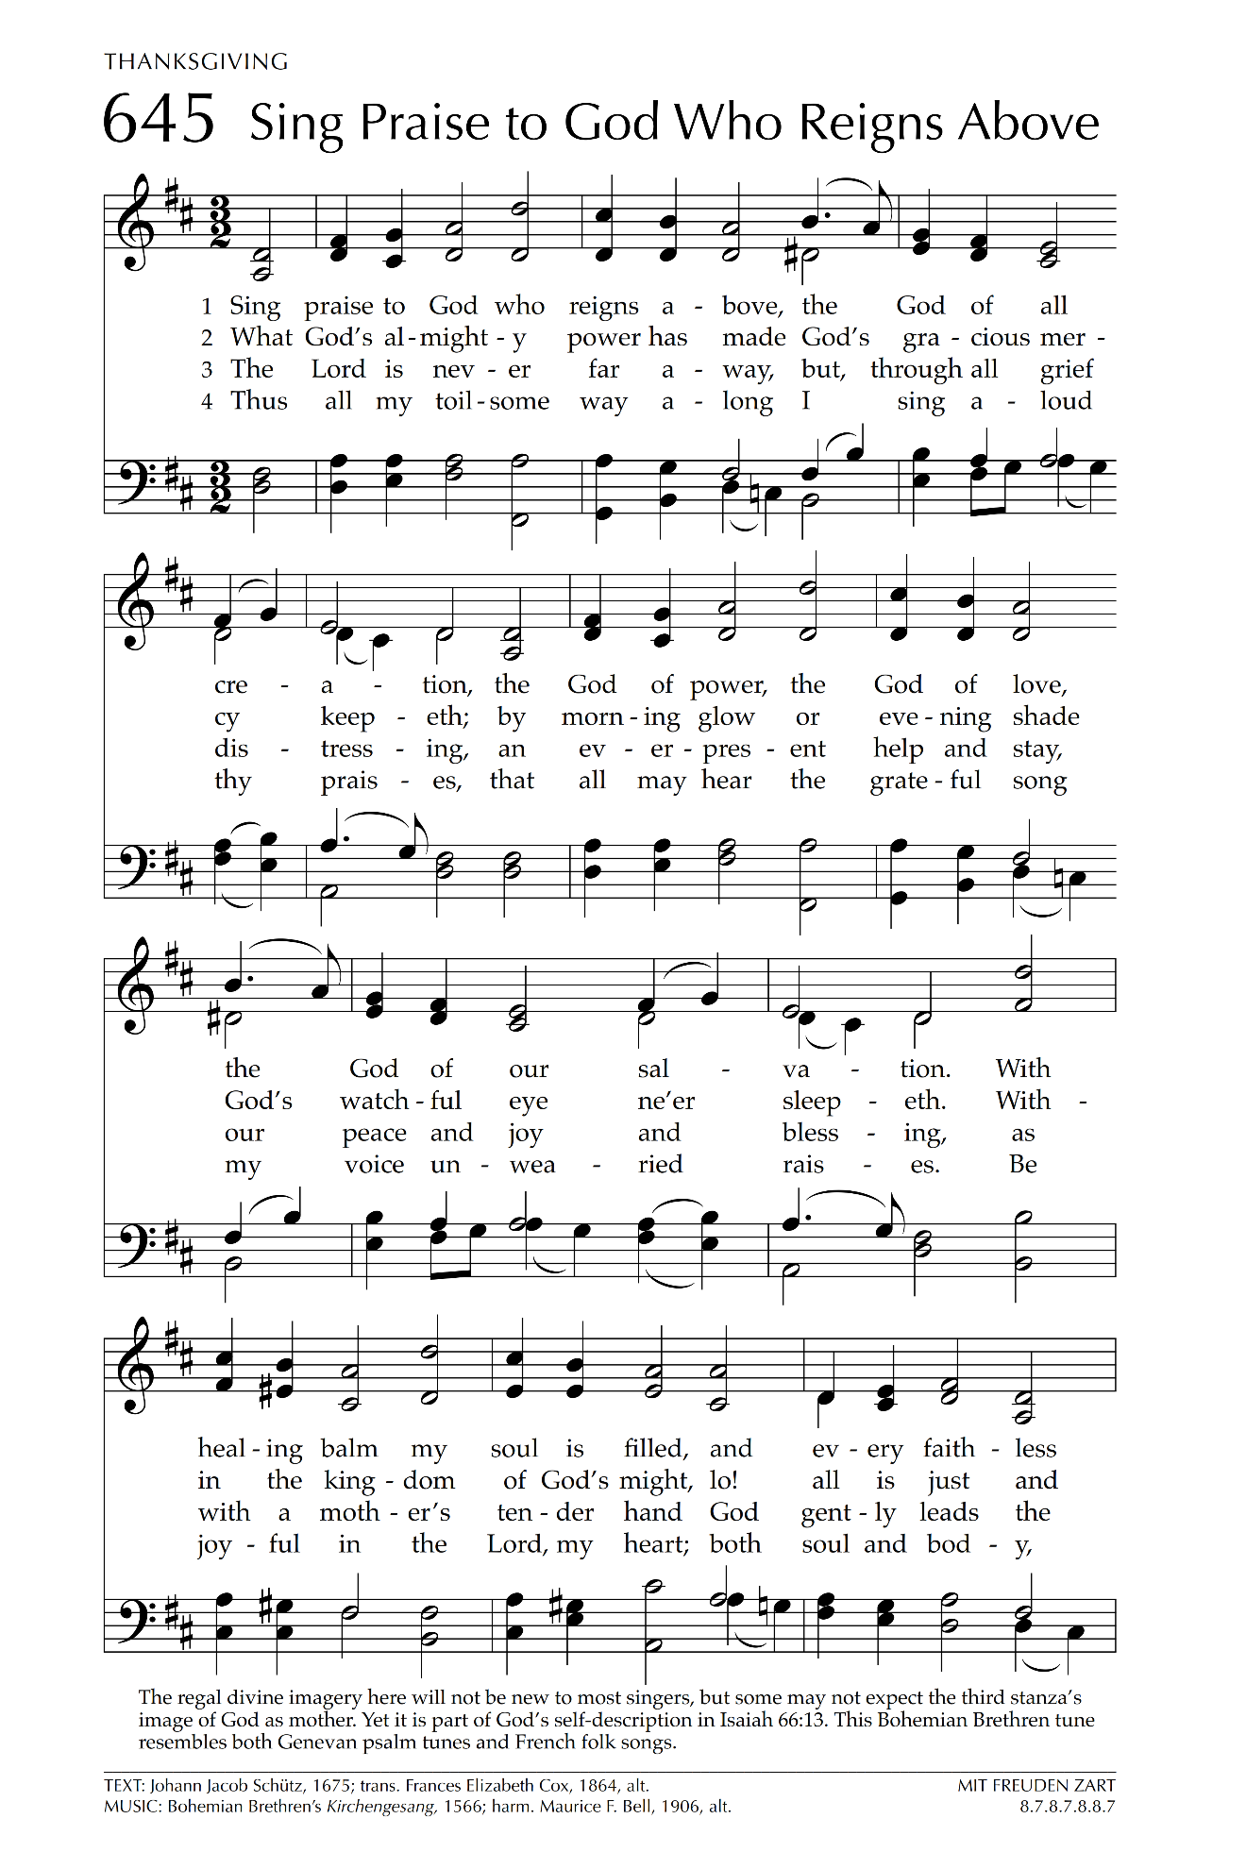

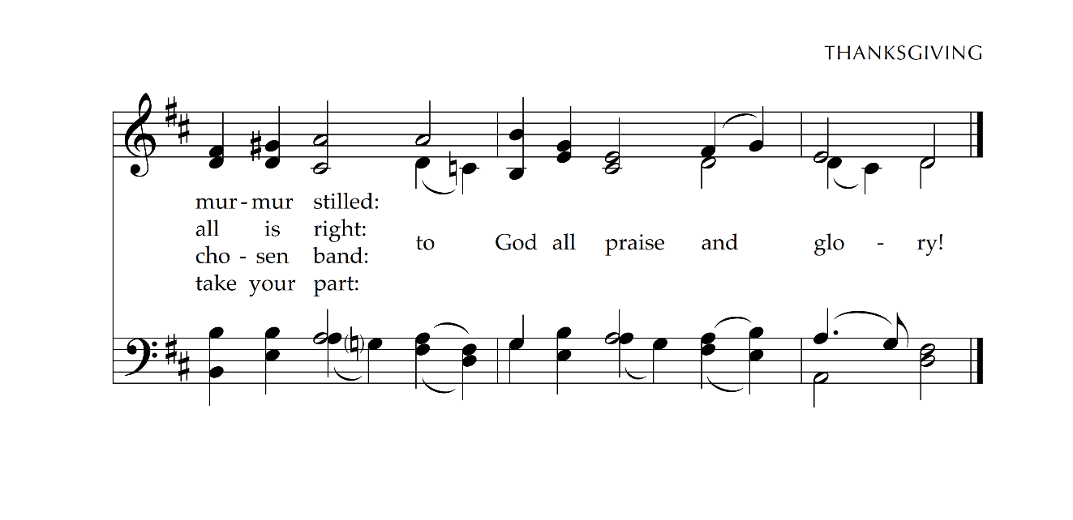

 

* THE LECTIONARY READINGS FOR THE NEXT WEEK***

**Acts 2:42–47 1 Peter 2:19–25**

Psalm 23 John 10:1–10

Questions for Reflection

Acts 2:42–47 describes what life was like in the early church. How do these words guide today’s church?

Household Prayer: Morning

Generous God, thank you for the gift of this new day. Help me to watch for your signs and wonders in the world today and fill my heart with gladness and generosity, that I may generate good will wherever I go. Amen.

Household Prayer: Evening

Thank you, God, for shepherding me through this day. As I lie down to sleep this night help me to imagine green pastures and still waters, and to remember all the ways you have set a table before me and filled my cup to overflowing. Amen.

**Taken from *Feasting on the Word Worship Companion: Liturgies for Year C, Volume 2*. © 2014 Westminster John Knox Press. All rights reserved. Used by permission.



**OUR STAFF**

Rev. Rebecca Taylor, Pastor rebecca@presbyterianwarren.com

Hunter Peterson, Director of Music hmpeterson100@gmail.com

Barb Hill, Administrative Assistant admin@presbyterianwarren.com

Betsy Griffin, Financial Secretary [finance@presyterianwarren.com](mailto:finance@presyterianwarren.com)

Events and Communications Coordinator [connect@presbyterianwarren.com](mailto:connect@presbyterianwarren.com)

Kyle Brecht, Property Manager Ben Check, Assist. Property Manager

Courtney Robillard, Childcare Curtis Tyler, Childcare

Lori VanOrd, Childcare Terri Shaw, Childcare

**THE SESSION**

Ross Bryan Joanna Elletson

Rene’ Davis Ann Ferguson

Gale Dyke Ray Pring

Larry Dyke Carrie Salapek

Jim Eggleston Lynn Sears

Vickie Eggleston

**\*\*\* ANNOUNCEMENTS AND EVENTS \*\*\***

**THE REVEREND DR. DAVID OYLER** is the special guest preacher today, Sunday, April 26, 2020.

**BULLETINS** will no longer be mailed to everyone after Sunday, April 26, 2020. Mailings will continue to those without email access. These will be available on the website: www.presbyterianwarren.com

**EASTER HOLIDAY HOT MEALS**-have been postponed. Information will be published once a new date has been set.

**ONE GREAT HOUR OF SHARING-**Join in God’s call to share our bread with the hungry, to aid and shelter people overcoming catastrophe and conflict, and to resource communities working to cast off the bonds of poverty and oppression. Gifts will be received through this Sunday, **April 26, 2020**. Online donations may be designated for One Great Hour of Sharing.

**BEING RESCHEDULED:** A BEAUTIFUL DAY IN THE NEIGHBORHOOD!

**SHARING PLACE-**For the foreseeable future we are not having the host churches send their teams.

**\*\*\* JOYS AND CONCERNS \*\*\***

**Joys:**

Janice & Don O’Neil, Lila Hookins’ sister & brother-in-law, hospitalized with Coronavirus, now able to be up and moving around in their hospital room.

Bob Sears who is training to assist in leading Bible Studies at SCI Cambridge Springs

**Concerns:**

Prayers for our members and friends residing in care facilities and receiving care at home

Prayers for those affected by the Coronavirus and those in the medical community attending to the sick

Prayers for Sam Salapek who will be having surgery this week

Prayers for Connor and Christian

Prayers for Bill

Prayers for Mary Schorman, recovering from surgery

Prayers of healing for Wanda Monts

Courage, Strength and Faith to Larfay Austin Jr during his incarceration

Prayers for Carinne Palm, Vickie Eggleston’s sister, undergoing radiation treatments

Prayers for Trevor, recovering from shoulder surgery

Prayers for Susan Wenzel, who has health concerns

Prayers for Lynda Slocum’s son Andy and grandson, Brayden

Prayers for Lois Buerkle, Lynn Sears’ sister, as she undergoes treatments for cancer

Prayers for Andy Yurick

Prayers for Louise Crozier and family

Prayers for Katie Roth Spiegel, who is undergoing treatment for cancer

Prayers for Wally Post

Prayers for Lisa Huey Hochberg and others struggling with dementia and alzheimer’s

Prayers for Seth

Prayers for Margaret Taylor, Rebecca’s mother, under Hospice care

Prayers for our members and friends residing in care facilities

Prayers for those affected by the Coronavirus.

Courage, strength, and faith to all those affected by violent crimes.

Those serving in our military, people struggling with addiction, and those in jail

Those facing famine and hunger in remote and desolate places.

Let the Light of the Lord shine on all peoples in all nations

**\*\*\* PRESBYTERY JOYS AND PRAYER CONCERNS \*\*\***

We pray for the churches and ministerial staff that constitute the Lake Erie Presbytery. This week we pray for Ripley, Commissioned Pastor, Phil Johnson and Rev. Carl Hull, Honorably Retired and Rev. Joe Filer, Honorably Retired.