**First Presbyterian Church**

300 Market Street, Warren, PA 16365-2360

Following Christ So All May Thrive

Office Hours: Monday-Friday 9:00AM-2:00PM

Phone: (814) 723-9200 Fax: (814) 723-6049 E-mail: admin@presbyterianwarren.com

Rev. Rebecca Taylor: (814) 313-1136 (h) (814) 596-8682 (c) Email: rebecca@presbyterianwarren.com

Website: www.presbyterianwarren.com

**June 7, 2020**



**THE SERVICE FOR THE LORD’S DAY**

Trinity Sunday

**June 7, 2020 10:00 AM**

*Thank you for silencing your electronic devices.*

**We GATHER in God’s GRACE**

PRELUDE  *Ave Maria*  Sergei Rachmaninoff

CALL TO WORSHIP (Responsive) (verses from Psalm 8)

L: When I look up at your skies, at what your fingers made, O God— the moon and the stars that you set firmly in place—

**P: What are human beings that you think about us; what are human beings that you pay attention to us?**

L: You’ve made us only slightly less than divine, crowning us with glory and grandeur!

**P: Lord, our Lord, how majestic is your name throughout the earth!**

*HYMN *Holy, Holy, Holy! Lord God Almighty!* #1

CALL TO CONFESSION: (based on Ephesians 2)

We are certain that our lives would be so much less than they are if it were not for God’s grace bringing us fullness of life through the richness of God’s mercy! Yet we are also certain that we do not honor the gift of God’s grace because we forget that who we are is God’s accomplishment. Trusting that we will be renewed by admitting our need for God’s grace, let us pray together:

PRAYER OF CONFESSION (Unison)

**Holy God, we know that we need you but we don’t always know how to ask for what we need! We thank you that you never give up on us, and that you are working on our behalf even if we fail to understand how! Strengthen us with your grace and hold us in your love! Help us accept your help that we may live more freely and fully for you! Hear us as we ask for your mercy in Jesus’ name. Amen.**

TIME FOR PERSONAL CONFESSION

WORDS ASSURING US OF GOD’S GRACE (Responsive) (based on Ephesians 2)

L: This is Good News: God saves us in grace and brings us the peace of Christ!

**P: We are reconciled to God through Christ’s death on the cross!**

L: In Christ we are forgiven and have become a living temple filled with God’s Spirit!

**P: We belong to God! Praise our Lord Jesus Christ!**

*RESPONSE *Glory to God, Whose Goodness Shines on Me* #582

**WE RECEIVE GOD’S WORD**

PRAYER OF ILLUMINATION (Unison):

**Grant us grace to hear you, O God, as you speak to us today! Grant us love to live for you, O Lord, as you lead us this day! Hear us as we pray in Jesus’ name. Amen.**

FIRST SCRIPTURE READING Genesis 1:1-5 (Common English Bible)

When God began to createthe heavens and the earth—the earth was without shape or form, it was dark over the deep sea, and God’s wind swept over the waters—God said, “Let there be light.” And so light appeared. God saw how good the light was. God separated the light from the darkness. God named the light Day and the darkness Night. There was evening and there was morning: the first day.

SECOND SCRIPTURE READING II Corinthians 13:11-13 (Common English Bible)

Finally, brothers and sisters, good-bye. Put things in order, respond to my encouragement, be in harmony with each other, and live in peace—and the God of love and peace will be with you. Say hello to each other with a holy kiss. All of God’s people say hello to you. The grace of the Lord Jesus Christ, the love of God, and the fellowship of the Holy Spirit be with you all.

SERMON: Whatever It Takes Rev. Rebecca Taylor

**WE RESPOND TO GOD’S WORD**

OFFERING

*Please consider sending your gift through the mail or by utilizing the online giving function on the church’s website! God’s mission continues!*

PRAYERS OF THE PEOPLE AND THE LORD’S PRAYER (traditional)

**Our Father who art in heaven, hallowed be thy name, thy kingdom come, thy will be done, on earth as it is in heaven. Give us this day our daily bread; and forgive us our debts, as we forgive our debtors; and lead us not into temptation, but deliver us from evil. For thine is the kingdom, and the power, and the glory, forever. Amen.**

*WORDS AFFIRMING OUR FAITH (Unison) (The Apostles’ Creed)

**I believe in God the Father Almighty, Maker of heaven and earth, and in Jesus Christ his only Son our Lord; who was conceived by the Holy Ghost, born of the Virgin Mary, suffered under Pontius Pilate, was crucified, dead, and buried; he descended into hell; the third day he rose again from the dead; he ascended into heaven, and sitteth on the right hand of God the Father Almighty; from thence he shall come to judge the quick and the dead. I believe in the Holy Ghost; the holy catholic Church; the communion of saints; the forgiveness of sins; the resurrection of the body; and the life everlasting. Amen.**

*HYMN *We Are One In the Spirit* #300

*BENEDICTION I Corinthians 14:7, 12 (Common English Bible)

Likewise, things that aren’t alive like a harp or a lyre can make a sound, but if there aren’t different notes in the sounds they make, how will the tune from the harp or the lyre be recognized? The same holds true for you: since you are ambitious for spiritual gifts, use your ambition to try to work toward being the best at building up the church.

Remember: you are never alone. You are always held in the love of God, kept in the grace of Jesus the Christ, and accompanied by the Holy Spirit!

* THE LECTIONARY READINGS FOR THE NEXT WEEK***

**Genesis 18:1–15** (21:1–7) **Romans 5:1–5**

Psalm 116:1–2, 12–19 Matthew 9:35–10:8 (9–23)

Questions for Reflection

How is God’s presence experienced in a Christian’s life?

Household Prayer: Morning

Holy Presence, let me be with you today. Awaken my senses to the wonders of your creation, and fill me with compassion for every person I meet. Protect me from those who would hurt me; make me watchful so that I do not harm anyone. Fill my inward being with the love of Christ, and inasmuch as it is possible, let others know your presence through me. In this way let me glorify you, Holy One, Holy Three. Amen.

Household Prayer: Evening Maker of day and night, creator of sun, moon, and all planets and stars, thank you for your protection during the hours I have passed in your light. Guard me, I pray, through the coming dark. As I settle into sleep, recall to my mind each blessing you gave me while I was awake so that I can rejoice in your goodness. Grant me peace, rest, and renewal as I close my eyes in your presence. Watch over me while I am helpless in the world. If it is your will to speak to me in dreams while my mind is quieted and still, grant that I may be attentive to your Word and guided by your Spirit when I awake to a new day. Let me arise and join my voice with all the faithful in giving you thanks and praise through Jesus Christ, the Light. Amen.

**Taken from *Feasting on the Word Worship Companion: Liturgies for Year C, Volume 2*. © 2014 Westminster John Knox Press. All rights reserved. Used by permission.



**OUR STAFF**

Rev. Rebecca Taylor, Pastor rebecca@presbyterianwarren.com

Hunter Peterson, Director of Music hmpeterson100@gmail.com

Barb Hill, Administrative Assistant admin@presbyterianwarren.com

Betsy Griffin, Financial Secretary [finance@presyterianwarren.com](mailto:finance@presyterianwarren.com)

Events and Communications Coordinator [connect@presbyterianwarren.com](mailto:connect@presbyterianwarren.com)

Kyle Brecht, Property Manager Ben Check, Assist. Property Manager

Courtney Robillard, Childcare Curtis Tyler, Childcare

Lori VanOrd, Childcare Terri Shaw, Childcare

**THE SESSION**

Ross Bryan Joanna Elletson

Rene’ Davis Ann Ferguson

Gale Dyke Ray Pring

Larry Dyke Carrie Salapek

Jim Eggleston Lynn Sears

Vickie Eggleston

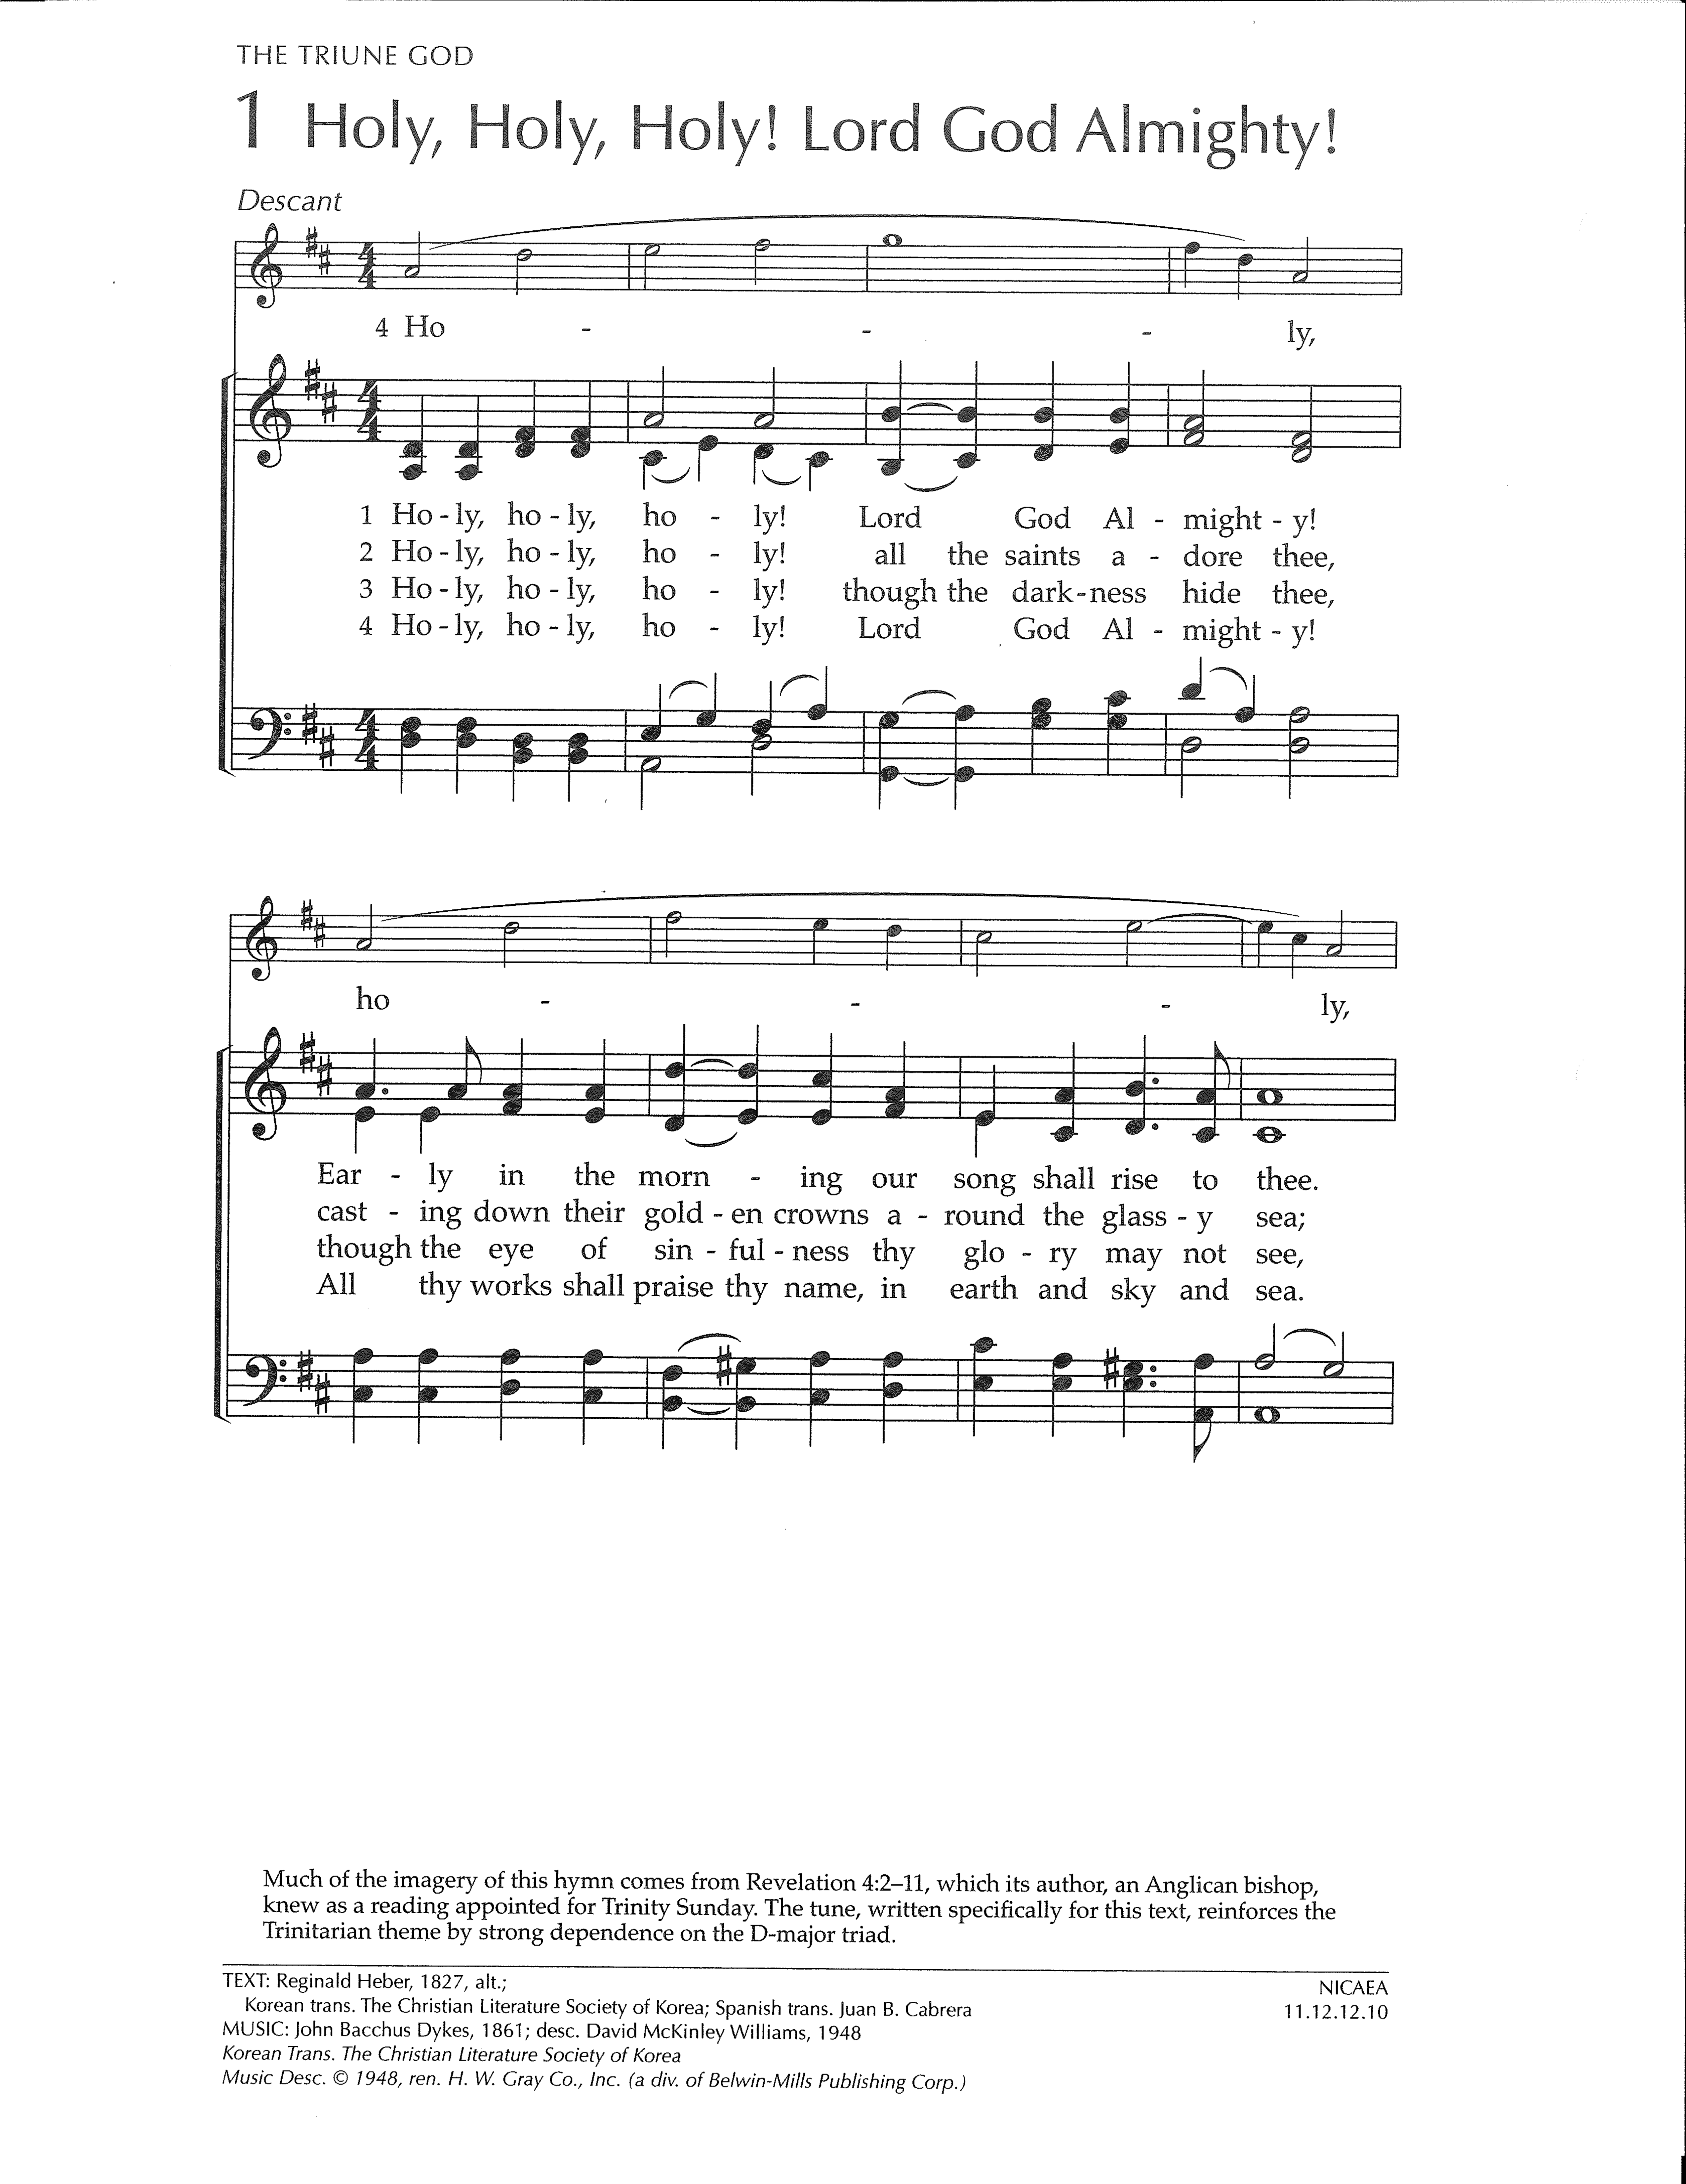 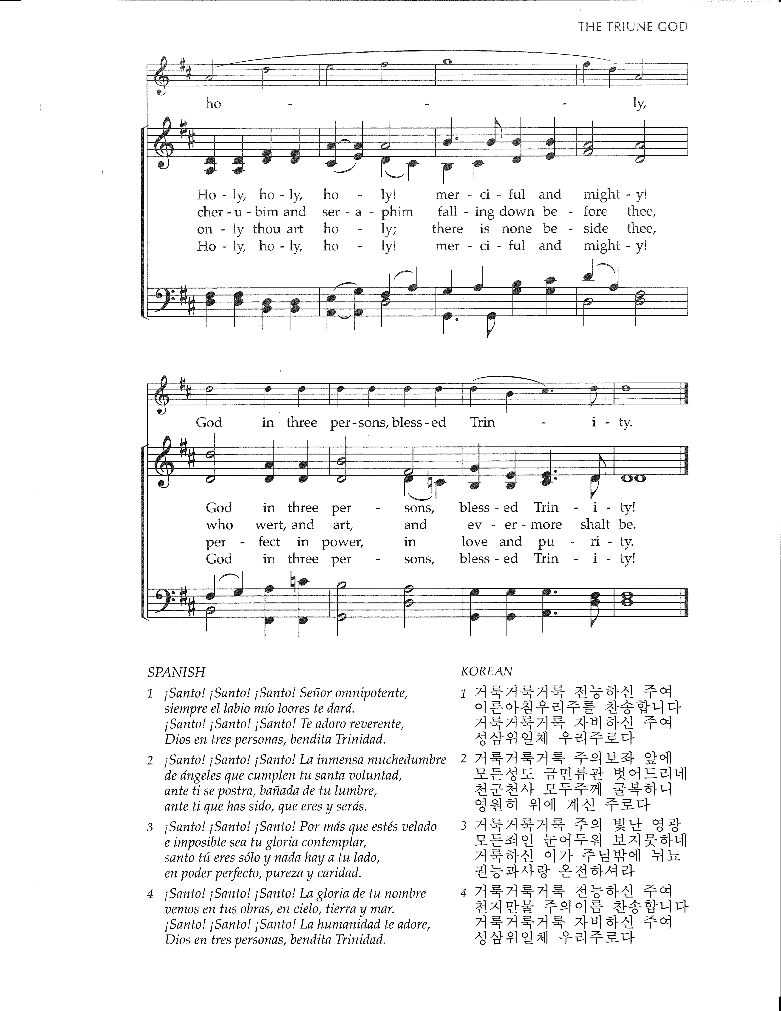



**\*\*\* JOYS AND CONCERNS \*\*\***

**Joys:**

Susan Wenzel, who is recovering from successful surgery

Bob Sears who is training to assist in leading Bible Studies at SCI Cambridge Springs

**Concerns:**

Prayers for Hunter Peterson’s grandfather, Rodney Anderson, hospitalized in Pittsburgh

Prayers for our members and friends residing in care facilities and receiving care at home

Prayers for those affected by the Coronavirus and those in the medical community attending to the sick

Prayers for Rob Stroup who is recovering from a recent ankle surgery

Prayers for Betty Steklacic, recently hospitalized and now recovering at home

Prayers for Bill

Prayers of healing for Wanda Monts

Courage, Strength and Faith to Larfay Austin Jr during his incarceration

Prayers for Carinne Palm, Vickie Eggleston’s sister, undergoing radiation treatments

Prayers for Norm Perschke who is at the Rouse Home

Prayers for Sherran Jones who is at the Rouse Home

Prayers for Lynda Slocum’s son Andy and grandson, Brayden

Prayers for Lois Buerkle, Lynn Sears’ sister, as she undergoes treatments for cancer

Prayers for Louise Crozier and family

Prayers for Katie Roth Spiegel, who is undergoing treatment for cancer

Prayers for Wally Post

Prayers for Lisa Huey Hochberg and others struggling with dementia and alzheimer’s

Prayers for Seth Courage, strength, and faith to all those affected by violent crimes.

Those serving in our military, people struggling with addiction, and those in jail

Those facing famine and hunger in remote and desolate places.

Let the Light of the Lord shine on all peoples in all nations!

**\*\*\* PRESBYTERY JOYS AND PRAYER CONCERNS \*\*\***

We pray for the churches and ministerial staff that constitute the Lake Erie Presbytery. This week we pray for Watson Run and North Shenango, Greg VanderVeen, preaching and Bimbilla District, Upper Northern Presbytery, 27 Congregations