**FOURTH SUNDAY AFTER PENTECOST**

**First Presbyterian Church**

300 Market Street, Warren, PA 16365-2360

Following Christ So All May Thrive

Office Hours: Monday-Friday 9:00AM-2:00PM

Phone: (814) 723-9200 Fax: (814) 723-6049 E-mail: admin@presbyterianwarren.com

Rev. Rebecca Taylor: (814) 313-1136 (h) (814) 596-8682 (c) Email: rebecca@presbyterianwarren.com

Website: www.presbyterianwarren.com

**June 28, 2020**



**THE SERVICE FOR THE LORD’S DAY**

Fourth Sunday after Pentecost

**June 28, 2020 10:00 AM**

*Thank you for silencing your electronic devices.*

**We GATHER in God’s GRACE**

PRELUDE  *Piece in G Major* Adolph Hesse

CALL TO WORSHIP (Responsive) (verses from Psalm 13)

L: How long must I bear pain in my soul, and have sorrow in my heart all day long?

**P: Consider and answer me, O Lord my God!**

L: I trusted in your steadfast love; my heart shall rejoice in your salvation.

**P: I will sing to the Lord, because he has dealt bountifully with me.**

*HYMN *The Lord Is God!* #63

CALL TO CONFESSION: (based on Ephesians 2)

We are certain that our lives would be so much less than they are if it were not for God’s grace bringing us fullness of life through the richness of God’s mercy! Yet we are also certain that we do not honor the gift of God’s grace because we forget that who we are is God’s accomplishment. Trusting that we will be renewed by admitting our need for God’s grace, let us pray together:

PRAYER OF CONFESSION (Unison)

**Good and gracious God, we confess that we do not always take seriously the claim you have on our lives. We admit that we are sometimes half-hearted in fulfilling our calling to serve you above all else. Forgive us for seeking our personal comfort over embracing the challenges of living faithfully in this world! Convince us of how precious we are to you and your mission on earth as we worship you this day! Hear us as we ask for your mercy in Jesus’ name. Amen.**

TIME FOR PERSONAL CONFESSION

WORDS ASSURING US OF GOD’S GRACE (Responsive) (based on Ephesians 2)

L: This is Good News: God saves us in grace and brings us the peace of Christ!

**P: We are reconciled to God through Christ’s death on the cross!**

L: In Christ we are forgiven and have become a living temple filled with God’s Spirit!

**P: We belong to God! Praise our Lord Jesus Christ!**

*RESPONSE *Glory to God, Whose Goodness Shines on Me* #582

**WE RECEIVE GOD’S WORD**

PRAYER FOR ILLUMINATION (Unison):

**Grant us grace to hear you, O God, as you speak to us today! Grant us love to live for you, O Lord, as you lead us this day! Hear us as we pray in Jesus’ name. Amen.**

FIRST SCRIPTURE READING Genesis 22:1-14 (Common English Bible)

After these events, God tested Abraham and said to him, “Abraham!” Abraham answered, “I’m here.” God said, “Take your son, your only son whom you love, Isaac, and go to the land of Moriah. Offer him up as an entirely burned offering there on one of the mountains that I will show you.” Abraham got up early in the morning, harnessed his donkey, and took two of his young men with him, together with his son Isaac. He split the wood for the entirely burned offering, set out, and went to the place God had described to him. On the third day, Abraham looked up and saw the place at a distance. Abraham said to his servants, “Stay here with the donkey. The boy and I will walk up there, worship, and then come back to you.” Abraham took the wood for the entirely burned offering and laid it on his son Isaac. He took the fire and the knife in his hand, and the two of them walked on together. Isaac said to his father Abraham, “My father?” Abraham said, “I’m here, my son.” Isaac said, “Here is the fire and the wood, but where is the lamb for the entirely burned offering?” Abraham said, “The lamb for the entirely burned offering? God will see to it, my son.” The two of them walked on together. They arrived at the place God had described to him. Abraham built an altar there and arranged the wood on it. He tied up his son Isaac and laid him on the altar on top of the wood. Then Abraham stretched out his hand and took the knife to kill his son as a sacrifice. But the Lord’s messenger called out to Abraham from heaven, “Abraham? Abraham?” Abraham said, “I’m here.” The messenger said, “Don’t stretch out your hand against the young man, and don’t do anything to him. I now know that you revere God and didn’t hold back your son, your only son, from me.” Abraham looked up and saw a single ramcaught by its horns in the dense underbrush. Abraham went over, took the ram, and offered it as an entirely burned offering instead of his son. Abraham named that place “the Lord sees.” That is the reason people today say, “On this mountain the Lord is seen.”

Leader: This is the Word of the Lord. **People: Thanks be to God!**

SECOND SCRIPTURE READING Matthew 10:34-39 (Common English Bible)

“Don’t think that I’ve come to bring peace to the earth. I haven’t come to bring peace but a sword. I’ve come to turn a man *against his father, a daughter against her mother, and a daughter-in-law against her mother-in-law*. *People’s enemies are members of their own households*. “Those who love father or mother more than me aren’t worthy of me. Those who love son or daughter more than me aren’t worthy of me. Those who don’t pick up their crosses and follow me aren’t worthy of me. Those who find their lives will lose them, and those who lose their lives because of me will find them.

Leader: This is the Word of the Lord. **People: Thanks be to God!**

SERMON: *When Does a Push Become a Shove?* Rev. Rebecca Taylor

**WE RESPOND TO GOD’S WORD**

OFFERING

*Please consider sending your gift through the mail or by utilizing the online giving function on the church’s website! God’s mission continues!*

PRAYERS OF THE PEOPLE AND THE LORD’S PRAYER (traditional)

**Our Father who art in heaven, hallowed be thy name, thy kingdom come, thy will be done, on earth as it is in heaven. Give us this day our daily bread; and forgive us our debts, as we forgive our debtors; and lead us not into temptation, but deliver us from evil. For thine is the kingdom, and the power, and the glory, forever. Amen.**

*WORDS AFFIRMING OUR FAITH (Unison) (from *A Declaration of Faith*)

**Jesus announced the coming of God's kingdom and its hidden presence in the midst of the world's kingdoms. He taught his disciples to seek God's kingdom first.**

**We believe Christ gives us and demands of us lives in pilgrimage toward God's kingdom. Like Christ we may enjoy on our journey all that sustains life and makes it pleasant and beautiful. No more than Christ are we spared the darkness, ambiguity, and threat of life in the world. We are in the world, but not of the world. Our confidence and hope for ourselves and other people do not rest in the powers and achievements of this world, but in the coming and hidden presence of God's kingdom. Christ calls each of us to a life appropriate to that kingdom: to serve as he has served us; to take up our cross, risking the consequences of faithful discipleship; to walk by faith, not by sight, to hope for what we have not seen.**

*HYMN *Will You Come and Follow Me* #726

*BENEDICTION Romans 8:35, 37-38a (Common English Bible)

Who will separate us from Christ’s love? Will we be separated by trouble, or distress, or harassment, or famine, or nakedness, or danger, or sword? But in all these things we win a sweeping victory through the one who loved us. I’m convinced that nothing can separate us from God’s love in Christ Jesus our Lord.

Remember: you are never alone. You are always held in the love of God, kept in the grace of Jesus the Christ, and accompanied by the Holy Spirit!

* THE LECTIONARY READINGS FOR THE NEXT WEEK***

Zechariah 9:9–12 **Romans 7:15–25a**

Psalm 145:8–14 **Matthew 11**:16–19, **25–30**

Questions for Reflection

How have you experienced God’s steadfast love?

Household Prayer: Morning

Loving God, I receive this new day as a gift from you. Help me to see signs today of your compassion, which is over all that you have made. Please keep me mindful to watch for ways today in which I can ease others’ burdens and give them rest, in Jesus’ name. Amen.

Household Prayer: Evening Caring God, thank you for my journey through this day. Whatever conflict I may feel within about what I did and did not do I give to you to carry for me now, and I let you give me rest. Amen.

**Taken from *Feasting on the Word Worship Companion: Liturgies for Year C, Volume 2*. © 2014 Westminster John Knox Press. All rights reserved. Used by permission.



**OUR STAFF**

Rev. Rebecca Taylor, Pastor rebecca@presbyterianwarren.com

Hunter Peterson, Director of Music hmpeterson100@gmail.com

Barb Hill, Administrative Assistant admin@presbyterianwarren.com

Betsy Griffin, Financial Secretary [finance@presyterianwarren.com](mailto:finance@presyterianwarren.com)

Events and Communications Coordinator [connect@presbyterianwarren.com](mailto:connect@presbyterianwarren.com)

Kyle Brecht, Property Manager Ben Check, Assist. Property Manager

Courtney Robillard, Childcare Curtis Tyler, Childcare

Lori VanOrd, Childcare Terri Shaw, Childcare

**THE SESSION**

Ross Bryan Joanna Elletson

Rene’ Davis Ann Ferguson

Gale Dyke Ray Pring

Larry Dyke Carrie Salapek

Jim Eggleston Lynn Sears

Vickie Eggleston

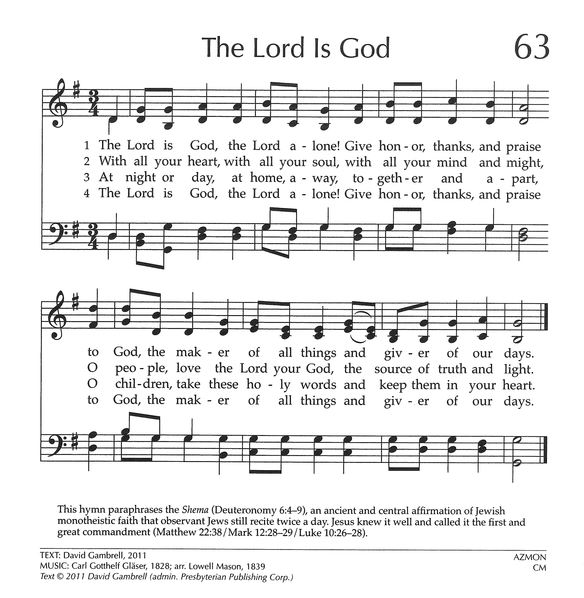



**\*\*\* JOYS AND CONCERNS \*\*\***

**Joys:**

Staff and Leadership is working towards in-person worship on July 5, 2020

Susan Wenzel, who is back in Warren.

Bob Sears who is training to assist in leading Bible Studies at SCI Cambridge Springs

**Concerns:**

Prayers for Dennis Bonace, recently hospitalized

Prayers for Steve Fox, Lynda Slocum’s son-in-law, on the death of his brother, Doug

Prayers for Hunter Peterson’s grandfather, Rodney Anderson, hospitalized in Pittsburgh

Prayers for our members and friends residing in care facilities and receiving care at home

**At Home:** Dennis Bonace **Rouse Home**: June Carlson

Coleen Christy Martha Jones

Dorothy Collins Sherran Jones

Hal Conarro Norm Perschke

Jacqueline Johnson **Cambridge Warren**: Martha Holtz

Katherine Judson Kathleen Mahaffy

**Warren Manor**: Betty Steklacic

Prayers for those affected by the Coronavirus and those in the medical community attending to the sick

Prayers for Rob Stroup who is recovering from a recent ankle surgery

Prayers for Andrew Dworek, 18 years old, recently diagnosed with cancer

Prayers for Bill

Prayers of healing for Wanda Monts

Courage, Strength and Faith to Larfay Austin Jr during his incarceration

Prayers for Carinne Palm, Vickie Eggleston’s sister, undergoing radiation treatments

Prayers for Lynda Slocum’s son Andy and grandson, Brayden

Prayers for Lois Buerkle, Lynn Sears’ sister, as she undergoes treatments for cancer

Prayers for Louise Crozier and family

Prayers for Katie Roth Spiegel, who is undergoing treatment for cancer

Prayers for Wally Post

Prayers for Lisa Huey Hochberg and others struggling with dementia and alzheimer’s

Prayers for Seth Courage, strength, and faith to all those affected by violent crimes.

Those serving in our military, people struggling with addiction, and those in jail

Those facing famine and hunger in remote and desolate places.

Let the Light of the Lord shine on all peoples in all nations!

**\*\*\* PRESBYTERY JOYS AND PRAYER CONCERNS \*\*\***

We pray for the churches and ministerial staff that constitute the Lake Erie Presbytery. This week we pray for Emmanuel, Erie, Rev. Anita Bernhardt, Temporary Supply Pastor and for Rev. Harvey Boal, Honorably Retired and Rev. Sue Montgomery, Honorably Retired.